A watershed-specific formula to predict salmon reproduction using functional flow metrics

Claire Kouba, Leland Scantlebury, Jason Wiener, Sarah Yarnell and Thomas Harter

June 2025

# Abstract

In many rural areas of arid and semi-arid regions, balancing agricultural and environmental water needs is a key challenge facing resource managers. This is complicated by the tendency for the water needs of cultivated crops to be better understood than those of aquatic ecosystems. This work aims to quantify hydrologic conditions that support persistence of key ecosystem species using functional flows, not in the context of a prescribed flow regime, but in terms of identifying features of the hydrograph that are empirically correlated with specific ecological outcomes. We use the coho (*Oncorhynchus kisutch*) and Chinook (*Oncorhynchus tshawytscha*) salmon runs in Scott Valley, a 2,109 km2 undammed rural watershed in northern California, USA, as a case study.

Taking advantage of a nearly two-decade ecological monitoring dataset and long-term stream gauge measurements, we first examined hydrological-ecological correlations, then compared six different statistical modeling structures, using two techniques: LASSO and MARSS. In LASSO regressions, to balance the explanatory power of the models with the risk of overfitting, we used k-fold cross-validation to find the lowest-error value of the tuning parameter lambda. In MARSS we calculated models for each individual hydrologic metric and compared them using AICc values.

Correlation coefficients indicate that hydrologic factors and spawner abundance both exert influence on juvenile fish production. Statistical models generally agreed that the hydrologic metrics with the highest coefficients are earlier river reconnection and greater fall flow magnitude during parents’ spawning for coho, and lower wet season median flow and slower spring recession rate for Chinook (though this could change with additional years of data, especially for the smaller coho dataset). The influence of some metrics, notably fall flow difference from dry season, was positive or negative depending on the fish life stage in which the flow occurred.

This approach for empirically identifying hydrologic metrics with high ecological importance for a threatened species may be useful in other watersheds, where sufficient ecological data are available, and could be used to evaluate trade-offs and support water management decisions in human-altered novel ecosystems.

# Practitioner points

1. Correlation coefficients indicate that production of juvenile outmigrant fish is not dominantly controlled by hydrologic factors or by spawner abundance but is influenced by both.
2. The most important hydrologic metrics were earlier river reconnection/preferred habitat access during parents’ spawning, and larger fall flow difference from dry season, for coho; and lower wet season median flow and slower maximum spring recession rate for Chinook.
3. This supports an interpretation that hydrologic conditions during coho parents’ spawning (potentially, more fall flow and earlier tributary reconnection providing more habitat or time to find a better nesting site) or as Chinook eggs (potentially, higher average winter flowrates causing egg burial or increasing energetic costs of foraging) and Chinook outmigrating smolt (potentially, slower spring recession producing more favorable outmigration conditions) may exert a significant influence on the mortality rates of the hatching juveniles in this study area.

# 1 Introduction

## 1.1 Motivation and objectives

Reconciliation ecology posits that some human-impacted ecosystems should be considered irrevocably-altered, “novel” systems (Moyle 2014), with their own specific management concerns. To implement this philosophy, rather than working to restore novel ecosystems to pre-human conditions, a natural resource manager would actively manage biodiversity in human-altered landscapes as a co-equal goal with extracting and cultivating natural resources to provide for human material needs (e.g., Robertson and Swinton 2005; Arthington, Bernardo, and Ilhéu 2014; Acreman et al. 2014; Yarnell et al. 2015). Ideally management would be based on an empirical or mechanistic understanding of two key linkages: firstly, how management actions affect availability and quality of water, and secondly, how those hydrologic changes affect human beneficial uses and ecological receptors (Rosenfeld 2017).

A large body of research has focused on general methods for quantifying connections between water management, flow, and ecological responses, as discussed below; however, in practice, such natural resource management is often specific and local (Tarlock 1993). Accordingly, the authors of this study have posed research questions tailored to conserving two specific salmon species, the threatened coho salmon (*Oncorhynchus kisutch*) and the less-threatened Chinook salmon (*Onchorhynchus tshawytscha*), in a specific study area: the Scott River watershed in northern California, USA. In this undammed, rural watershed, water use is primarily managed by managing land use. Balancing the competing water needs of fish and farmers is a key challenge for local water managers (Siskiyou County 2021). Agricultural water needs are well-known and can be estimated and scheduled (Siskiyou Resource Conservation District 1994; Parry 2013; CDFW 2021), but, in spite of decades of investigation by local, state and federal actors (e.g., SRWC and Siskiyou RCD 2003; NMFS 2014; CDFW et al. 2015; CDFW 2021), the ecological water needs in this balancing act are not as well constrained.

One method for estimating ecological water needs, developed for the Mediterranean climate and hydrologic landscape of California, is the functional flows approach (Escobar-Arias and Pasternack 2010; Yarnell et al. 2015, 2020; Grantham et al. 2020; Stein et al. 2021). Functional flow metrics are used to quantify potential ecological services provided by river flow in terms of flowrate magnitude, timing, frequency, and duration in distinct seasons of a water year, where water year is here defined to begin on October 1 of the year preceding the calendar year of the same number (i.e., water year 2020 begins on October 1, 2019). These metrics can be calculated for any location with daily river data using signal-processing algorithms (Patterson et al. 2020; Carpenter 2024). While much environmental flows work has been dedicated to “top down” approaches (Tharme 2003) that characterize a natural or altered flow regime in its entirety (e.g., Yarnell et al. 2020; Stein et al. 2021), in this study we use a functional flows approach to quantify meaningful flow components and assess which aspects of the natural flow regime are more influential in different life stages of two different species. In addition to functional flows, we define two other useful hydrologic metrics.

Using this framework, we here address the second (“flow-to-ecology”) linkage referenced above: we assess the potential to empirically identify and prioritize hydrologic features that support the ecological needs of specific species (coho and Chinook salmon) in a specific ecological region (the Scott River watershed). We focus on the questions: while we expect both biotic (e.g., number of spawners) and abiotic (e.g., hydrological) factors to influence fishery success (Ward et al. 2024), which hydrologic metrics are more correlated with specific ecological outcomes, and thus amenable to this predictive exercise? Is the predictive power of hydrology different for two different species? Can we identify and prioritize important hydrologic metrics that could then be used by managers for evaluating the effects of different management actions on this aquatic ecosystem?

## 1.2 Utility of modeling ecological responses to flow

Juvenile outmigrant production is one of the most obvious indicators of the health of an anadromous fishery (Jager and Rose 2003), but is predicting outmigrant production (or any ecological response) using flow alone a worthwhile exercise, given the many interacting non-hydrologic factors (channel geomorphology, water quality, food resources, internal population dynamics) influencing a fishery (McMahon 1983; Bradford, Taylor, and Allan 1997; Escobar-Arias and Pasternack 2010; Willis et al. 2016)?

For some applications, it is not. Flow observations alone cannot represent site-specific hydraulics, which dictate the physical conditions for aquatic life; indeed, in different geomorphology, the same flow can produce very different hydraulic environments (Turner and Stewardson 2014). Flow observations also fail to capture other critical ecological drivers such as water quality, habitat quality, or food resources (e.g., Willis et al. 2016). Thus it is often fruitless to attempt to predict numerical fish recruitment based solely on hydrologic data; more complex approaches such as combining hydraulics with bioenergetic models (Bellido-Leiva, Lusardi, and Lund 2021), fish population and mortality (Jager and Rose 2003) or considering flow and water temperature (Nislow and Armstrong 2012) may produce better recruitment forecasts.

Nevertheless, in the absence of data such as site-specific flow-hydraulic relationships and dynamic population models, hydrologic-only approaches may be suitable for some types of natural resource planning (Nislow and Armstrong 2012; Turner and Stewardson 2014). Furthermore, they may enhance efforts to balance environmental and resource-extraction objectives (Jager and Smith 2008) while being based on relatively cheap and abundant hydrologic data. Among hydrologic-only methods, “top-down” approaches aim to support the flow needs of the entire ecosystem, often based on alteration of calculated hydrologic metrics from a pre-development flow regime (e.g., Poff et al. 2010; Arthington 2012; Yarnell et al. 2020), while “bottom-up” approaches aim to identify the individual flow features most critical to supporting a given objective (Tharme 2003). This study falls into the latter category.

## 1.3 Previous findings on California salmon flow requirements

Even within the geographic context of California, specific flows identified as being important to salmonids have varied by the study region, objective, and species under consideration. They include, in Central Valley rivers, winter minimum flows (Jager and Rose 2003); early summer pulse flows and late winter overbank pulse flows (Jager 2014); but also an indication that juvenile survival was highest in an intermediate flow range in the Sacramento River (Michel et al. 2021). In one adaptive management retrospective, two individual dam release pulse events improved habitat conditions for rearing juveniles during a critically dry year (Sellheim, Zeug, and Merz 2020). Optimal flow regimes are also different for different species-specific environmental objectives, and vary based on water year type (e.g., a recommendation to provide high spring flows in wet years) (Jager and Rose 2003). Conversely, in at least one study, flow differences had little effect on migration timing or growth of salmonids [specifically, South Fork Eel River steelhead; Kelson and Carlson (2019)].

Such variability reflects the diversity of habitat and ecological effects across different geomorphic and hydroclimate contexts. This study aims to contribute to this body of work by proposing a method for identifying empirical relationships between flows and species focusing on the scale of a single watershed at which several other types of management choices are made.

## 1.4 History of flow-ecology relationships

A river’s flow regime is often referred to as a “master variable” controlling geomorphic, chemical, and other conditions in its aquatic ecosystems, and organisms that have evolved to persist in specific flow regimes are commonly negatively affected by flow alteration (Bunn and Arthington 2002; Poff et al. 2010). Consequently, in recent decades a diverse body of research has sought to identify and quantify ecological responses to changes in flow (see Supplement for additional review of work in this field).

Bridging the gap between science and policy has been a persistent challenge and ongoing focus of work in this field. In many cases a key research motivation is to support decision-making in a variety of contexts, including dam operation, river restoration, and regulations of water extraction and land use (Richter et al. 2006; Han et al. 2015; Sinnathamby et al. 2018; Bradley et al. 2017; Brummer et al. 2016). But historical approaches based on relationship-finding are several steps removed from the policy-making process (Webb et al. 2018). For example, the Indicators of Hydrologic Alteration (Richter et al. 1996, 2017) and Ecological Limits of Hydrologic Alteration (ELOHA) (Poff et al. 2010; McManamay et al. 2013) approaches generate flow standards for particular rivers, and are a top-down method for determining the flow needs of the whole ecosystem, but cannot translate specific management decisions into hydrologic outcomes, or predict specific ecological outcomes of the described alteration (Richter et al. 2006; Cartwright et al. 2017). Additionally, identifying natural flow regimes may be less immediately relevant to water resource management than an approach which can quantify ecological responses to “designer” or functional flows (which can often be controlled or influenced by dam releases) (Arthington, Bernardo, and Ilhéu 2014; Webb et al. 2018), with the caveat that the designer flows approach may risk overlooking ecological flow needs that are not currently monitored (Bower et al. 2022).

An ideal framework for supporting decision-making would involve two key steps, firstly connecting land and water management actions to flow changes (“management-to-flow”), and secondly connecting flow changes to ecological responses (“flow-to-ecology”) (Peterson and Freeman 2016; DeWeber and Peterson 2020; Acero Triana, Chu, and Stein 2021). Both steps can involve complex models and substantial uncertainty, often representing an interdisciplinary challenge. Threshold values for “sufficient” flows would be ideal for a management context (Rosenfeld 2017), but can be difficult to identify and in some cases may not exist (Lueders and McManamay 2023). Finally, stakeholders in at least one study requested flow-ecology relationships based on empirical monitoring, rather than more easily-simulated proxies like flow changes or thermal exposure (DeWeber and Peterson 2020).

The present study is a longitudinal “bottom-up” analysis, using empirical data and a case study, to identify characteristics of flow most critical to support two specific species, and thus address the “flow-to-ecology” linkage described above. We use empirical data to develop multiple predictive models of a biological response to measurable (and simulatable) changes in flow metrics. A forthcoming companion study will investigate the “management-to-flow” link, simulating flow changes from watershed management actions using an appropriate hydrologic model, as a basis for studying unavoidable water management tradeoffs within the watershed.

# 2 Methods: Case study setting and species of concern

Exploring the empirical relationship between river hydrology and an ecological response requires both spatial and temporal overlap in a study area’s hydrologic and ecological monitoring data.

These requirements are met to some degree in Scott Valley, though as is typical, ecological data is the limiting factor. Hydrologic data is provided by daily river flow monitoring, which has been ongoing since the 1940s at the USGS stream gauge downstream of the town of Fort Jones (Station ID #11519500, or the Fort Jones Gauge or FJ Gauge; Figure 1). The flow at this gauge is correlated with flow in tributary streams (Foglia et al. 2013), and though a single monitoring location may not be able represent flow status in the full stream system at all times, it has been used in recent water planning documents as an indicator of overall hydrologic conditions (Siskiyou County 2021). Because most water use in Scott Valley occurs upgradient of this gauge, its measurements are used to inform water management decisions in the populated areas of the valley (see *Supplement* for historical Scott Valley water management flow-ecology work).

## 2.1 Geography, climate and hydrology

The Scott River drains a 2,109 km2 (814 square mile) watershed known as Scott Valley, flowing generally from south to north and joining the Klamath River after flowing through a steep canyon (Figure 1). The Scott is a major tributary to the Klamath, which drains an area spanning sections of Northern California and Southern Oregon (Figure 1, inset map). Scott Valley has a Mediterranean climate with distinctive seasons of cool, wet winters and warm, dry summers. This seasonality in water input creates highly seasonal flow in the Scott River and tributary streams, where the beginning of a water year coincides with low flow conditions that immediately precede the onset of winter precipitation (Figure 2).

In most dry-to-average water years, sections of the Scott River become seasonally dewatered (NCRWQCB 2005; Figure 5 in Tolley, Foglia, and Harter 2019). This occurs when the elevation of the water table drops below the bottom of the river channel, as streams and groundwater are highly interconnected in the Scott River watershed. Tributary streams, particularly along their alluvial fan apeces, and the upper Scott River are sources of recharge to the aquifer (Mack 1958; Harter and Hines 2008). Groundwater discharge sustains streamflow in low-lying areas, especially during the dry season of August through October or November (Tolley, Foglia, and Harter 2019). For consistency with regulatory and management programs in this region, this document uses units of cubic feet per second (cfs) when reporting hydrologic fluxes.

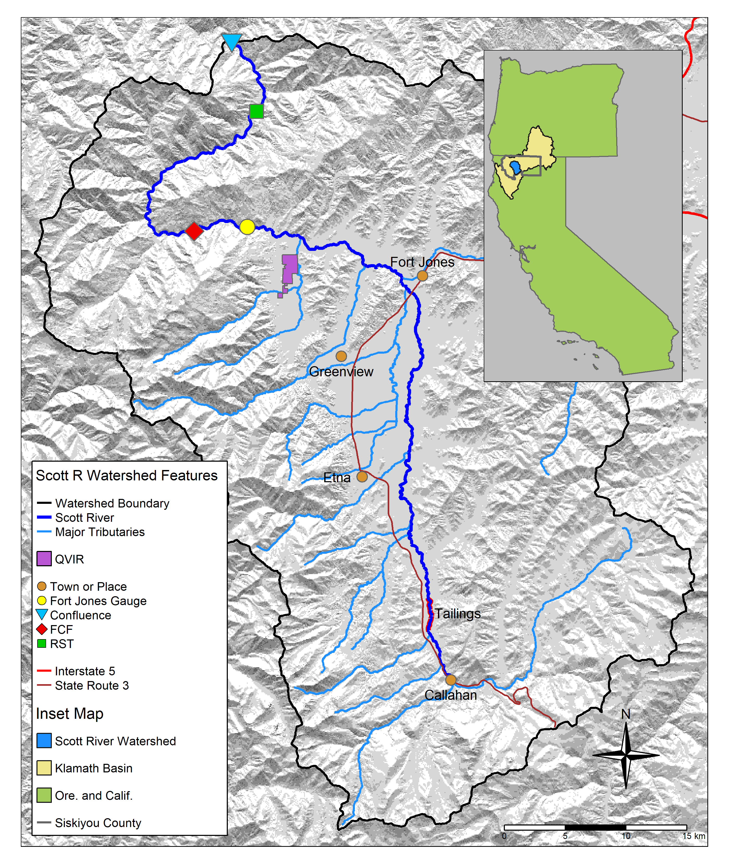

Figure 1: The Scott River watershed, with regional geographic context (see inset) and local features, including the Scott River Fish Counting Facility (FCF) and Scott River Rotary Screw Trap (RST).



Figure 2: Each translucent line traces one annual hydrograph measured at the Fort Jones gauge, and the darker lines illustrate the 30-day smoothed median daily flow in Dry, Below Average, Above Average, and Wet water year types, for water years 1942-2023. The water year type is defined by quartiles of the distribution of total annual flow.

## 2.2 Species of concern: coho and Chinook salmon

This study intends to identify key hydrologic characteristics that correlate with reproductive success of two species, coho and Chinook salmon. To this end, we used long records of hydrologic and ecological data (more than eight and two decades, respectively) collected in the Scott River watershed. Although both species utilize fall flows (including fall pulses, when they occur) to migrate from the ocean to natal spawning streams, the life history strategies of these two salmonids are distinct in several ways, and consequently their outcomes are expected to be correlated with different functional flows (see Supplement for detailed life history information). Chinook and coho salmon are distinct in several ways relevant to this study and to management considerations:

* The vast majority of Scott River coho salmon outmigrate at 1+ years and return to spawn at 2+ years of age, producing a distinct cohort every 3 years (Knechtle and Giudice 2020), while the amount of time spent by Chinook in the ocean is more variable and more dependent on ocean conditions, and distinct cohort structure is not observed (Groot and Margolis 1991; Bourret, Caudill, and Keefer 2016).
* Juvenile coho salmon are affected by 2 years of freshwater conditions, while juvenile Chinook are affected by only one year of freshwater conditions (Figure 3) (Agrawal et al. 2005; Knechtle and Giudice 2020). This means Chinook avoid summer low flow conditions by migrating to the ocean, while coho often over-summer in freshwater habitats fed by springs or snowmelt, or supported by wetlands (Lusardi et al. 2020, 2021).
* In most years Chinook spawning migration takes place earlier (September-December) than coho (October-January).
* Due to multiple factors, including preferred gravel size and requirements for habitat during summer low-flow conditions, the majority of coho redds are found in (higher-gradient, snow-fed) Scott River tributaries, while Chinook redds are more commonly found in the mainstem Scott River (e.g., Magranet and Yokel 2017; Magranet 2017). Several tributaries tend to disconnect from the mainstem Scott River. Additionally, due to historical mining activity, a key mainstem reach known as the “tailings” (Figure 1) often dewaters during average-to-dry years, restricting spawning access to some headwaters habitat (Scott River Watershed Council 2018).
* Declining populations of coho salmon have been noted in the Klamath basin and more broadly in coastal California streams since the 1990s (e.g., Brown, Moyle, and Yoshiyama 1994), while regional Chinook populations have historically been more robust (Wainwright et al. 2013). However, a declining trend was observed in the Klamath run of Chinook in the 2010s, and this trend was more significant in the Scott River system than the broader Klamath basin (Knechtle and Giudice 2023). These trends have prompted additional monitoring of Scott Valley Chinook in the past decade (e.g., spawning surveys such as Magranet 2015b, 2017) (Table 14).



Figure 3: Seasons (as defined in the California Environmental Flows Framework; Yarnell et al. 2020) and life stages experienced by a coho and a Chinook salmon cohort in the Scott River watershed. Season identifiers listed here are used throughout the document.

# 3 Methods: Quantitative analysis

We used functional flow metrics to describe the history of the Scott River as observed over eight decades at the Fort Jones gauge. Then, we used correlation coefficients to explore relatedness between Z-scored hydrologic metrics and log-transformed ecological records (*Supplemental Figure A*). We then conducted twelve total statistical modeling exercises: two modeling techniques, LASSO (James et al. 2013; Ranstam and Cook 2018) and MARSS (See and Holmes 2015), to predict three different predictor-response pairs for each species (Table 1).

## 3.1 Step 1. Calculate predictors and screen for collinearity: Flow metrics to describe Scott River flow regime

To calculate a set of hydrologic predictor metrics for the Scott River, we used functional flows algorithms tuned for “flashy” (or flow regimes with rapid changes in flows common to rain-driven or altered systems) river systems (Figure 9) (Yarnell et al. 2020; Patterson et al. 2020; Carpenter 2024). These functional flows were calculated from the daily flow record at the Fort Jones river gauge from 1942-2023 using the general approach of Patterson et al. (2020), updated to better reflect the characteristics of ephemeral streams (Carpenter 2024). The full suite of 30 annual metrics is calculated on a water-year basis (i.e., each type of metric produces one value for each water year; Tables 6 through 11). Descriptions, abbreviations, relevant time periods (including salmon life stage alignment; see Section 3.3), and metric calculation details are listed in Table 5; additional information is available in Patterson et al. (2020) and supporting documentation.

All functional flow metrics have some known ecological function or interpretation, e.g., total annual flow is used to evaluate water year type. Phenomena measured with fall metrics, such as magnitude of the fall pulse [defined as at least two times the dry season baseflow; Patterson et al. (2020)]) and fall pulse timing, provide olfactory migration signals and spawning access to anadromous fish; however, a sufficiently large fall pulse does not occur in every water year, so a magnitude-agnostic fall pulse difference metric was included that can be calculated annually (after Baruch et al. 2024). Wet season metrics, such as wet season onset timing and median flow magnitude, can be used to gauge conditions during egg incubation or the overwintering period for juvenile coho salmon. Spring metrics, such as spring flow recession magnitude and rate of change, occur during the transition from wet to dry season, and indicate conditions during early juvenile salmon rearing as well as the flow available for outmigration from Scott Valley to the ocean. Finally, metrics like the duration and median flow of the dry season indicate the timing and severity of low-flow conditions in which spatial habitat is constrained and connectivity between reaches may be limited, and which set conditions preceding fall spawning runs.

Secondly, two additional metrics were devised for this study area related to timing of anadromous fish access to preferred spawning habitat in this specific watershed (illustrated in Figure 10). These metrics are referred to as “reconnection” and “disconnection” dates, and are defined further in the following section and in the Supplement (Table 12).

### 3.1.1 Selecting flow thresholds for dis- and re-connection timing

In average-to-dry water years, after portions of the Scott River and tributaries run dry (Figure 1), the timing of end-of-dry-season fall river reconnection determines when salmon can access mainstem and tributary spawning habitat and thus whether salmon passage exists during the preferred migration time window (Scott River Watershed Council 2018). Conversely, at the end of the wet season, the timing of river disconnection in the spring and summer can influence conditions for outmigrating smolt.

To calculate the timing of river connectivity, three discrete thresholds were selected from the continuum of flows to represent a partially and a fully connected stream system. The thresholds correspond to two distinct events: first, 20 and 40 cfs (0.57 to 1.1 cms), corresponding to the low and high estimates of what constitutes connectivity within mainstem Scott River (Siskiyou County 2021); and second, 120 cfs (3.4 cms), representing connectivity of the full stream network, allowing access to most tributary habitat. These values are calculated as number of days after Aug. 31 of the preceding water year, to account for rare September storms; if connectivity is never lost, the reconnection or disconnection date is assumed to be the first or last day of the modified water year, respectively. These metrics are similar to several California-specific functional flows, namely, the timing and slope of spring recess and the timing of a fall pulse flow (Table 12), but differ in the simplicity of their calculation and their direct relevance to salmon access to two distinct Scott River habitat zones.

Because these flows are measured at the Fort Jones gauge, they are a proxy for conditions in the full stream network; however, hydrograph and precipitation analyses suggest that 120 cfs at the Fort Jones gauge is a good indicator of mostly-full soil and aquifer storage, or a “spilling” watershed condition that maintains a connected stream network (Kouba and Harter 2024).

### 3.1.2 Screen predictors for collinearity

Because many metrics are influenced by the same phenomena taking place in wet and dry years, significant collinearity was present in the hydrologic metrics used in this predictive exercise. To account for this, collinear predictors, defined as predictors correlated with each other [a Spearman’s *R* greater than 0.7 or less than -0.7; Dormann et al. (2013)], were grouped, and one predictor was selected to represent each group. In Supplemental text and Table 13, we describe each group and the ultimate selected predictors in conceptual terms. In this screening we aimed to retain metrics occurring in each of the eight seasons influencing coho rearing in freshwater (and for Chinook, four seasons) (Figure 3).

## 3.2 Step 2. Assemble responses: Ecological monitoring data

Seven total observed quantities (three for Chinook; four for coho) were evaluated as candidates to represent the ecological response (dependent variable) in the flow-ecology relationship. These records were pulled from public monitoring reports published by the California Department of Fish and Wildlife (CDFW).

Factors influencing the population size of anadromous fish include ocean conditions and freshwater conditions. This study focused on the conditions in their natal streams. Hence, we focus on fish population metrics that are influenced by the freshwater system. The ecological observations considered for use in the final flow-ecology relationship are:

1. Number of adults migrating from the ocean to freshwater natal streams to spawn. This quantity, the ‘escapement’, is measured at the Scott River Fish Counting Facility, using a resistance board weir and video counting flume in the Scott River (e.g., Knechtle and Giudice 2023) (Figure 1).
2. Number of juvenile yearling, or smolt, salmon. Smolt are counted as outmigrants, at the Scott River Rotary Screw Trap facility (Figure 1) (e.g., Massie and Morrow 2021; Romero and Robinson 2024) .
3. Number of salmon gravel nests, or redds, observed during spawning window (e.g., Magranet 2015b) (for coho only).

Two combined metrics historically calculated and reported by regional agencies (Knechtle and Giudice 2023) were also considered. These metrics use data from multiple years to capture multiple life stages for a given cohort:

1. The number of outmigrating coho smolt produced per spawning female (coho spf) and the outmigrating Chinook juveniles per spawner (Chinook jpa).

These time series of observations are the result of decades of investment in local ecological monitoring. Monitoring activity in the past 20 years has included population estimates from a video counting flume and a rotary screw trap operated by CDFW (CDFW 2015; Massie and Morrow 2021; Knechtle and Giudice 2023), and spawning surveys for Chinook (Magranet 2015a, 2017, 2018a) and coho (Maurer 2003; Siskiyou RCD 2004, 2010; Quigley 2005, 2006, 2007; D. Yokel 2011, 2013, 2014; Franklin 2012; Magranet 2015b; Magranet and Yokel 2017).

## 3.3 Step 3. Align predictor and response metrics with timing of species cohorts

The empirical basis for this predictive modeling exercise is a table of hydrologic metrics (one per water year) and ecological observations influenced by this hydrology (Tables 15 through 26). However, the row-by-row basis for the table must account for the life history of the two species under consideration.

A cohort of coho salmon will experience conditions during multiple water years while residing in their spawning habitat, and flow impacts are specific to life-stage. Vice versa, a specific hydrologic event will have a different effect on fish experiencing it as a hatchling fry than on those experiencing it as 1+ year old parr (Nislow and Armstrong 2012). Here we define the alignment (i.e., mapping) of a specific generation of fish (ecological outcome) with observed hydrologic metrics (predictors) via their specific life stage (Tables 15 through 26).

### 3.3.1 Data alignment - coho

The relevant unit of time for identifying the impacts of Scott River freshwater hydrology on a coho salmon cohort is defined as a ~2 year period spanning eight seasons, starting in the dry season preceding the parents’ spawning, and ending in the spring of smolt outmigration (Figure 3). The coho life cycle is largely regular in Scott Valley, with 3 defined cohorts in which the vast majority of individuals return to natal streams at 3 years of age (e.g., CDFW 2021).

Following standard practice for functional flows (Patterson et al. 2020), each functional flow and hydrologic metric were labeled with the season in which it occurred. Additionally, each hydrologic metric was assigned to the brood year of each affected cohort of coho salmon, according to the year (first or second) in which the cohort experienced it. Specifically, the eight seasons are designated as the first and second dry, fall, wet and spring seasons (abbreviated d1, f1, w1, s1, d2, f2, w2, and s2; Figure 3). In some rare cases, flow metrics may fall outside their designated subperiods (e.g., the extreme dry water year of 2014, in which the “fall reconnection” of flows in brood year 2013 did not occur until February of the following calendar year). Nonetheless, for consistency, even a January or February reconnection date will be referred to by the previous fall year designation.

### 3.3.2 Data alignment - Chinook

Because spawning occurs in the fall for both coho and Chinook salmon in the Scott River watershed (California Department of Fish and Wildlife 2021), Chinook ecological data was aligned with hydrologic metrics in the same manner as coho observations. Distinct life histories produced one significant difference: because Chinook migrate to the ocean in their first year of life, the duration of freshwater residence for each Chinook cohort is shorter than for coho, ranging from fall spawning to the subsequent spring or summer. Thus, only metrics from the first year (d1, f1, w1, and s1) were considered for the Chinook model (Figure 3).

## 3.4 Step 4. Transform data, calculate correlation coefficients, rule out temporally impossible relationships

After aligning the hydrologic predictors and ecological responses, we standardized (converted to Z-scores) all hydrologic metrics to facilitate comparisons of modeled coefficients. Because the ecological observations typically covered multiple orders of magnitude, we transformed ($log_{10}$) the ecological responses for the predictive exercise. We then calculated Pearson correlation coefficients (Pearson 1895) $R$ between the Z-score for each predictor and each log-transformed response. A significant number of potential predictor-response pairs do not represent a temporally plausible relationship: e.g., the wet season values in water year 2011 would not influence the number of spawners that arrived the previous season, in fall of 2010. These implausible pairs were excluded from the resulting $R$ matrix. Additionally, to assess the relative importance of biotic (i.e., spawner abundance) and abiotic (hydrologic) factors on ecological outcomes, we included spawner abundance Z-scores as “predictors” in the final $R$ matrix.

## 3.5 Step 5. Generate predictive models

We conducted twelve total statistical modeling exercises: two modeling techniques, LASSO (James et al. 2013; Ranstam and Cook 2018) and MARSS (See and Holmes 2015), to predict three different predictor/response pairs (hydrology/juvenile-to-spawner ratio, hydrology/juvenile abundance, and hydrology plus spawner abundance/juvenile abundance) for each species (coho and Chinook salmon) (Table 1).

Table 1: Description of the six techniques considered in this study for modeling ecological outcomes using hydrologic metrics (and in some cases, spawner abundance).

| ID | Predicts (log-transformed obs.) | Method | Predictors (Z-scored) |
| --- | --- | --- | --- |
| A | juveniles per adult | LASSO | hydrologic metrics |
| B | juveniles per adult | MARSS | hydrologic metrics |
| C | juvenile abundance | LASSO | hydrologic metrics |
| D | juvenile abundance | MARSS | hydrologic metrics |
| E | juvenile abundance | LASSO | hydrologic metrics and spawner abundance |
| F | juvenile abundance | MARSS | hydrologic metrics and spawner abundance |

### 3.5.1 Comparison of two statistical methods

To assess robustness of the predictive modeling results, we employed two statistical techniques: LASSO and MARSS.

LASSO (Least Absolute Shrinkage and Selection Operator) regression (James et al. 2013; Ranstam and Cook 2018) is similar to multiple linear regression in that its output is a linear combination of coefficients multiplied by observed values of a set of predictors. However, LASSO regression also includes a lambda ($λ$) “tuning” parameter, that penalizes model complexity. This is valuable in high-dimensional data settings, where overfitting is likely because the number of possible predictors (here, hydrologic metrics) approaches or exceeds the number of observations being predicted (here, ecological records) (Reineking and Schröder 2006). Additionally, because it sets some coefficient values to 0, it can be used to identify the most important predictors, or the predictors that explain the most variation in the response (i.e., perform predictor selection) (James et al. 2013; Ranstam and Cook 2018).

For purposes of the present study, a disadvantage of the LASSO approach is that, like multiple linear regression, it assumes each observation in a record is independent (James et al. 2013) and thus is not a time series modeling approach. When working with ecological time series, this assumption of independence is often invalid, because a previous state of an ecosystem (i.e., the number of spawners in a salmonid cohort 3 years ago) has a direct influence on its present state; in other words, autocorrelation at some time lag is often present.

Conversely, MARSS (Multiple Autoregression State Space) (See and Holmes 2015) was designed for working with autocorrelated ecological time series data. It can be used to generate predictive models based only on the observed quantity itself (i.e., an ecological record), or the observed quantity as well as covariate data (i.e., hydrologic metrics) (See and Holmes 2015). However, it lacks the advantages of predictor selection and an overfitting penalty.

### 3.5.2 Prediction units and model structure

Though seven types of ecological data were available as prediction targets (see Section 3.2), we focused on predicting either absolute or relative abundance of outmigrating juveniles, because outmigrant abundance is directly related to the persistence of a fishery, and it represents the integrated output of the freshwater-dwelling period of life. Many biotic factors also influence juvenile abundance, and it is beyond the scope of this paper to account for all of them; however, spawner abundance, representing the “input” to the freshwater-dwelling period, would intuitively have a high degree of influence on juvenile abundance, and is a readily available biotic record.

Consequently, we chose to include spawner abundance as a factor in this predictive exercise for comparative purposes. We tested two ways of structuring our analysis: spawners were included either as the denominator of a juveniles-to-spawner ratio, or as a separate (Z-score) predictor treated similar to hydrologic metrics (Table 1). We made separate models for each species, rather than combining coho and Chinook observations, because of their distinctly different exposure to hydrologic events.

### 3.5.3 LASSO regression

We used the R programming environment (The R Foundation 2025) and the linear modeling package glmnet (Friedman, Hastie, and Tibshirani 2010) to calculate and cross-validate two LASSO models for each species (Table 1). We used k-fold cross validation to calculate test error based on different penalty values and determine the value of $λ$ that minimized test error. In the case of model structures A and C for coho, we selected an alternative lambda value that produced an error nearly identical to the minimum error but which explained a higher percent of deviance.

### 3.5.4 MARSS method

We used the R programming environment (The R Foundation 2025) and the autoregressive modeling package MARSS (See and Holmes 2015) to calculate three types of MARSS models models for each species (Table 1). In structures B and D, we calculated for juveniles-to-spawner and juvenile abundance, respectively, a single-covariate model based on each relevant hydrologic metric. In structure F, we calculated a set of two-covariate models of juvenile abundance, where the two covariates were a single hydrologic metric and (Z-scored) spawner abundance. In contrast to the output from LASSO, prediction using an autoregressive model is more complex in that it can be used to make predictions based on all observations, or on all observations up to the point of prediction (See and Holmes 2015).

# 4 Results

## 4.1 History of the Scott River, described in functional flow metrics

Diagnostic metrics of Scott River flow have demonstrated clear trends over the past 8 decades. Between 1942 and 2021, total annual flow measured at the Fort Jones gauge has dropped from an average of approximately 600 to 400 thousand acre-feet (TAF, or from >800 to <600 million m3) (Figure 4, panel A). Annual flows have always shown large variability, ranging across an order of magnitude, from 67 TAF (in water year 1977) to 1,336 TAF (in water year 1974). More recently, the frequency of years with low annual flows (200 TAF or less) has significantly increased: 3 such years over the first four decades of the gauge record, but 10 such years over the second four decades. In contrast, very high annual flows of over 600 TAF were exceeded in at least five years for each two-decade period between 1941 and 2000, but only twice in the most recent two-decade record.

Ecosystem functional flow metrics, calculated with signal-processing techniques (Patterson et al. 2020; Carpenter 2024) (illustrated in Supplemental Figure 9), also show clear trends over time (Figure 4, panels B-H). The fall pulse onset date has trended slightly later (though a distinct fall pulse flow does not occur every year), and the magnitude of the fall pulse flows has decreased. Years with a fall pulse flow magnitudes of less than 400 cfs have become more frequent, resulting in a visible downward trend in fall pulse magnitude over the period of record (Figure 4, panel B).

The onset of the wet season has trended slightly later, though wet season median baseflows have remained stable on average (with a very slight downward trend). Wet season baseflow rates vary from less than 50 cfs (1977) to over 2000 cfs (1997) with typical winter flow ranging from 400 to 1000 cfs (Figure 4, panel E).

After April, the chance of large precipitation events becomes minimal leading to a gradual, near-exponential decline of streamflow rates during May through July as the snowpack in the upper watershed melts off. While a very consistent feature in the annual hydrograph (e.g., Supplemental Figure 10), the rate of flow reduction (i.e., the rate of exponential decline) during the spring has increased over the period of record. The spring recession curve has grown steeper and accelerated the annual recession process: the rate of decline was just above 0.05%/day in 1940, and it was nearly 0.07%/day in 2020 (Figure 4, panel F).

The median dry season flow has dropped by approximately 50%, with many years since 1977 seeing flows below 30 cfs, a condition not seen prior to 1977 and largely related discontinuation of inefficient flood irrigation with surface water during the 1970s and the introduction of efficient sprinkler irrigation with groundwater allowing for an extended irrigation season (Tolley, Foglia, and Harter 2019). The onset of the dry season is earlier, and the duration of the dry season has increased, in some of the most recent years to over 200 days (Figure 4, panels G and H).

The reconnection and disconnection dates also show significant trends over time. As a result, the wet season has notably narrowed over time with (approximate) fall onset trending later and the spring flow recession trending to begin earlier. In 2020, the expected reconnection at the 120 cfs threshold occurs more than a month later than in 1940, and the expected summer disconnection more than two weeks earlier (Figure 5).

In aggregate over the past 80 years, these metrics show an increasing prevalence of unfavorable hydrologic conditions for salmonids, in terms of the flows needed during critical life stages. The primary causes of this reduced ecological functionality are a changing climate (especially a reduced snowpack and earlier snowmelt) and long-term changes in local consumptive water use and use patterns (Drake, Tate, and Carlson 2000; Van Kirk and Naman 2008; Foglia et al. 2013).



Figure 4: Total annual flow volume (panel A) and functional flow metrics (panels B-H; Patterson et al. 2020), derived from daily average flow measurements at the Fort Jones USGS flow gauge (ID 11519500) for water years 1942-2023.



Figure 5: Disconnection and reconnection dates for the 120 cfs (3.4 cms) flow threshold, water years 1942-2023. The disconnection date refers to the first day in the spring on which flow drops below the designated threshold (120 cfs); the reconnection date refers to the first date in the fall on which flow rises above the designated threshold. Trends over the past 80 years suggest that the summer river disconnection is trending earlier, and the fall river reconnection is trending later.

## 4.2 Hydrology-ecology correlations

Seventeen hydrologic predictors remained after screening the initial set of 79 metrics for collinearity greater than $\left|R\right|>0.7$ (Table 13; Figure 6). Notably, the screened set of metrics retained no metrics from the second dry season d2. This is because metrics in this season are highly collinear with metrics from the preceding and following seasons. This high degree of collinearity between d2 metrics and those calculated from other seasons suggests that conditions during the dry season may be set during the surrounding rainfall and snowmelt events (assuming relatively consistent water use patterns year-to-year). This is exploited in recent work to predict Scott River dry season minimum flows about five months in advance (Kouba and Harter 2024).

Correlations between Z-scored hydrologic and log-transformed ecologic metrics were not particularly strong (Figure 6; *Supplemental Figure A*); nonetheless, the relative relatedness of individual predictor-response pairs provide context for a predictive multivariable modeling exercise. The maximum absolute $R$ value was -0.78, calculated between baseflow median of the first wet season (w1_Wet_BFL_Mag_50) and Chinook smolt abundance, indicating that a higher wet season median flow is associated with lower Chinook smolt production. Only 6 absolute $R$ values were greater than 0.5. This is consistent with the understanding that hydrology is only one factor influencing salmonid reproductive outcomes.

The correlation coefficients do not show uniform effects of hydrology on both species: for example, a high baseflow magnitude in the first wet season is negatively correlated with Chinook juveniles but has no or a slight positive correlation with coho juveniles (Figure 6). Furthermore, hydrology tends to have different effects on different life stages: the magnitude of the fall flow increase (FA_Dif_num) and coho juvenile abundance are positively correlated when it occurs in the first fall (f1), during their parents spawning, but are negatively correlated when it occurs in the second fall (f2), when they are overwintering juveniles.

Though it is outside the scope of this study to capture all biological influences on fish production, it would be remiss to overlook some of the obvious relationships between the ecological data series used in this study. A full set of $R$ values among ecological observations is shown in *Supplemental Figure A*, but only spawner abundances (Z-scored for consistency with hydrologic metrics) were highlighted as predictors in Figure 6. As we might expect, spawner abundance is positively correlated with smolt abundance (and observed redds, for coho). However, hydrology seems to have an equivalent or slightly higher influence on juvenile production as spawner abundance: for both species, the spawner-juvenile $\left|R\right|$ is lower than at least one hydrologic-juvenile $\left|R\right|$ value (Figure 6).

## null device   
## 1

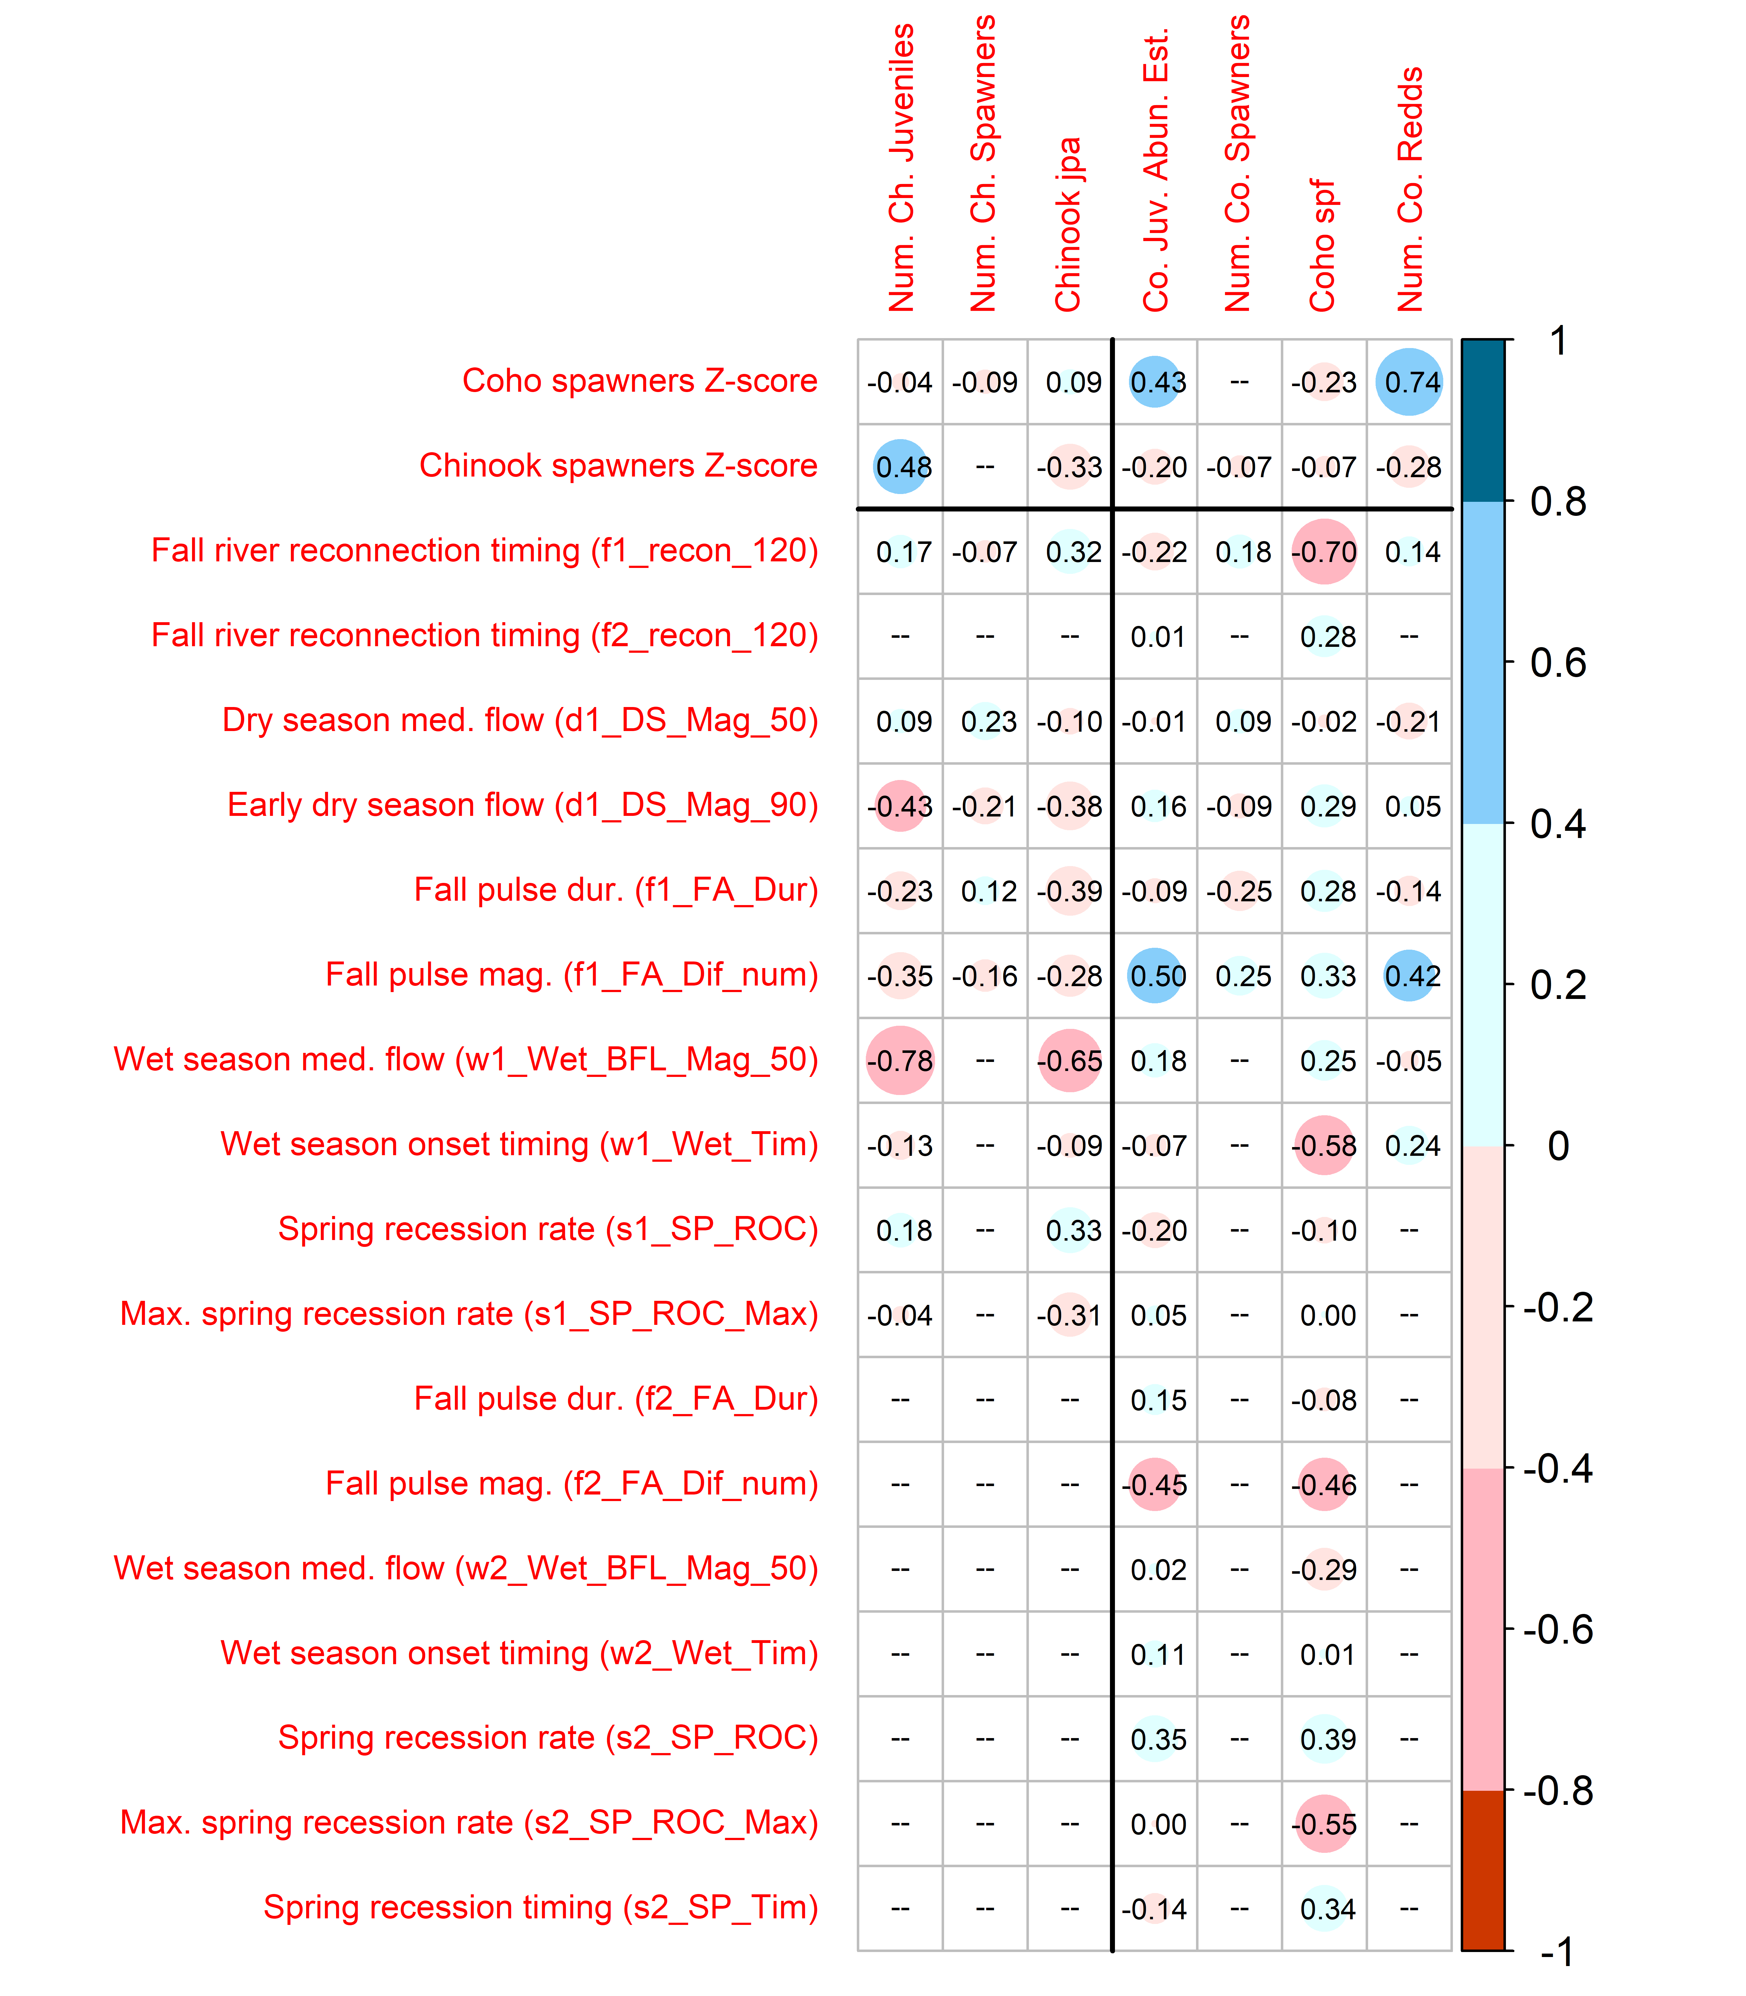

Figure 6: Correlations between 19 Z-scored predictors (2 spawner observation records and 17 hydrologic metrics, prescreened for collinearity) and 7 log-transformed ecological monitoring records for Chinook (left three columns) and coho (right four columns). Large blue circles indicate that the quantity (such as the first wet season median baseflow, or w1_Wet_BFL_Mag_50) is positively correlated with observed fish metrics. For dates, a blue dot indicates that a later date is correlated with higher fish values, while a red dot indicates that an earlier date is correlated with higher fish values. The full suite of calculated R values is shown in Supplemental Figure A.

## 4.3 Predictive modeling

To assess robustness of the results, six different statistical model structures, using two statistical techniques, were tested for predicting each species (Table 2) (see Supplement for additional details).

### 4.3.1 Roadmap for highlighted and full model results

Two example LASSO model structures are illustrated in Figure 7, with the full set shown in the Supplement (Figures 12 throuh 14 and Tables 27 through 32). Additionally, a time series of predicted and observed values of the example LASSO models shown in Figure 8. In LASSO results, a $λ$ value was selected through k-fold cross-validation, or an alternate $λ$ value was used that preserved a low test error but explained a higher deviance (e.g., Figure 7, panels A and B). For each of the six LASSO models the $λ$ value was used to calculate the percent of null deviance explained (e.g., Figure 7, panels C and D) and linear coefficient values for the prediction equation (e.g., Figure 7, panels E and F; Tables 3 and 4).

In MARSS results, shown in the Supplment, individual models were calculated for each individual hydrologic predictor, and compared using AICc values (Tables 33 through 38). The three models with the lowest AICc values for each model structure are shown as time series of predicted and observed values (Figures 15 through 17).

### 4.3.2 Comparison of statistical model structures and results

We used side-by-side comparison (Table 2) and four framing questions to evaluate the combined results of all statistical model structures. In the text below, “important” serves as shorthand to refer to predictors selected in low-error LASSO regression, or metrics with higher absolute coefficient values, or metrics producing a lower value of the small-sample-size-corrected Akaike Information Criterion (AICc) in MARSS methods.

Table 2: Description of six different techniques for modeling two types of ecological outcomes (column 1) based on hydrologic metrics and, in some cases, spawner abundance (column 2). The type of flow associated with higher values of ecological outcome (i.e., the sign of the coefficient) is described in columns 4 and 5, Most Important Hydrologic Metrics (i.e., earlier first fall reconnection). Full tables of coefficient values and results figures are located in the Supplement.

| Predicts | Using | Method | Most Important Hydrologic Metrics | | Hydrologic vs. Spawner Influence (Coef. Ratios) | | Min. AICc | |
| --- | --- | --- | --- | --- | --- | --- | --- | --- |
|  |  |  | Coho | Chinook | Coho | Chinook | Co. | Ch. |
| juv/ spawn | hydro. | LASSO | Earlier first fall reconnection, smaller second fall pluse, earlier first wet season onset | Lower wet season baseflow, slower max. spring recession rate | -- | -- | -- | -- |
| juv/ spawn | hydro. | MARSS | Earlier first fall reconnection, larger first fall pulse,  greater first wet season baseflow,  greater early summer flows | Greater early summer flows,  slower max. spring recession rate,  earlier fall reconnection,  greater dry season median flows | -- | -- | -- | -- |
| juv. abun. | hydro. | LASSO | Larger first fall pulse, smaller second fall pulse, faster second spring recession | Lower wet season baseflow | -- | -- | -- | -- |
| juv. abun. | hydro. | MARSS | Larger first fall pulse,  smaller second fall pulse,  higher second wet season baseflows,  greater early summer flows | Lower wet season baseflow,  slower max. spring recession rate,  greater dry season median flow,  earlier wet season onset | -- | -- | 40.4 | 32.7 |
| juv. abun. | hyd. + spawn | LASSO | Larger first fall pulse, smaller second fall pulse, slower first spring recession | Lower wet season baseflow, parental spawner abundance, slower max. spring recession rate, earlier wet season onset | Greater hydro influence; |Hydro-to-Spawner| >8x (spawners not included in selected predictors) | Greater hydro influence; |Hydro-to-Spawner| >2x | -- | -- |
| juv. abun. | hyd. + spawn | MARSS | Larger first fall pulse,  earlier first fall reconnection,  greater first early summer flows,  greater first wet season baseflow | Slower max. spring recession rate,  lower wet season baseflow,  earlier fall reconnection,  earlier wet season onset | ~Equivalent influence |Hydro-to-Spawner| of 0.7 to 1.5 | Greater hydro influence; |Hydro-to-Spawner| of 1.7 to 6.3 | 32.1 | 36 |

1. Do MARSS and LASSO models identify the same hydrologic metrics as important?

The two statistical methods produced different sets of important metrics, though there is some clear overlap (Table 2). For juveniles-per-adult models, most important predictor for coho (f1_recon_120, or earlier full-system river reconnection during parents’ spawning) is the same in both MARSS and LASSO models. For Chinook juveniles-per-adult the MARSS and LASSO results are more dissimilar, with only one overlapping predictor identified in the top three in both methods (s1_SP_ROC_Max, or slower maximum spring recession rate).

In juvenile abundance models for coho, all four structures (LASSO and MARSS, with and without a spawner predictor/covariate) identified f1_FA_Dif_num, or a larger fall pulse during parents’ spawning, as high-importance, and three out of four identified a *smaller* second fall pulse (f2_FA_Dif_num) as the second-most important. Similarly, for juvenile abundance models of Chinook, all four structures identified w1_Wet_BFL_Mag_50 (lower wet season baseflows), and three of four identified s1_SP_ROC_Max (slower maximum spring recession rate), as the first or second-most important metric.

1. Between the two different prediction units (i.e., juvenile abundance and juveniles-per-spawner), are the same hydrologic metrics identified as important?

Hydrologic metrics were more consistent for Chinook than for coho. For Chinook, lower wet season baseflow (w1_Wet_BFL_Mag_50) was the most important (or a close second) in five out of six model structures, but was third in the MARSS model of juveniles-per-spawner. For coho, first fall metrics were highlighted as important for both prediction units, but the timing was more important in predicting juveniles-per-spawner outcomes (earlier first fall river reconnection or f1_recon_120), while the magnitude was more important in predicting juvenile abundance (f1_FA_Dif_num).

1. For models of juvenile abundance, what is the relative importance (based on coefficients and AICc values) of spawners versus hydrology?

Across all model structures, the influence of hydrology ranged from approximately equivalent to the influence of spawners to more than eight times as important (based on coefficient ratios; Table 2). The addition of spawners to the LASSO model of juvenile abundance made a significant difference in the predictors selected for Chinook but not for coho (Tables 29 through 32). This is corroborated by the change in AICc values among MARSS models: adding spawners as a covariate produced a lower AICc (better model) for Chinook but a higher AICc (worse model) for coho (Table 2; Tables 35 through 38).

1. Are the coefficient signs (positive or negative) for hydrologic metrics consistent across statistical model structures and life stages, or is the same flow related to both more and less juvenile production in different contexts?

Some flows are assigned the same coefficient sign: earlier fall reconnections, earlier wet season starts, and later spring recession starts are consistently associated with increased juvenile abundance (absolute and relative to spawners). However, both positive and negative coefficients were calculated for some hydrologic metrics: variations in wet season median flows (larger or smaller), fall pulse differences (larger or smaller), and spring recession rates of change (slower or faster) are associated with higher ecological outcomes for different model structures and life stages. This suggests flow variation from year to year may support different life stage needs in Chinook and coho.

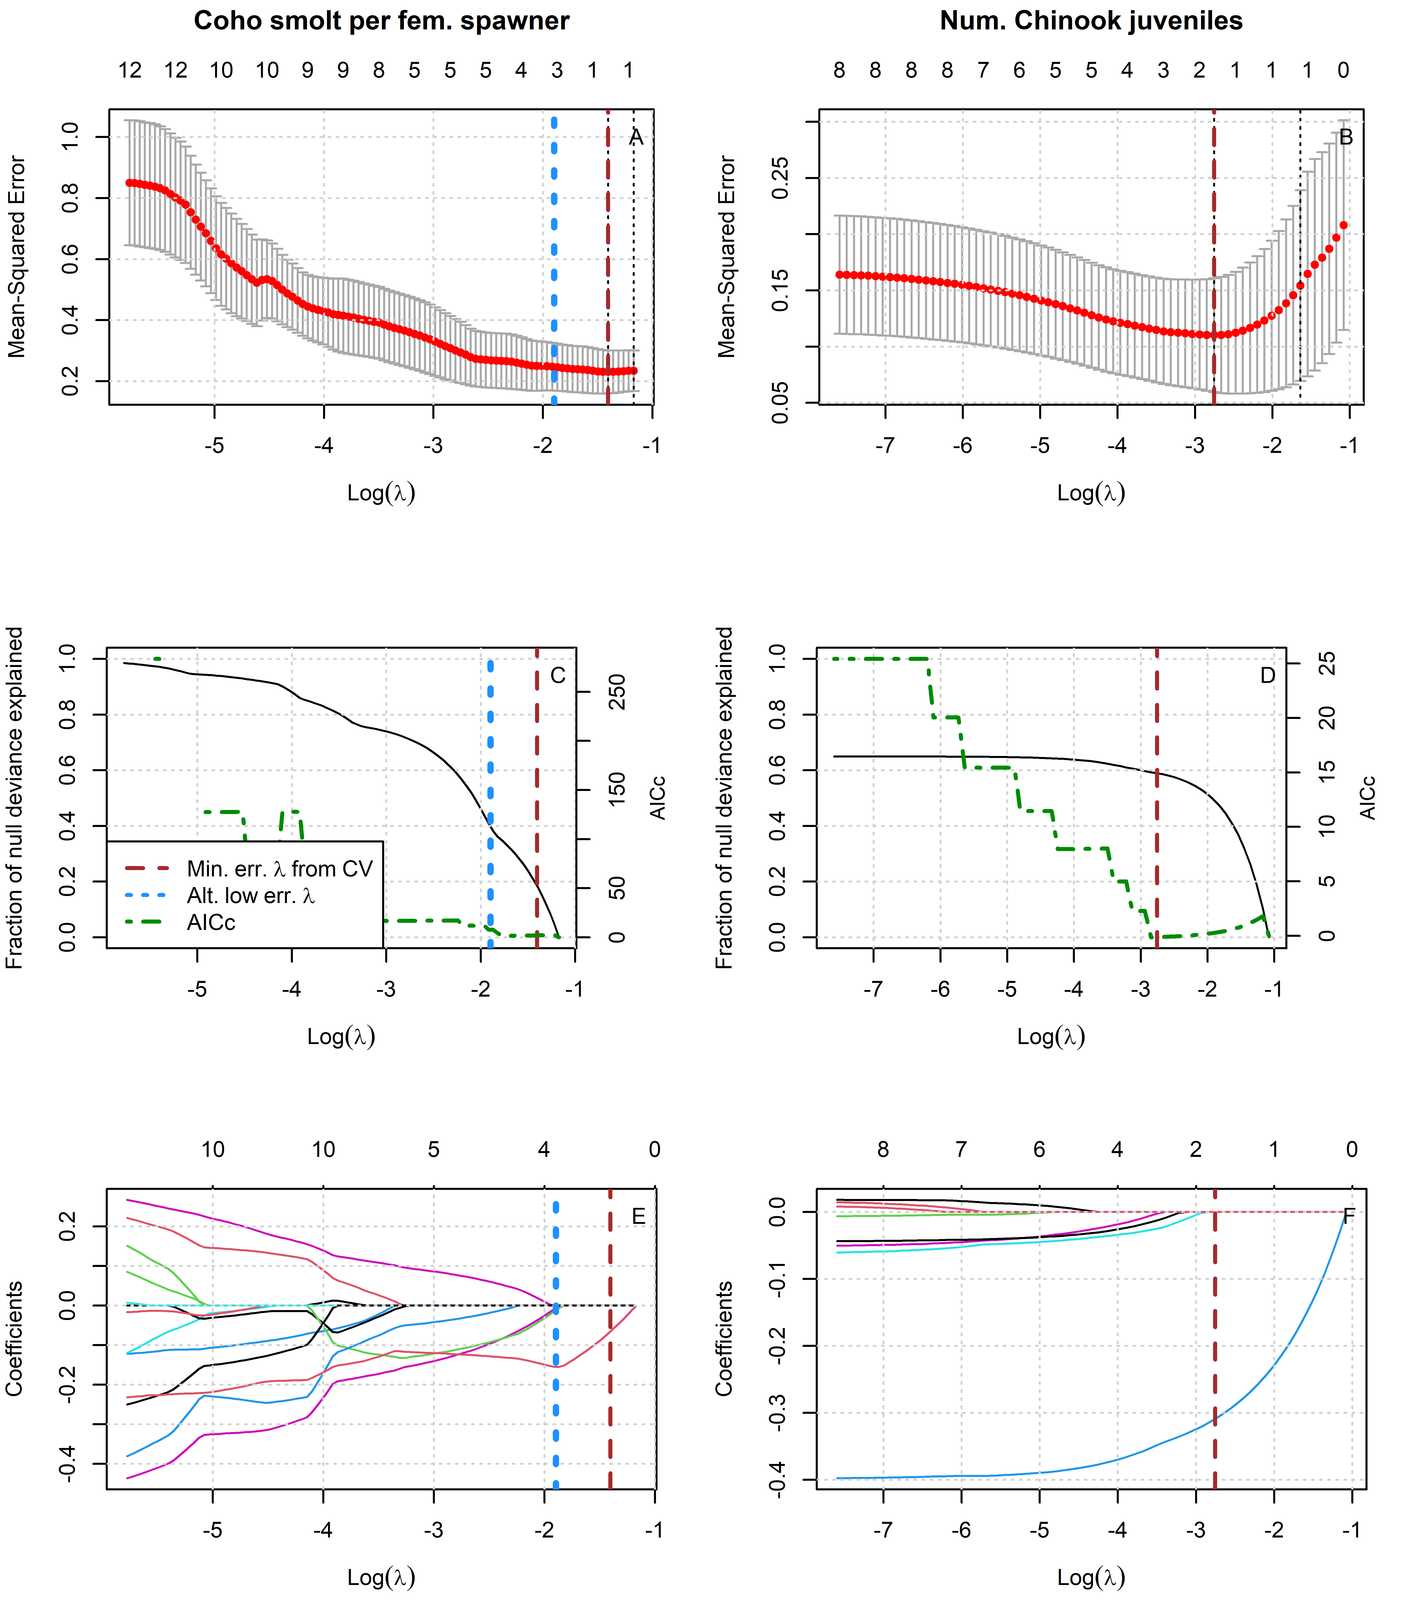

Figure 7: Results of two example LASSO regressions to predict log-transformed coho and Chinook outcomes with Z-scored hydrologic metrics. Models with more coefficients explain a greater fraction of deviance in the dataset (middle panels), but also produce higher test errors (top panels), indicating some overfitting at lower lambda values. Higher values of lambda tend to shrink the absolute values of regression coefficients toward 0 (bottom panels).

Table 3: Values for the intercept and coefficient terms in the predictive function for coho spf abundance, including a description of which phenomena are associated with higher ecological outcome values.

| Predictor | Value | Greater predicted ecological outcome associated with |
| --- | --- | --- |
|  | 1.592 | (Intercept) |
| f1_recon_120 | -0.155 | Earlier fall reconnection (during parents' spawning) |
| f2_FA_Dif_num | -0.012 | Smaller fall pulse (as juvenile fish) |
| w1_Wet_Tim | -0.007 | -0.007 |

Table 4: Values for the intercept and coefficient terms in the predictive function for Chinook juv. abundance abundance, including a description of which phenomena are associated with higher ecological outcome values.

| Predictor | Value | Greater predicted ecological outcome value associated with |
| --- | --- | --- |
|  | 5.450 | Intercept |
| w1_Wet_BFL_Mag_50 | -0.309 | Lower wet season baseflows (first wet season, as eggs and fry) |

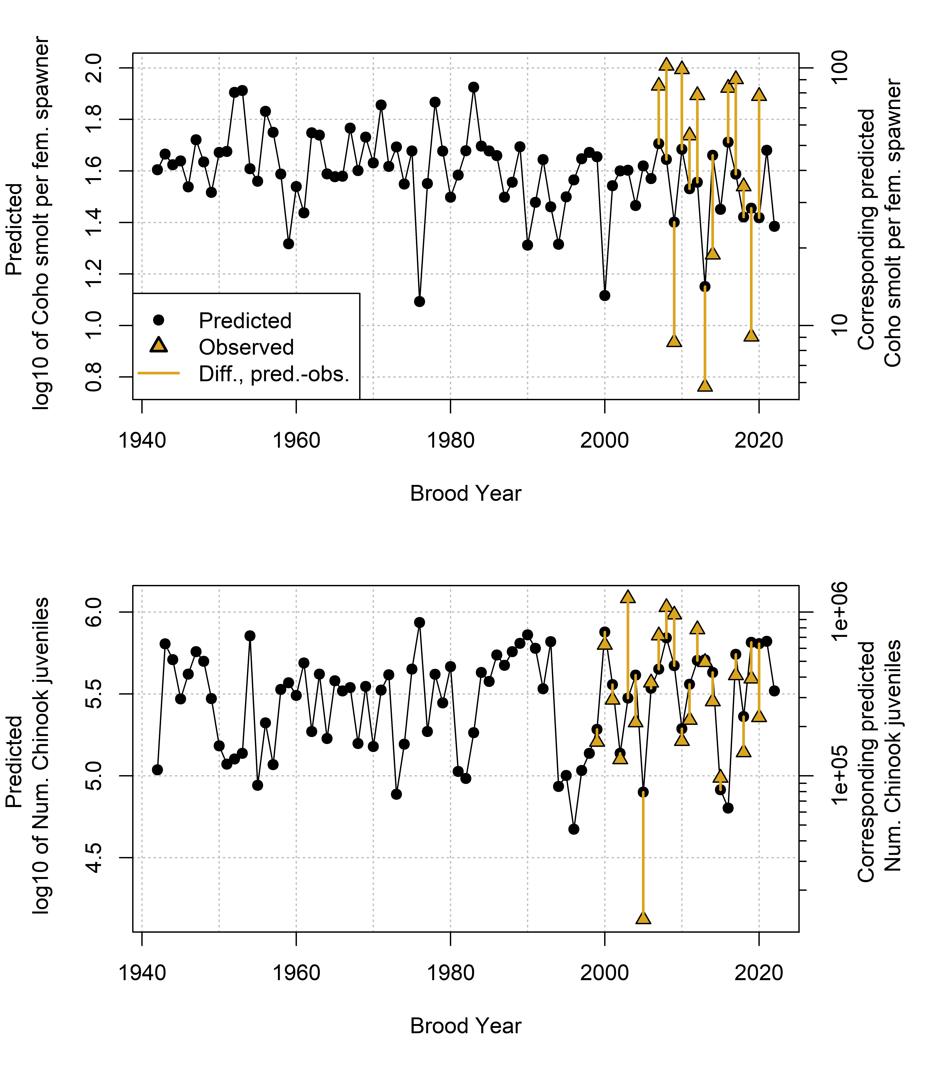

Figure 8: Annual observed and predicted values of coho smolt produced per female spawner (coho spf, top panel) and abundance of outmigrating Chinook juveniles (lower panel). Predicted quantities (black dots) are shown as log10(ecological observation); this is transformed back to straight numerical values of the observation on the right side axis. The predicted and observed values are plotted by each cohort’s brood year.

# 5 Discussion

## 5.1 Correlations and predictor selection results suggest potential mechanisms for flow-ecology relationships

As one would expect, the Chinook spawner record is correlated with outmigrating Chinook smolts, and coho spawners are correlated with redds and outmigrating coho smolts. Interestingly, Chinook spawners are not correlated with any coho records, and the reverse is also true: all cross-species spawner-ecological $\left|R\right|$ values are less than 0.3 (Figure 6).

Correlation coefficients and results from both LASSO and MARSS models suggest that coho smolt production, both in absolute abundance terms and relative to spawners, is sensitive to conditions during the end of the dry season and the fall river reconnection, especially during their parents’ spawning (Figure 6; Table 2). Earlier fall reconnection or a larger fall flow differences could allow spawners more time or greater physical access to reach preferred tributary habitat or higher-quality local nesting sites. Notably, coho smolt abundance with the fall flow difference is positively correlated when it occurs during the first fall when a cohort’s parents are spawning, but is negatively correlated when it occurs in the second fall, when coho are oversummering juveniles (Figure 6). This matches findings that fall pulse flows can have a positive or negative effect on salmonids depending on life stage or timing (Nislow and Armstrong 2012).

LASSO model results also suggest than Chinook juvenile abundance seems to be sensitive to, and negatively affected by, high median wet season baseflow magnitude; this corroborates findings that being swept downstream by high average winter flowrates has a significant influence on survival of recently-hatched juveniles (Nislow and Armstrong 2012). Chinook, which preferentially lay eggs in the mainstem river, would be more vulnerable to these high flowrates than coho, which prefer tributary habitats. MARSS models of Chinook abundance agree in identifying a negative correlation with wet season baseflow, but also highlight a relationship with spring flow conditions: a steeper maximum recession rate of recession is negatively related to juvenile abundance. A more abrupt spring flow recession could mean smolts are outmigrating through slower flow velocities, which could increase transit time and vulnerability to predation (McCormick et al. 1998).

Lastly, due to the small available sample size, we caveat these results by noting that the hydrologic metrics identified as important may shift if this analysis is recapitulated in the future with additional years of data. Additionally, the results are sensitive to decisions made during the prescreening step, which is why we carefully considered which metrics are most conceptually central in representing the collinear predictor groups (Table 13).

## 5.2 Biotic and abiotic influence on coho and Chinook outcomes

Based on coefficient ratios, all model structures comparing spawner and hydrologic influence suggested that hydrologic influence was equivalent or greater than spawner influence (Table 2). This is corroborated by the fact that both spawner abundance and a variety of hydrologic metrics are correlated with absolute and relative smolt production (Figure 6). We intended to identify in which species juvenile production was more limited by, or sensitive to, the hydrology versus the number of parental spawners, but the picture is murky.

LASSO models explain a greater percent of deviance in Chinook data than in corresponding coho models, suggesting that Chinook are more limited by flow (Figures 12 through 14). However, Chinook juvenile production also seems more sensitive to spawner abundance in that, when spawners were added to the LASSO model of Chinook juvenile abundance, it increased the number of selected predictors from one to four, including spawner abundance (Tables 29 and 31); conversely, when spawners were added to the model of coho juvenile abundance, it retained the first two predictors and only influenced the selection of the third (Tables 30 and 32). On the other hand, coho salmon seem more sensitive to the introduction of a spawner factor in MARSS models, as adding spawners as a covariate produced a lower AICc (better model) for coho but a higher AICc (worse model) for Chinook (Table 2). In any case, neither spawner abundance nor hydrology seems completely dominant in explaining smolt production for either species.

Using flow alone to predict fish outcomes involves non-negligible uncertainties: in the example time series shown, error terms (predicted minus observed values) are substantial (Figure 8). This is partly a consequence of LASSO regression imposing a penalty on model flexibility, and represents a conservative estimate of the degree of variation in ecological outcomes that can be explained with flow metrics, although MARSS results in most cases produced similarly large error terms (Figures 15 through 17). Though this exercise includes only hydrology and the number of spawners as predictors, many additional biotic and abiotic factors influence juvenile salmonid growth and survival, such as water quality, temperature, habitat structure, or food resources (e.g., McMahon 1983; Willis et al. 2016; Lusardi et al. 2020). Interactions between hydrology, these other factors, and juvenile production could be investigated in future work.

## 5.3 Implications for Scott River water and fisheries management

Critical management questions in Scott Valley include, at what flow can salmonids pass key chokepoints (in the vicinity of the Fort Jones gauge; Figure 1) and/or access their preferred tributary habitat? And at what flow do Scott River salmon become more productive? We do not provide short or confident answers to these questions in this study, but can elaborate on them.

Interestingly, for both species, the number of spawners is not highly correlated with freshwater hydrologic metrics in the dry season preceding, or the fall season during, their spawning window; i.e., the $\left|R\right|$ values between coho and Chinook spawners for any hydrologic metric did not exceed 0.25 (Figure 6). This means predicting spawner passage based on dry season flows or end-of-dry-season timing would be a prohibitively uncertain exercise. Questions about what flow metric(s) is (are) sufficient for spawning passage may be more suited to weekly or daily scale observations of flow and migrating spawners, as recorded in observation reports (e.g., Knechtle and Giudice 2023), and are beyond the scope of this study of seasonal metrics.

Minimum flow regimes are a valuable management tool, but in this analysis we find more evidence for a gradient of benefit provided by flow, rather than any clear empirical threshold. Although flow tends to provide ecological services to fish in a nonlinear fashion (Rosenfeld 2017), simple linear representations often perform as well or better than nonlinear ones (Ward et al. 2024), and in scatterplots of (untransformed) hydrology versus ecological observations, we did not see clear evidence of threshold behavior. Consequently, this empirical analysis does not quantify flow metric thresholds that would sustain the Scott River salmonid fisheries, but it does highlight metrics or seasons that are especially correlated with observed fish outcomes.

## 5.4 Implications for general water and fisheries management

This study contributes a novel approach and insights to the large body of work seeking to understand and conserve aquatic ecosystems in the Klamath basin, and in aquatic ecosystems in Mediterranean climates more generally. We expect that the proposed approach could be employed in other regional studies (e.g., Baruch et al. 2024), though in systems with shorter or minimal ecological monitoring records, opportunities to find correlations between flow and biological metrics may be sample size-limited to an even greater degree than in this study. However, this study may show the value of even a dozen years of monitoring data in a range of water year types, and could provide motivation to continue investing in data collection and the monitoring of sensitive species.

# 6 Conclusions

This case study uses calculated functional flows and long-term biological monitoring to relate hydrologic conditions to watershed-scale anadromous fish reproduction rates. The empirical flow-biology relationships evaluated here also suggest hypotheses regarding the watershed- and species-specific mechanisms of ecological response to flow variability.

To learn if it was possible to empirically identify important features of the hydrograph corresponding to ecological needs of Scott River coho and Chinook salmon, we examined correlation coefficients between seventeen hydrologic metrics and seven types of local salmon observations (Figure 6). We then formulated multiple predictions of an ecological response to flow, by comparing six different statistical model structures for each species.

This empirical analysis does not quantify flow metric thresholds that would sustain the Scott River salmonid fisheries, but it does highlight metrics or seasons that are especially correlated with observed fish outcomes. The flows identified as most important in predicting relative coho reproduction occur during the dry-to-wet-season transition: earlier and higher-magnitude fall flows during a cohort’s parents’ spawning are associated with higher reproductive outcomes, as well as greater wet season baseflow. Fall flow magnitude and spring flow recession rates are associated with positive and negative effects for coho, depending on the life stage in which they occur. In contrast, higher Chinook production is predicted by lower winter baseflows, as well as slower spring recession rates during their outmigration.

With continuing trends of a narrowing wet season in the Scott River watershed (e.g., Figure 5), entities aiming to sustain local fisheries may find themselves working with ever-thinner margins for error. Globally, in communities living and working with local natural resources, climate change may transform biodiversity-preservation activities into long-term engineering of novel ecosystems. If this occurs, long-term monitoring and frequently re-evaluated flow-ecology relationships will be necessary to support such efforts.

# 7 References

Acero Triana, Juan S., Maria L. Chu, and Jeffrey A. Stein. 2021. “Assessing the Impacts of Agricultural Conservation Practices on Freshwater Biodiversity Under Changing Climate.” *Ecological Modelling* 453 (August): 109604. <https://doi.org/10.1016/j.ecolmodel.2021.109604>.

Acreman, Mike, Angela H. Arthington, Matthew J Colloff, Carol Couch, Neville D Crossman, Fiona Dyer, Ian Overton, Carmel A Pollino, Michael J Stewardson, and William Young. 2014. “Environmental Flows for Natural, Hybrid, and Novel Riverine Ecosystems in a Changing World.” *Frontiers in Ecology and the Environment* 12 (8): 466–73. <https://doi.org/10.1890/130134>.

Agrawal, A, R S Schick, E P Bjorkstedt, R G Szerlong, M N Goslin, B C Spence, T H Williams, and K M Burnett. 2005. “PREDICTING THE POTENTIAL FOR HISTORICAL COHO, CHINOOK AND STEELHEAD HABITAT IN NORTHERN CALIFORNIA.” National Marine Fisheries Service.

Alomía Herrera, Ilia, and Patricia Carrera Burneo. 2017. “Environmental Flow Assessment in Andean Rivers of Ecuador, Case Study: Chanlud and El Labrado Dams in the Machángara River.” *Ecohydrology & Hydrobiology* 17 (2): 103–12. <https://doi.org/10.1016/j.ecohyd.2017.01.002>.

Arriana Brand, L., Juliet C. Stromberg, David C. Goodrich, Mark D. Dixon, Kevin Lansey, Doosun Kang, David S. Brookshire, and David J. Cerasale. 2011. “Projecting Avian Response to Linked Changes in Groundwater and Riparian Floodplain Vegetation Along a Dryland River: A Scenario Analysis.” *Ecohydrology* 4 (1): 130–42. <https://doi.org/10.1002/eco.143>.

Arthington, Angela H. 2012. *Environmental Flows: Saving Rivers in the Third Millennium*. Freshwater Ecology Series 4. Berkeley, CA: University of California Press. <https://doi.org/10.1525/9780520953451>.

Arthington, Angela H., J. M. Bernardo, and M. Ilhéu. 2014. “TEMPORARY RIVERS: LINKING ECOHYDROLOGY, ECOLOGICAL QUALITY AND RECONCILIATION ECOLOGY.” *River Research and Applications* 30 (10): 1209–15. <https://doi.org/10.1002/rra.2831>.

Ayllón, Daniel, Graciela G. Nicola, Irene Parra, Benigno Elvira, and Ana Almodóvar. 2014. “Spatio-Temporal Habitat Selection Shifts in Brown Trout Populations Under Contrasting Natural Flow Regimes.” *Ecohydrology* 7 (2): 569–79. <https://doi.org/10.1002/eco.1379>.

Baruch, Ethan M., Sarah M. Yarnell, Theodore E. Grantham, Jessica R. Ayers, Andrew L. Rypel, and Robert A. Lusardi. 2024. “Mimicking Functional Elements of the Natural Flow Regime Promotes Native Fish Recovery in a Regulated River.” *Ecological Applications* 34 (6): e3013. <https://doi.org/10.1002/eap.3013>.

Bellido-Leiva, F. J., Robert A. Lusardi, and Jay R. Lund. 2021. “Modeling the Effect of Habitat Availability and Quality on Endangered Winter-Run Chinook Salmon (Oncorhynchus Tshawytscha) Production in the Sacramento Valley.” *Ecological Modelling* 447 (May): 109511. <https://doi.org/10.1016/j.ecolmodel.2021.109511>.

Booth, Derek B., Yantao Cui, Zooey Diggory, Dirk Pedersen, Jordan Kear, and Michael Bowen. 2014. “Determining Appropriate Instream Flows for Anadromous Fish Passage on an Intermittent Mainstem River, Coastal Southern California, USA.” *Ecohydrology* 7 (2): 745–59. <https://doi.org/10.1002/eco.1396>.

Bourret, Samuel L., Christopher C. Caudill, and Matthew L. Keefer. 2016. “Diversity of Juvenile Chinook Salmon Life History Pathways.” *Reviews in Fish Biology and Fisheries* 26 (3): 375–403. <https://doi.org/10.1007/s11160-016-9432-3>.

Bower, Luke M., Brandon K. Peoples, Michele C. Eddy, and Mark C. Scott. 2022. “Quantifying Flow–Ecology Relationships Across Flow Regime Class and Ecoregions in South Carolina.” *Science of The Total Environment* 802 (January): 149721. <https://doi.org/10.1016/j.scitotenv.2021.149721>.

Bradford, Michael J., Garth C. Taylor, and J. Andrew Allan. 1997. “Empirical Review of Coho Salmon Smolt Abundance and the Prediction of Smolt Production at the Regional Level.” *Transactions of the American Fisheries Society* 126 (1): 49–64. <https://doi.org/10.1577/1548-8659(1997)126<0049:EROCSS>2.3.CO;2>.

Bradley, D. C., M. J. Streetly, D. Cadman, M. Dunscombe, E. Farren, and A. Banham. 2017. “A Hydroecological Model to Assess the Relative Effects of Groundwater Abstraction and Fine Sediment Pressures on Riverine Macro-Invertebrates.” *River Research and Applications* 33 (10): 1630–41. <https://doi.org/10.1002/rra.3191>.

Brown, Larry R., Peter B. Moyle, and Ronald M. Yoshiyama. 1994. “Historical Decline and Current Status of Coho Salmon in California.” *North American Journal of Fisheries Management* 14 (2): 237–61. <https://doi.org/10.1577/1548-8675(1994)014<0237:HDACSO>2.3.CO;2>.

Brummer, T. J., A. E. Byrom, J. J. Sullivan, and P. E. Hulme. 2016. “A Quantitative Framework to Derive Robust Characterization of Hydrological Gradients: Framework for Robust Design of Flow-Ecology Studies.” *River Research and Applications* 32 (7): 1517–29. <https://doi.org/10.1002/rra.3001>.

Bunn, Stuart E., and Angela H. Arthington. 2002. “Basic Principles and Ecological Consequences of Altered Flow Regimes for Aquatic Biodiversity.” *Environmental Management* 30 (4): 492–507. <https://doi.org/10.1007/s00267-002-2737-0>.

Bustard, David R., and David W. Narver. 1975. “Aspects Ofthe Winter Ecology of Juvenile Coho Sahnon (Oncorhynchus Kisutch) and Steelhead Trout (Salmo Gairdneri).” *Journal of the Fisheries Resources Board of Canada* 32 (5): 667–80. <https://doi.org/10.1139/f75-086>.

California Department of Fish and Wildlife. 2015. “Recovery Strategy for California Coho Salmon Progress Report 2004 - 2012.”

———. 2021. “Scott River Best Available Scientific Information for Instream Flow Criteria.”

California Department of Fish and Wildlife, NOAA-Fisheries, Scott River Water Trust, Siskiyou Resource Conservation District, and U.S. Forest Service - Klamath National Forest. 2015. “Cooperative Scott River Coho Rescue & Relocation Effort: 2014 Drought Emergency.”

California Department of Water Resources. 2021. “Agricultural Land & Water Use Estimates.” https://water.ca.gov/Programs/Water-Use-And-Efficiency/Land-And-Water-Use/Agricultural-Land-And-Water-Use-Estimates.

Carpenter, Cameron. 2024. “Accurately Identifying Functional Flow Metrics in Flashy and Highly Altered Stream Systems.” Master’s thesis, University of California, Davis.

Cartwright, Jennifer, Casey Caldwell, Steven Nebiker, and Rodney Knight. 2017. “Putting Flow–Ecology Relationships into Practice: A Decision-Support System to Assess Fish Community Response to Water-Management Scenarios.” *Water* 9 (3): 196. <https://doi.org/10.3390/w9030196>.

Catford, Jane A., William K. Morris, Peter A. Vesk, Christopher J. Gippel, and Barbara J. Downes. 2014. “Species and Environmental Characteristics Point to Flow Regulation and Drought as Drivers of Riparian Plant Invasion.” Edited by Jeffrey Diez. *Diversity and Distributions* 20 (9): 1084–96. <https://doi.org/10.1111/ddi.12225>.

Chowdhury, Shahadat, and Patrick Driver. 2007. “An Ecohydrological Model of Waterbird Nesting Events to Altered Floodplain Hydrology.” In *MODSIM 2007 International Congress on Modelling and Simulation*, 2896–2902. Modeling and Simulation Society of Australia and New Zealand.

Coordinated Resource Management Planning Committee, and Scott River Watershed Council. 2000. “FINAL REPORT.”

Daneshvar, Fariborz, Amir Pouyan Nejadhashemi, Matthew R. Herman, and Mohammad Abouali. 2017. “Response of Benthic Macroinvertebrate Communities to Climate Change.” *Ecohydrology & Hydrobiology* 17 (1): 63–72. <https://doi.org/10.1016/j.ecohyd.2016.12.002>.

DeWeber, J. Tyrell, and James T. Peterson. 2020. “Comparing Environmental Flow Implementation Options with Structured Decision Making: Case Study from the Willamette River, Oregon.” *JAWRA Journal of the American Water Resources Association* 56 (4): 599–614. <https://doi.org/10.1111/1752-1688.12845>.

Dormann, Carsten F., Jane Elith, Sven Bacher, Carsten Buchmann, Gudrun Carl, Gabriel Carré, Jaime R. García Marquéz, et al. 2013. “Collinearity: A Review of Methods to Deal with It and a Simulation Study Evaluating Their Performance.” *Ecography* 36 (1): 27–46. <https://doi.org/10.1111/j.1600-0587.2012.07348.x>.

Drake, Daniel J., Kenneth W. Tate, and Harry Carlson. 2000. “Analysis Shows Climate-Caused Decreases in Scott River Fall Flows.” *California Agriculture* 54 (6): 46–49. <https://doi.org/10.3733/ca.v054n06p46>.

Escobar-Arias, M. I., and Gregory B. Pasternack. 2010. “A Hydrogeomorphic Dynamics Approach to Assess in-Stream Ecological Functionality Using the Functional Flows Model, Part 1—Model Characteristics.” *River Research and Applications* 26 (9): 1103–28. <https://doi.org/10.1002/rra.1316>.

Foglia, Laura, Alison McNally, Courtney Hall, Lauren Ledesma, Ryan Hines, and Thomas Harter. 2013. “Scott Valley Integrated Hydrologic Model: Data Collection, Analysis, and Water Budget.” Davis, CA: North Coast Regional Water Quality Control Board.

Franklin, Tom. 2012. “Scott River Adult Coho Spawning Ground Surveys 2011 Season.” Etna, CA: Siskiyou Resource Conservation District.

Friedman, Jerome, Trevor Hastie, and Robert Tibshirani. 2010. “Regularization Paths for Generalized Linear Models via Coordinate Descent.” *Journal of Statistical Software* 33 (1). <https://doi.org/10.18637/jss.v033.i01>.

Gao, Ye, Yong-hong Xie, and Dong-sheng Zou. 2020. “Hydrological Regime Change and Its Ecological Responses in East Dongting Lake, China.” *Ecohydrology & Hydrobiology* 20 (1): 142–50. <https://doi.org/10.1016/j.ecohyd.2019.07.003>.

Grantham, Ted, Jeffrey Mount, Eric D Stein, and Sarah M. Yarnell. 2020. “Making the Most of Water for the Environment: A Functional Flows Approach for California’s Rivers.” Public Policy Institute of California.

Groot, Cornelis, and Leo Margolis, eds. 1991. “Life History of Chinook Salmon (Onchorhynchus Tshawytscha).” In *Pacific Salmon Life Histories*. Vancouver: UBC Press.

Guareschi, S., A. Laini, E. Racchetti, T. Bo, S. Fenoglio, and M. Bartoli. 2014. “How Do Hydromorphological Constraints and Regulated Flows Govern Macroinvertebrate Communities Along an Entire Lowland River?” *Ecohydrology* 7 (2): 366–77. <https://doi.org/10.1002/eco.1354>.

Guedes, Gustavo Henrique Soares, Tailan Moretti Mattos, Geysa Da Silva Camilo, Wagner Uehara, Débora Lisandra De Paiva Ferreira, and Francisco Gerson Araújo. 2020. “Artificial Flow Regime Promotes Abiotic and Biotic Gradients: Testing the Concept of Longitudinal Zonation in an Off-River Reservoir.” *Ecohydrology & Hydrobiology* 20 (2): 256–64. <https://doi.org/10.1016/j.ecohyd.2020.02.002>.

Hain, Ernie F., Jonathan G. Kennen, Peter V. Caldwell, Stacy A. C. Nelson, Ge Sun, and Steven G. McNulty. 2018. “Using Regional Scale Flow–Ecology Modeling to Identify Catchments Where Fish Assemblages Are Most Vulnerable to Changes in Water Availability.” *Freshwater Biology* 63 (8): 928–45. <https://doi.org/10.1111/fwb.13048>.

Hale, Robin, Jian D. L. Yen, Charles R. Todd, Ivor G. Stuart, Henry F. Wootton, Jason D. Thiem, John D. Koehn, et al. 2023. “Is My Model Fit for Purpose? Validating a Population Model for Predicting Freshwater Fish Responses to Flow Management.” *Ecosphere* 14 (9): e4660. <https://doi.org/10.1002/ecs2.4660>.

Han, Ming, Chengyi Zhao, Gary Feng, Markus Disse, Fengzhi Shi, and Juyan Li. 2015. “An Eco-Hydrological Approach to Predicting Regional Vegetation and Groundwater Response to Ecological Water Conveyance in Dryland Riparian Ecosystems.” *Quaternary International* 380–381 (September): 224–36. <https://doi.org/10.1016/j.quaint.2015.02.032>.

Harter, Thomas, and Ryan Hines. 2008. “SCOTT VALLEY COMMUNITY GROUNDWATER STUDY PLAN.” University of California, Davis.

Herbst, David B., Scott D. Cooper, Robert Bruce Medhurst, Sheila W. Wiseman, and Carolyn T. Hunsaker. 2019. “Drought Ecohydrology Alters the Structure and Function of Benthic Invertebrate Communities in Mountain Streams.” *Freshwater Biology* 64 (5): 886–902. <https://doi.org/10.1111/fwb.13270>.

Hunt, Sharon L, Timothy J Mulligan, and Kenichiro Komori. 1999. “Oceanic Feeding Habits of Chinook Salmon, Oncorhynchus Tshawytscha, Off Northern Californi.” *Fishery Bulletin* 97 (3): 717–21.

Jager, Henriette I. 2014. “Thinking Outside the Channel: Timing Pulse Flows to Benefit Salmon via Indirect Pathways.” *Ecological Modelling* 273 (February): 117–27. <https://doi.org/10.1016/j.ecolmodel.2013.11.007>.

Jager, Henriette I., and Kenneth A. Rose. 2003. “Designing Optimal Flow Patterns for Fall Chinook Salmon in a Central Valley, California, River.” *North American Journal of Fisheries Management* 23 (1): 1–21. <https://doi.org/10.1577/1548-8675(2003)023<0001:DOFPFF>2.0.CO;2>.

Jager, Henriette I., and Brennan T. Smith. 2008. “Sustainable Reservoir Operation: Can We Generate Hydropower and Preserve Ecosystem Values?” *River Research and Applications* 24 (3): 340–52. <https://doi.org/10.1002/rra.1069>.

James, Gareth, Daniela Witten, Trevor Hastie, and Robert Tibshirani. 2013. *An Introduction to Statistical Learning*. Vol. 103. Springer Texts in Statistics. New York, NY: Springer New York. <https://doi.org/10.1007/978-1-4614-7138-7>.

Kelson, Suzanne J., and Stephanie M. Carlson. 2019. “Do Precipitation Extremes Drive Growth and Migration Timing of a Pacific Salmonid Fish in Mediterranean-Climate Streams?” *Ecosphere* 10 (3): e02618. <https://doi.org/10.1002/ecs2.2618>.

Kevic, Maja, Johannes Ortlepp, Uta Mürle, and Christopher T. Robinson. 2018. “Effects of Experimental Floods in Two Rivers with Contrasting Valley Morphologies.” *Fundamental and Applied Limnology* 192 (2): 145–60. <https://doi.org/10.1127/fal/2018/1177>.

Knechtle, Morgan, and Domenic Giudice. 2020. “2019 SCOTT RIVER SALMON STUDIES FINAL REPORT.” California Department of Fish and Wildlife.

———. 2023. “2022 SCOTT RIVER SALMON STUDIES FINAL REPORT.” Yreka, CA: California Department of Fish and Wildlife.

Konrad, Christopher P., Julian D. Olden, David A. Lytle, Theodore S. Melis, John C. Schmidt, Erin N. Bray, Mary C. Freeman, et al. 2011. “Large-Scale Flow Experiments for Managing River Systems.” *BioScience* 61 (12): 948–59. <https://doi.org/10.1525/bio.2011.61.12.5>.

Kouba, Claire, and Thomas Harter. 2024. “Seasonal Prediction of End-of-Dry-Season Watershed Behavior in a Highly Interconnected Alluvial Watershed in Northern California.” *Hydrology and Earth System Sciences* 28 (3): 691–718. <https://doi.org/10.5194/hess-28-691-2024>.

Lamouroux, Nicolas, and Jean-Michel Olivier. 2015. “Testing Predictions of Changes in Fish Abundance and Community Structure After Flow Restoration in Four Reaches of a Large River ( F Rench R hône).” *Freshwater Biology* 60 (6): 1118–30. <https://doi.org/10.1111/fwb.12324>.

Larsen, Stefano, Bruno Majone, Patrick Zulian, Elisa Stella, Alberto Bellin, Maria Cristina Bruno, and Guido Zolezzi. 2021. “Combining Hydrologic Simulations and Stream-Network Models to Reveal Flow-Ecology Relationships in a Large Alpine Catchment.” *Water Resources Research* 57 (4): e2020WR028496. <https://doi.org/10.1029/2020WR028496>.

Lueders, Mark B., and Ryan A. McManamay. 2023. “Species Depletion Profiles as an Alternative to Streamflow Alteration Thresholds in a Hydroecological Risk Assessment.” *Ecological Indicators* 147 (March): 109989. <https://doi.org/10.1016/j.ecolind.2023.109989>.

Lusardi, Robert A., Bruce G. Hammock, Carson A. Jeffres, Randy A. Dahlgren, and Joseph D. Kiernan. 2020. “Oversummer Growth and Survival of Juvenile Coho Salmon (Oncorhynchus Kisutch) Across a Natural Gradient of Stream Water Temperature and Prey Availability: An in Situ Enclosure Experiment.” *Canadian Journal of Fisheries and Aquatic Sciences* 77 (2): 413–24. <https://doi.org/10.1139/cjfas-2018-0484>.

Lusardi, Robert A., Andrew L. Nichols, Ann D. Willis, Carson A. Jeffres, A. Haven Kiers, Erwin E. Van Nieuwenhuyse, and Randy A. Dahlgren. 2021. “Not All Rivers Are Created Equal: The Importance of Spring-Fed Rivers Under a Changing Climate.” *Water* 13 (12): 1652. <https://doi.org/10.3390/w13121652>.

Mack, Seymour. 1958. “Geology and Ground-Water Features of Scott Valley, Siskiyou County, California.” Geological {{Survey Water-Supply Paper}} 1462. United States Geological Survey. <https://doi.org/10.3133/wsp1462>.

Magranet, Lindsay. 2015a. “Scott River Fall Chinook Spawning Ground Surveys.” Etna, CA: Siskiyou Resource Conservation District.

———. 2015b. “Scott River Adult Coho Spawning Ground Surveys 2014-2015 Season.” Etna, CA: Siskiyou Resource Conservation District.

———. 2017. “Scott River Fall Chinook Spawning Ground Surveys.” Etna, CA: Siskiyou Resource Conservation District.

———. 2018a. “Scott River Fall Chinook Spawning Ground Surveys 2017 Season.” Etna, CA: Siskiyou Resource Conservation District.

———. 2018b. “2017 Monitoring Report.” Scott River Water Trust.

Magranet, Lindsay, and Erich Yokel. 2017. “Scott River Adult Coho Spawning Ground Surveys 2016-2017 Season.” Etna, CA: Siskiyou Resource Conservation District.

Mansfield, Carol, George Van Houtven, Amy Hendershott, Patrick Chen, Jeremy Porter, Vesall Nourani, and Vikram Kilambi. 2012. “Klamath River Basin Restoration Nonuse Value Survey.”

Massie, Margaret, and Harrison Morrow. 2021. “2020 SCOTT RIVER JUVENILE SALMONID OUTMIGRANT STUDY.” California Department of Fish and Wildlife.

Maurer, Sue. 2003. “Scott River Watershed Adult Coho Salmon Spawning Survey.” Etna, CA: Siskiyou Resource Conservation District.

Mazor, Raphael D., Jason T. May, Ashmita Sengupta, Kenneth S. McCune, Brian P. Bledsoe, and Eric D. Stein. 2018. “Tools for Managing Hydrologic Alteration on a Regional Scale: Setting Targets to Protect Stream Health.” *Freshwater Biology* 63 (8): 786–803. <https://doi.org/10.1111/fwb.13062>.

McCormick, Stephen D, Lars P Hansen, Thomas P Quinn, and Richard L Saunders. 1998. “Movement, Migration, and Smolting of Atlantic Salmon (Salmo Salar).”

McMahon, Thomas E. 1983. “Habitat Suitability Index Models: Coho Salmon.” FWS/OBS-82/10.49. U.S. Fish and Wildlife Service.

McManamay, Ryan A., and Emmanuel A. Frimpong. 2015. “Hydrologic Filtering of Fish Life History Strategies Across the United States: Implications for Stream Flow Alteration.” *Ecological Applications* 25 (1): 243–63. <https://doi.org/10.1890/14-0247.1>.

McManamay, Ryan A., Donald J. Orth, Charles A. Dolloff, and David C. Mathews. 2013. “Application of the ELOHA Framework to Regulated Rivers in the Upper Tennessee River Basin: A Case Study.” *Environmental Management* 51 (6): 1210–35. <https://doi.org/10.1007/s00267-013-0055-3>.

Mellado-Díaz, Andrés, Jorge Rubén Sánchez-González, Simone Guareschi, Fernando Magdaleno, and Manuel Toro Velasco. 2019. “Exploring Longitudinal Trends and Recovery Gradients in Macroinvertebrate Communities and Biomonitoring Tools Along Regulated Rivers.” *Science of The Total Environment* 695 (December): 133774. <https://doi.org/10.1016/j.scitotenv.2019.133774>.

Michel, Cyril J., Jeremy J. Notch, Flora Cordoleani, Arnold J. Ammann, and Eric M. Danner. 2021. “Nonlinear Survival of Imperiled Fish Informs Managed Flows in a Highly Modified River.” *Ecosphere* 12 (5): e03498. <https://doi.org/10.1002/ecs2.3498>.

Monk, Wendy A., Paul J. Wood, David M. Hannah, and Douglas A. Wilson. 2008. “Macroinvertebrate Community Response to Inter-Annual and Regional River Flow Regime Dynamics.” *River Research and Applications* 24 (7): 988–1001. <https://doi.org/10.1002/rra.1120>.

Monk, Wendy A., Paul J. Wood, David M. Hannah, Douglas A. Wilson, Chris A. Extence, and Richard P. Chadd. 2006. “Flow Variability and Macroinvertebrate Community Response Within Riverine Systems.” *River Research and Applications* 22 (5): 595–615. <https://doi.org/10.1002/rra.933>.

Moyle, Peter B. 2002. “Coho Salmon, Oncorhynchus Kisutch (Walbaum).” In *Inland Fishes of California*, 245–51. University of California Press.

———. 2014. “NOVEL AQUATIC ECOSYSTEMS: THE NEW REALITY FOR STREAMS IN CALIFORNIA AND OTHER MEDITERRANEAN CLIMATE REGIONS.” *River Research and Applications* 30 (10): 1335–44. <https://doi.org/10.1002/rra.2709>.

National Marine Fisheries Service. 2014. “Final SONCC Coho Recovery Plan.” National Oceanic and Atmospheric Administration.

Nickelson, Thomas E., Jeffrey D. Rodgers, Steven L. Johnson, and Mario F. Solazzi. 1992. “Seasonal Changes in Habitat Use by Juvenile Coho Salmon (Oncorhynchus Kisutch) in Oregon Coastal Streams.” *Canadian Journal of Fisheries and Aquatic Sciences* 49 (4): 783–89. <https://doi.org/10.1139/f92-088>.

Nislow, K. H., and J. D. Armstrong. 2012. “Towards a Life-History-Based Management Framework for the Effects of Flow on Juvenile Salmonids in Streams and Rivers.” *Fisheries Management and Ecology* 19 (6): 451–63. <https://doi.org/10.1111/j.1365-2400.2011.00810.x>.

North Coast Regional Water Quality Control Board. 2005. “Staff Report for the Action Plan for the Scott River Watershed Sediment and Temperature Total Maximum Daily Loads.” Santa Rosa, CA.

———. 2006. “ACTION PLAN FOR THE SCOTT RIVER SEDIMENT AND TEMPERATURE TOTAL MAXIMUM DAILY LOADS.” *Basin Plan Language*. https://www.waterboards.ca.gov/northcoast/water_issues/programs/tmdls/scott_river/060307/bpl/Basin_Plan_Language.pdf.

Parry, Ashley. 2013. “Evaluation and Modernization of the Scott Valley Irrigation District.” PhD thesis, San Luis Obispo, CA: California Polytechnic State University.

Patterson, Noelle K., Belize A. Lane, Samuel Sandoval-Solis, Gregory B. Pasternack, Sarah M. Yarnell, and Yexuan Qiu. 2020. “A Hydrologic Feature Detection Algorithm to Quantify Seasonal Components of Flow Regimes.” *Journal of Hydrology* 585 (June): 124787. <https://doi.org/10.1016/j.jhydrol.2020.124787>.

Pearson, Karl. 1895. “Note on Regression and Inheritance in the Case of Two Parents.” *Proceedings of the Royal Society of London* 58 (Jan): 240–42. <https://doi.org/10.1098/rspl.1895.0041>.

Peek, Ryan, Katie Irving, Sarah M. Yarnell, Rob Lusardi, Eric D. Stein, and Raphael Mazor. 2022. “Identifying Functional Flow Linkages Between Stream Alteration and Biological Stream Condition Indices Across California.” *Frontiers in Environmental Science* 9 (January): 790667. <https://doi.org/10.3389/fenvs.2021.790667>.

Peterson, James T., and Mary C. Freeman. 2016. “Integrating Modeling, Monitoring, and Management to Reduce Critical Uncertainties in Water Resource Decision Making.” *Journal of Environmental Management* 183 (December): 361–70. <https://doi.org/10.1016/j.jenvman.2016.03.015>.

Poff, N. LeRoy, Brian D. Richter, Angela H. Arthington, Stuart E. Bunn, Robert J. Naiman, Eloise Kendy, Mike Acreman, et al. 2010. “The Ecological Limits of Hydrologic Alteration (ELOHA): A New Framework for Developing Regional Environmental Flow Standards.” *Freshwater Biology* 55 (1): 147–70. <https://doi.org/10.1111/j.1365-2427.2009.02204.x>.

Qian, Kuimei, Xia Liu, and Yuwei Chen. 2016. “Effects of Water Level Fluctuation on Phytoplankton Succession in Poyang Lake, China – A Five Year Study.” *Ecohydrology & Hydrobiology* 16 (3): 175–84. <https://doi.org/10.1016/j.ecohyd.2016.08.001>.

Quigley, Danielle. 2005. “Scott River Watershed Adult Coho Spawning Ground Surveys November 2004 – January 2005.” Etna, CA: Siskiyou Resource Conservation District.

———. 2006. “Final Report Scott River Adult Coho Spawning Ground Surveys November 2005 – January 2006.” Etna, CA: Siskiyou Resource Conservation District.

———. 2007. “Final Report Adult Coho Spawning Ground Surveys 2006-2007.” Etna, CA: Siskiyou Resource Conservation District.

Quiñones, Rebecca M., Marcel Holyoak, Michael L. Johnson, and Peter B. Moyle. 2014. “Potential Factors Affecting Survival Differ by Run-Timing and Location: Linear Mixed-Effects Models of Pacific Salmonids (Oncorhynchus Spp.) in the Klamath River, California.” Edited by Christopher J. Fulton. *PLoS ONE* 9 (5): e98392. <https://doi.org/10.1371/journal.pone.0098392>.

Ranstam, J, and J A Cook. 2018. “LASSO Regression.” *British Journal of Surgery* 105 (10): 1348–48. <https://doi.org/10.1002/bjs.10895>.

Reineking, Björn, and Boris Schröder. 2006. “Constrain to Perform: Regularization of Habitat Models.” *Ecological Modelling* 193 (3-4): 675–90. <https://doi.org/10.1016/j.ecolmodel.2005.10.003>.

Richter, Brian D., Jeffrey V. Baumgartner, Jennifer Powell, and David P. Braun. 1996. “A Method for Assessing Hydrologic Alteration Within Ecosystems.” *Conservation Biology* 10 (4): 1163–74. <https://doi.org/10.1046/j.1523-1739.1996.10041163.x>.

———. 2017. “Protection and Restoration of Freshwater Ecosystems.” In *Water Policy and Planning in a Variable and Changing Climate*, edited by Kathleen A. Miller, Alan F. Hamlet, Douglas S. Kenney, and Kelly T. Redmond, 1st edition. Boca Raton: CRC Press.

Richter, Brian D., Andrew T. Warner, Judy L. Meyer, and Kim Lutz. 2006. “A Collaborative and Adaptive Process for Developing Environmental Flow Recommendations.” *River Research and Applications* 22 (3): 297–318. <https://doi.org/10.1002/rra.892>.

Riis, Tenna, Alastair M. Suren, Bente Clausen, and Kaj Sand-Jensen. 2008. “Vegetation and Flow Regime in Lowland Streams.” *Freshwater Biology* 53 (8): 1531–43. <https://doi.org/10.1111/j.1365-2427.2008.01987.x>.

Robertson, G Philip, and Scott M. Swinton. 2005. “Reconciling Agricultural Productivity and Environmental Integrity: A Grand Challenge for Agriculture.” *Frontiers in Ecology and the Environment* 3 (1): 38–46. <https://doi.org/10.1890/1540-9295(2005)003[0038:RAPAEI]2.0.CO;2>.

Romero, Rosemary, and Crystal Robinson. 2024. “2023 SCOTT RIVER JUVENILE SALMONID OUTMIGRANT STUDY.” Yreka, CA: California Department of Fish and Wildlife.

Rosenfeld, Jordan S. 2017. “Developing Flow–Ecology Relationships: Implications of Nonlinear Biological Responses for Water Management.” *Freshwater Biology* 62 (8): 1305–24. <https://doi.org/10.1111/fwb.12948>.

Saby, Linnea, Kevin L. McKee, Prakrut Kansara, Jonathan L. Goodall, Lawrence E. Band, and Venkataraman Lakshmi. 2022. “Sensitivity of Remotely Sensed Vegetation to Hydrologic Predictors Across the Colorado River Basin, 2001–2019.” *JAWRA Journal of the American Water Resources Association* 58 (6): 1017–29. <https://doi.org/10.1111/1752-1688.12965>.

Scott River Watershed Council. 2005. “Limiting Factors Analysis for Coho Salmon and Other Anadromous Fish.”

———. 2018. “Restoring Priority Coho Habitat in the Scott River Watershed Modeling and Planning Report.”

Scott River Watershed Council, and Siskiyou Resource Conservation District. 2003. “Scott River Fall Flows Action Plan Accomplishments, 1995 to 2003.” Siskiyou Resource Conservation District.

———. 2005. “Initial Phase of the Scott River Watershed Council Strategic Action Plan.” Etna, CA.

Scott Valley Area Plan Committee. 1980. “Scott Valley Area Plan.” Siskiyou County.

See, Kevin E., and Elizabeth E. Holmes. 2015. “Reducing Bias and Improving Precision in Species Extinction Forecasts.” *Ecological Applications* 25 (4): 1157–65. <https://doi.org/10.1890/14-2003.1>.

Sellheim, Kirsten, Steven Zeug, and Joseph Merz. 2020. “Informed Water Management Alternatives for an over-Allocated River: Incorporating Salmon Life Stage Effects into a Decision Tree Process During Drought.” *Fisheries Management and Ecology* 27 (5): 498–516. <https://doi.org/10.1111/fme.12432>.

Sinnathamby, Sumathy, Kyle R. Douglas-Mankin, Muluken E. Muche, Stacy L. Hutchinson, and Aavudai Anandhi. 2018. “Ecohydrological Index, Native Fish, and Climate Trends and Relationships in the Kansas River Basin.” *Ecohydrology* 11 (1): e1909. <https://doi.org/10.1002/eco.1909>.

Siskiyou County. 2021. “Scott Valley Groundwater Sustainability Plan.” *Scott Valley FINAL GSP*. https://www.co.siskiyou.ca.us/naturalresources/page/scott-valley-final-gsp.

Siskiyou Resource Conservation District. 1994. “Scott Valley Irrigation District Study.”

———. 2004. “Final Report Scott River Coho Spawning Assessment: 2003-2004.” Etna, CA: Siskiyou Resource Conservation District.

———. 2010. “Scott River Adult Coho Spawning Ground Surveys December 2009 - January 2010.” Etna, CA: Siskiyou Resource Conservation District.

———. 2025. “Siskiyou Resource Conservation District - Etna, CA.” https://www.siskiyourcd.com.

Stein, Eric D., Julie Zimmerman, Sarah M. Yarnell, Bronwen Stanford, Belize Lane, Kristine T. Taniguchi-Quan, Alyssa Obester, Theodore E. Grantham, Robert A. Lusardi, and Samuel Sandoval-Solis. 2021. “The California Environmental Flows Framework: Meeting the Challenges of Developing a Large-Scale Environmental Flows Program.” *Frontiers in Environmental Science* 9 (October): 769943. <https://doi.org/10.3389/fenvs.2021.769943>.

Stewart-Koster, B., J. D. Olden, M. J. Kennard, B. J. Pusey, E. L. Boone, M. Douglas, and S. Jackson. 2011. “Fish Response to the Temporal Hierarchy of the Natural Flow Regime in the Daly River, Northern Australia.” *Journal of Fish Biology* 79 (6): 1525–44. <https://doi.org/10.1111/j.1095-8649.2011.03072.x>.

Tarlock, A Dan. 1993. “Local Government Protection of Biodiversity: What Is Its Niche?” *The University of Chicago Law Review* 60 (2): 555–613. <https://www.jstor.org/stable/1600079>.

Tesfaye, Samuale, Emiru Birhane, Toon Leijnse, and S. E. A. T. M. Van Der Zee. 2017. “Climatic Controls of Ecohydrological Responses in the Highlands of Northern Ethiopia.” *Science of The Total Environment* 609 (December): 77–91. <https://doi.org/10.1016/j.scitotenv.2017.07.138>.

Tharme, R. E. 2003. “A Global Perspective on Environmental Flow Assessment: Emerging Trends in the Development and Application of Environmental Flow Methodologies for Rivers.” *River Research and Applications* 19 (5-6): 397–441. <https://doi.org/10.1002/rra.736>.

The R Foundation. 2025. “R: The R Project for Statistical Computing.” https://www.r-project.org/.

Tolley, D., L. Foglia, and T. Harter. 2019. “Sensitivity Analysis and Calibration of an Integrated Hydrologic Model in an Irrigated Agricultural Basin With a Groundwater-Dependent Ecosystem.” *Water Resources Research* 55 (9): 7876–7901. <https://doi.org/10.1029/2018WR024209>.

Turner, Margot, and Michael Stewardson. 2014. “Hydrologic Indicators of Hydraulic Conditions That Drive Flow–Biota Relationships.” *Hydrological Sciences Journal* 59 (3-4): 659–72. <https://doi.org/10.1080/02626667.2014.896997>.

Van Kirk, Robert W., and Seth W. Naman. 2008. “Relative Effects of Climate and Water Use on Base-Flow Trends in the Lower Klamath Basin.” *Journal of the American Water Resources Association* 44 (4): 1035–52. <https://doi.org/10.1111/j.1752-1688.2008.00212.x>.

Wainwright, Thomas C, Thomas H Williams, Kurt L Fresh, and Brian K Wells. 2013. “CCIEA PHASE II REPORT: ECOSYSTEM COMPONENTS, FISHERIES AND PROTECTED SPECIES - SALMON: Chinook and Coho Salmon.” National Marine Fisheries Service.

Ward, Eric J., Mary E. Hunsicker, Kristin N. Marshall, Kiva L. Oken, Brice X. Semmens, John C. Field, Melissa A. Haltuch, et al. 2024. “Leveraging Ecological Indicators to Improve Short Term Forecasts of Fish Recruitment.” *Fish and Fisheries* 25 (6): 895–909. <https://doi.org/10.1111/faf.12850>.

Webb, J. Angus, Robyn J. Watts, Catherine Allan, and John C. Conallin. 2018. “Adaptive Management of Environmental Flows.” *Environmental Management* 61 (3): 339–46. <https://doi.org/10.1007/s00267-017-0981-6>.

Welch, David Warren, Aswea Dawn Porter, and Erin Leanne Rechisky. 2021. “A Synthesis of the Coast-Wide Decline in Survival of West Coast Chinook Salmon (Oncorhynchus Tshawytscha, Salmonidae).” *Fish and Fisheries* 22 (1): 194–211. <https://doi.org/10.1111/faf.12514>.

White, James C., Andy House, Neil Punchard, David M. Hannah, Nicholas A. Wilding, and Paul J. Wood. 2018. “Macroinvertebrate Community Responses to Hydrological Controls and Groundwater Abstraction Effects Across Intermittent and Perennial Headwater Streams.” *Science of The Total Environment* 610–611 (January): 1514–26. <https://doi.org/10.1016/j.scitotenv.2017.06.081>.

Willis, Ann D., Amy M. Campbell, Ada C. Fowler, Christopher A. Babcock, Jeanette K. Howard, Michael L. Deas, and Andrew L. Nichols. 2016. “Instream Flows: New Tools to Quantify Water Quality Conditions for Returning Adult Chinook Salmon.” *Journal of Water Resources Planning and Management* 142 (2): 04015056. <https://doi.org/10.1061/(ASCE)WR.1943-5452.0000590>.

Yao, Weiwei, Ruidong An, Guoan Yu, Jia Li, and Xiaoyi Ma. 2021. “Identifying Fish Ecological Risk Patterns Based on the Effects of Long-Term Dam Operation Schemes.” *Ecological Engineering* 159 (January): 106102. <https://doi.org/10.1016/j.ecoleng.2020.106102>.

Yarnell, Sarah M., Geoffrey E. Petts, John C. Schmidt, Alison A. Whipple, Erin E. Beller, Clifford N. Dahm, Peter Goodwin, and Joshua H. Viers. 2015. “Functional Flows in Modified Riverscapes: Hydrographs, Habitats and Opportunities.” *BioScience* 65 (10): 963–72. <https://doi.org/10.1093/biosci/biv102>.

Yarnell, Sarah M., Eric D. Stein, J. Angus Webb, Theodore Grantham, Rob A. Lusardi, Julie Zimmerman, Ryan A. Peek, Belize A. Lane, Jeanette Howard, and Samuel Sandoval-Solis. 2020. “A Functional Flows Approach to Selecting Ecologically Relevant Flow Metrics for Environmental Flow Applications.” *River Research and Applications* 36 (2): 318–24. <https://doi.org/10.1002/rra.3575>.

Yokel, Danielle. 2011. “Scott River Adult Coho Spawning Ground Surveys 2010-2011 Season.” Etna, CA: Siskiyou Resource Conservation District.

———. 2013. “Scott River Adult Coho Spawning Ground Surveys 2012-2013 Season.” Etna, CA: Siskiyou Resource Conservation District.

———. 2014. “Scott River Adult Coho Spawning Ground Surveys 2013-2014 Season.” Etna, CA: Siskiyou Resource Conservation District.

Yokel, Erich, Shari Witmore, Betsy Stapleton, Charnna Gilmore, and Michael M Pollock. 2018. “Scott River Beaver Dam Analogue Coho Salmon Habitat Restoration Program 2017 Monitoring Report.” Etna, CA: Scott River Watershed Council.

# Supplement to “A watershed-specific formula to predict salmon reproduction using functional flow metrics”

# 8 Overview of research on flow-ecology relationships

Work on this topic of quantifying ecological responses to changes in flow spans multiple categories of ecological response, hydrologic predictor, and ultimate cause of hydrologic alteration. Two widely studied ecological response metric categories are, firstly, the stream health index, based on density and species richness of macroinvertebrates observed at designated sampling sites (e.g., Monk et al. 2006; Guareschi et al. 2014; Kevic et al. 2018; Mazor et al. 2018; Larsen et al. 2021; Peek et al. 2022), and secondly, fish diversity and community assemblage (e.g., McManamay et al. 2013; Peterson and Freeman 2016; Cartwright et al. 2017; Sinnathamby et al. 2018; Hain et al. 2018; Guedes et al. 2020; Yao et al. 2021). Ecological responses can also be based on the abundance of a single or a few species, often of fish (Stewart-Koster et al. 2011; Booth et al. 2014; DeWeber and Peterson 2020; Hale et al. 2023), as well as the extent of habitat types (Chowdhury and Driver 2007; Arriana Brand et al. 2011) and the presence of organisms including vegetation and plankton (Riis et al. 2008; Catford et al. 2014; Qian, Liu, and Chen 2016; Tesfaye et al. 2017; Saby et al. 2022). Hydrologic predictors range widely, with a heavy emphasis on extreme (low or high) flow events and the duration of components of the flow regime (e.g., Ayllón et al. 2014; Lamouroux and Olivier 2015; McManamay and Frimpong 2015; Bower et al. 2022). Alteration from a natural flow regime is a widely-used framework for calculating hydrologic predictors (Richter et al. 1996; Poff et al. 2010). Causes of the change in hydrology include the operation of dams, changes in human water use, climate change, and natural flow variability (e.g., Alomía Herrera and Carrera Burneo 2017; Gao, Xie, and Zou 2020; White et al. 2018; Daneshvar et al. 2017; Herbst et al. 2019).

Investigations of flow-ecology relationships can also be grouped by approach Brummer et al. (2016). In experimental flow studies the flow is directly manipulated with dam releases and biological responses are monitored (e.g., Konrad et al. 2011). In longitudinal studies, long-term ecological and hydrological records can be used to infer local or regional correlations (e.g., Mellado-Díaz et al. 2019). Finally, in space-for-time approaches, the hydrology of multiple river systems in a region is used to populate the distribution of different hydrologic behavior, and ecological monitoring is related to flow differences between streams (e.g., Monk et al. 2008; Riis et al. 2008; Catford et al. 2014; Bower et al. 2022). Space-for-time analyses require considerably fewer resources than experimental flows and longitudinal studies, and thus are more numerous (Brummer et al. 2016).

# 9 Brief history of Scott River water use, management, and investigations

Water in Scott Valley is used for agricultural, domestic, and municipal supply. It also facilitates recreation and provides Native American cultural services, among other designated beneficial uses (NCRWQCB 2006). Because the watershed is undammed, managers and water users influence Scott River flow primarily via diversion of surface waters and pumping of groundwater. Consequently, the most powerful tool available to manage Scott River water flow is regulation of land use and thus water demand (Siskiyou County 2021). This summary focuses on work relevant to the current study; for a more comprehensive list of natural resource work in the region see the library at Siskiyou Resource Conservation District (2025).

Historically, local regulation of land use has focused on maintaining the rural and agricultural character of Scott Valley (Scott Valley Area Plan Committee 1980). Regulating land use to improve ecological outcomes would entail significant economic, political and social risks, because much of the economic activity in this area is related to agriculture. The primary crops grown in Scott Valley are pasture for cattle feed and alfalfa (Siskiyou County 2021). In addition to local economic impact, Scott River conditions influence fish population dynamics both within the watershed and in the broader Klamath system. The health of the Klamath salmon run has implications for commercial fishing, recreational activities, and cultural practices of Native American tribes in the region, including the Quartz Valley Indian Community and the Karuk and Yurok Tribes (Mansfield et al. 2012).

Recent management activity has included the leasing of surface water rights from landowners to enhance summer flows (e.g., SRWT 2018b), the prioritization of stream reaches for habitat restoration (SRWC 2018), several pilot projects to construct and assess the impact of beaver dam analogs (BDAs) on aquatic habitat and fish populations (Yokel 2018), a coordinated rescue effort to relocate juvenile salmon that were cut off from outmigrating by disconnected river reaches (CDFW 2015), and the development of long-term groundwater management plan by Siskiyou County and local stakeholders (Siskiyou County 2021).

Flow-ecology relationships have been investigated before in the Scott River Watershed, but the empirical “flow-to-ecology” link described above has not been quantified. Over the past three decades, several organizations and agencies have conducted extensive monitoring and published a series of reports and plans regarding the salmon fisheries in the Scott River watershed. In the 1990s, fall flows in the Scott River were reported to be too low in some years to allow for Chinook spawning in September-November (CRMP and SRWC 2000), but in the mid-2000s it was reported that low fall flows rarely affected the later (November-January) spawning runs of steelhead and coho salmon (SRWC and Siskiyou RCD 2005). More recently, fall flows have affected coho salmon as well as Chinook, as the late onset of winter storms has delayed coho spawning in some water years (e.g., CDFW 2015). In the mid-2000s, a local conservation organization identified the lack of suitable summer and winter rearing habitat as a probable limitation on Scott River coho smolt production (SRWC and Siskiyou RCD 2005). Several years later, in a NOAA Fisheries Coho Recovery Plan, NMFS identified the juvenile life stage as the most limited in the population (NMFS 2014).

# 10 Species of concern - coho and Chinook salmon

### 10.0.1 Life cycle and status of coho salmon (*Oncorhynchus kisutch*)

Returning adult coho spawn in natal streams between November and January (Knechtle and Giudice 2020), and juvenile coho spend approximately one full year in freshwater streams before migrating to the ocean as smolts (Moyle 2002; McMahon 1983). In the Scott River system these natal streams are the tributaries along the margins of the valley floor (SRCD 2004).

In previous studies, the strongest predictor of juvenile coho abundance in a stream system was spatial habitat (Bradford, Taylor, and Allan 1997; Nickelson et al. 1992; Bustard and Narver 1975), although adequate food and cover were also important (McMahon 1983). The primary mechanism for spatial constraints on abundance appears to be that juvenile coho become more territorial as they grow (McMahon 1983).

Some coho salmon return to spawn at age 2 as grilse, but the majority (e.g., 92.4% in 2020) return after more than one year in the ocean, giving the Scott coho salmon run its characteristic 3-year cohort return interval (Knechtle and Giudice 2020).

Coho salmon in the Scott Valley are listed as threatened under the federal and California Endangered Species Acts (ESAs). They belong to the Southern Oregon / Northern California Coast (SONCC) Evolutionarily Significant Unit (ESU), which was listed as threatened under the federal and state ESAs in 1997 and 2005, respectively. State-wide, coho populations have declined more than 90% since the 1940s (Brown, Moyle, and Yoshiyama 1994).

### 10.0.2 Life cycle and status of Chinook salmon (*Onchorhynchus tsawytscha*)

Chinook salmon in the Scott Valley are a candidate for listing under the federal ESA, and are not listed under the California ESA. They belong to the Southern Oregon / Northern California Coast (SONCC) Evolutionarily Significant Unit (ESU). Typically, adult Chinook salmon return to spawn in Scott Valley streams in the fall months September-December when flows are sufficient for salmon passage (Knechtle and Giudice 2020; Magranet 2015a, 2017). Chinook in this watershed hatch in the spring and migrate to the ocean in their first year of life (Agrawal et al. 2005). Chinook spend the majority of their life in the ocean, and return to their natal streams shortly before spawning (Groot and Margolis 1991). However, substantial variability exists within this broader structure: Chinook salmon exhibit variation in multiple life stages, including time of seaward migration, age of maturity, and timing of return to natal stream (Groot and Margolis 1991; Bourret, Caudill, and Keefer 2016).

As recently as 2013, the SONCC Chinook population was stable and becoming more complex (Wainwright et al. 2013). However, in monitoring from 2015-2020, the number of returning adults (the escapement) was 65% below historical average, and the change in the Scott River Chinook population has been more rapid than the decline in the overall Klamath Basin Chinook run (California Department of Fish and Wildlife 2021). Ocean conditions may have contributed to a broad decline in Chinook populations from Alaska to California (Welch, Porter, and Rechisky 2021). Some studies have found that the leading cause of declining Chinook populations are ocean conditions, including including temperature, upwelling currents and food resources (Hunt, Mulligan, and Komori 1999), while others have identified hatchery practices as the primary cause (Quiñones et al. 2014).

# 11 Hydrologic Metrics

## 11.1 Functional Flows Background

The annual functional flow metrics calculated from Fort Jones average daily flow (USGS Gauge 11519500) (Patterson et al. 2020; Carpenter 2024) are shown in Tables 6 through 11 below. These are then aligned with a salmon cohort for the statistical modeling exercise.

Table 5: Explanation of functional flows used in this analysis (Patterson et al. 2020; Baruch et al. 2024). Each type of metric, for each threshold value (e.g., 100 cfs or 50th flow percentile), produces one value per water year.

| Abbrev. | Full Name | Thresholds | Description |
| --- | --- | --- | --- |
| DS_Dur_WS | Dry Season Duration | -- | Dry-season baseflow duration (# of days from start of dry season to start of wet season) |
| DS_Tim | Dry Season Onset Timing | -- | Dry-season baseflow start timing (water year day of dry season) |
| DS_Mag | Dry Season Flow Magnitude | 50th and 90th flow percentile | Percentile of daily flow within dry season (with 90th and 50th %ile flows representing early summer flows and median summer baseflow, respectively). |
| FA_Dur | Fall Pulse Duration | -- | Duration (# of days) of the fall pulse event |
| FA_Tim | Fall Pulse Timing | -- | Start date of fall pulse event in water year days |
| FA_Mag | Fall Pulse Magnitude | -- | Peak magnitude of fall pulse event (maximum daily peak flow during event) (cfs) in relevant lifestage. |
| FA_Dif_num | Fall Pulse Magnitude (modified) |  | Difference between peak fall pulse discharge and dry season median discharge (Baruch et al. 2024). |
| Wet_BFL_Dur | Wet Season Baseflow Duration | -- | Wet-season baseflow duration (# of days from start of wet-season to start of spring season) |
| Wet_BFL_Mag | Wet Season Baseflow Magnitude | 50th and 10th percentile | The magnitude of flow during the wet season, with the 10th %ile corresponding to baseflow levels and 50th %ile corresponding to the median flow including winter storms. |
| Wet_Tim | Wet Season Onset Timing | -- | Start date of wet-season in water year days |
| Peak_Dur | Duration of high-flow events | 2, 5, and 10-year return interval | Number of days exceeding the 2, 5 and 10 year recurrence intervals of annual peak flow (50%, 20%, and 10% exceedance values). |
| Peak_Fre | Frequency of high-flow events | 2, 5, and 10-year return interval | Number of times that flow crosses over the threshold values for the 2-, 5- and 10-year flow (50%, 20%, and 10% exceedance values). |
| Peak_Tim | Timing of first high-flow event in a water year | 2, 5, and 10-year return interval | Timing of first exceedance of threshold value for the 2-, 5- and 10-year flow (50%, 20% and 10% exceedance values), in water year days |
| Peak | Magnitude of high-flow events | 2, 5, and 10-year return interval | Single value for each threshold corresponding to the 2-, 5- and 10- year flow exceedance values, in cfs |
| SP_ROC | Spring Recession Rate of Change | -- | Spring flow recession rate (median daily rate of change over decreasing periods during the recession) |
| SP_ROC_Max | Maximum Spring Recession Rate of Change |  | Maximum daily rate of change over decreasing periods during the recession |
| SP_Dur | Duration of Spring Recession |  | Period elapsed from the start date of the spring recession until the start date of the following dry season. |
| SP_Mag | Magnitude of Spring Recession |  | Flow magnitude on the start date of the spring recession (the "peak" of the snowmelt pulse). |
| SP_Tim | Spring Onset Timing | -- | Start date of spring flow recession in water year days |
| Mean_Ann_Flow | Mean Annual Flow | -- | Mean daily flow rate over a full water year. |
| WY_Cat | Water Year Category | -- | Category of water year (Dry, Moderate, Wet) |

## [1] FALSE



Figure 9: Figure 2 from Yarnell et al., 2020. Illustration of five functional flow categories identified for a mixed rain-snowmelt runoff river in California.

## 11.2 Data tables: annual values for Fort Jones Gauge functional flows

Table 6: Functional Flows calculated for Scott River Gauge 11519500, columns 1 through 7 of 32, using the Flashy Calculator (Carpenter 2024).

| Year | DS_Dur_WS | DS_Tim | DS_Mag_50 | DS_Mag_90 | FA_Dur | FA_Mag |
| --- | --- | --- | --- | --- | --- | --- |
| 1942 |  | 326 |  |  |  |  |
| 1943 | 90 | 325 | 69.0 | 147.0 | 8 | 129.0 |
| 1944 | 87 | 335 | 48.0 | 151.4 | 3 | 190.0 |
| 1945 | 95 | 319 | 54.0 | 174.5 | 3 | 470.0 |
| 1946 | 154 | 327 | 84.0 | 380.8 | 4 | 614.0 |
| 1947 | 104 | 292 | 48.0 | 156.6 | 2 | 1,020.0 |
| 1948 | 120 | 310 | 89.0 | 141.0 | 3 | 634.0 |
| 1949 | 120 | 302 | 51.0 | 74.0 | 7 | 216.0 |
| 1950 | 67 | 323 | 59.0 | 76.9 | 3 | 82.0 |
| 1951 | 90 | 315 | 61.0 | 115.0 | 1 | 103.0 |
| 1952 | 141 | 313 | 104.5 | 243.9 | 4 | 200.0 |
| 1953 | 118 | 326 | 128.0 | 644.0 | 8 | 614.0 |
| 1954 | 101 | 309 | 93.0 | 105.0 | 5 | 698.0 |
| 1955 | 101 | 312 | 38.0 | 60.9 | 1 | 399.0 |
| 1956 | 74 | 361 | 167.0 | 333.8 | 1 | 66.0 |
| 1957 | 106 | 301 | 91.0 | 421.4 | 3 | 258.0 |
| 1958 | 90 | 361 | 116.0 | 195.0 | 10 | 1,010.0 |
| 1959 | 145 | 317 | 53.5 | 63.0 | 6 | 265.0 |
| 1960 | 115 | 310 | 61.0 | 75.0 |  |  |
| 1961 | 87 | 331 | 67.5 | 107.3 | 3 | 97.0 |
| 1962 | 79 | 341 | 271.5 | 1,136.0 | 3 | 109.0 |
| 1963 | 75 | 325 | 66.0 | 117.0 | 6 | 6,780.0 |
| 1964 | 138 | 287 | 57.0 | 113.6 | 2 | 123.0 |
| 1965 | 94 | 359 | 110.0 | 290.0 | 5 | 139.0 |
| 1966 | 89 | 320 | 57.0 | 64.0 | 4 | 516.0 |
| 1967 | 87 | 342 | 88.5 | 120.3 | 3 | 88.0 |
| 1968 | 128 | 306 | 53.0 | 221.0 | 3 | 191.0 |
| 1969 | 65 | 335 | 81.0 | 113.5 | 13 | 250.0 |
| 1970 | 71 | 317 | 50.5 | 60.0 | 2 | 127.0 |
| 1971 | 71 | 359 | 123.0 | 353.2 | 4 | 80.0 |
| 1972 | 123 | 318 | 78.5 | 132.7 | 5 | 259.0 |
| 1973 | 87 | 298 | 25.0 | 53.3 | 3 | 135.0 |
| 1974 | 86 | 342 | 74.0 | 137.8 | 1 | 66.0 |
| 1975 | 130 | 279 | 100.0 | 424.0 | 1 | 119.0 |
| 1976 | 161 | 346 | 82.0 | 93.0 | 4 | 905.0 |
| 1977 | 109 | 290 | 15.0 | 22.1 |  |  |
| 1978 | 204 | 262 | 116.0 | 356.0 | 4 | 25.0 |
| 1979 | 117 | 293 | 24.0 | 196.0 | 4 | 184.0 |
| 1980 | 115 | 311 | 38.0 | 75.5 | 11 | 1,040.0 |
| 1981 | 132 | 276 | 14.0 | 56.6 | 3 | 80.0 |
| 1982 | 85 | 327 | 81.5 | 210.5 | 2 | 27.0 |
| 1983 | 51 | 360 | 203.0 | 553.9 | 2 | 210.0 |
| 1984 | 89 | 316 | 59.5 | 166.0 | 4 | 427.0 |
| 1985 | 127 | 299 | 43.5 | 107.2 | 12 | 131.0 |
| 1986 | 91 | 302 | 46.5 | 89.8 | 6 | 129.0 |
| 1987 | 145 | 280 | 18.0 | 41.0 | 1 | 81.0 |
| 1988 | 107 | 291 | 16.5 | 34.0 | 1 | 30.0 |
| 1989 | 88 | 298 | 27.0 | 47.0 | 3 | 35.0 |
| 1990 | 107 | 292 | 17.5 | 39.0 | 1 | 49.0 |
| 1991 | 146 | 284 | 16.0 | 51.2 | 2 | 28.0 |
| 1992 | 103 | 293 | 22.0 | 75.0 | 7 | 53.0 |
| 1993 | 143 | 317 | 70.0 | 132.8 | 2 | 53.0 |
| 1994 | 192 | 271 | 10.0 | 66.0 | 6 | 109.0 |
| 1995 | 102 | 333 | 69.0 | 96.2 | 7 | 45.0 |
| 1996 | 98 | 314 | 34.0 | 97.0 | 5 | 193.0 |
| 1997 | 253 | 165 | 128.0 | 829.2 | 7 | 97.0 |
| 1998 | 81 | 346 | 115.0 | 1,270.0 | 4 | 216.0 |
| 1999 | 100 | 324 | 63.0 | 182.0 | 3 | 174.0 |
| 2000 | 154 | 308 | 50.0 | 97.0 | 5 | 141.0 |
| 2001 | 170 | 260 | 5.3 | 16.0 |  |  |
| 2002 | 137 | 301 | 15.1 | 78.1 | 4 | 502.0 |
| 2003 | 97 | 329 | 61.4 | 114.6 | 15 | 37.5 |
| 2004 | 127 | 305 | 25.3 | 95.3 | 5 | 99.0 |
| 2005 | 109 | 310 | 27.8 | 204.7 | 3 | 103.0 |
| 2006 | 115 | 321 | 61.9 | 286.0 | 9 | 488.0 |
| 2007 | 129 | 279 | 12.6 | 91.5 | 12 | 103.0 |
| 2008 | 86 | 310 | 19.4 | 39.7 | 11 | 778.0 |
| 2009 | 117 | 286 | 10.6 | 27.6 | 11 | 39.9 |
| 2010 | 84 | 318 | 47.3 | 316.6 | 2 | 32.9 |
| 2011 | 124 | 330 | 94.8 | 108.6 | 4 | 755.0 |
| 2012 | 109 | 306 | 20.5 | 55.0 |  |  |
| 2013 | 209 | 276 | 46.0 | 56.2 | 2 | 55.4 |
| 2014 | 156 | 260 | 8.1 | 70.7 |  |  |
| 2015 | 248 | 221 | 9.4 | 225.4 | 5 | 192.0 |
| 2016 | 129 | 305 | 18.5 | 527.4 | 14 | 692.0 |
| 2017 | 95 | 319 | 61.2 | 84.4 | 7 | 486.0 |
| 2018 | 173 | 268 | 13.4 | 62.4 | 4 | 114.0 |
| 2019 | 174 | 305 | 53.5 | 134.0 | 4 | 108.0 |
| 2020 | 158 | 278 | 8.8 | 15.5 | 6 | 273.0 |
| 2021 | 131 | 268 | 9.3 | 18.1 | 2 | 35.0 |
| 2022 | 159 | 290 | 9.3 | 45.1 | 2 | 501.0 |
| 2023 | 117 | 310 | 47.5 | 83.3 | 16 | 40.0 |
| 2024 |  | 301 | 33.2 | 43.4 | 8 | 83.8 |

Table 7: Functional Flows calculated for Scott River Gauge 11519500, columns 7 through 12 of 32, using the Flashy Calculator (Carpenter 2024).

| Year | FA_Mag | FA_Tim | FA_Dif_num | SP_ROC | SP_ROC_Max | SP_Dur |
| --- | --- | --- | --- | --- | --- | --- |
| 1942 |  |  |  | 0.042 | 0.165 | 77 |
| 1943 | 129.0 | 40 | 58.0 | 0.040 | 0.300 | 122 |
| 1944 | 190.0 | 26 | 120.0 | 0.031 | 0.141 | 90 |
| 1945 | 470.0 | 35 | 422.0 | 0.037 | 0.203 | 94 |
| 1946 | 614.0 | 31 | 560.0 | 0.044 | 0.136 | 96 |
| 1947 | 1,020.0 | 50 | 935.5 | 0.057 | 0.150 | 77 |
| 1948 | 634.0 | 17 | 586.0 | 0.064 | 0.172 | 55 |
| 1949 | 216.0 | 35 | 127.0 | 0.055 | 0.182 | 77 |
| 1950 | 82.0 | 42 | 30.5 | 0.045 | 0.160 | 80 |
| 1951 | 103.0 | 9 | 43.0 | 0.046 | 0.450 | 187 |
| 1952 | 200.0 | 24 | 138.5 | 0.073 | 0.222 | 62 |
| 1953 | 614.0 | 68 | 508.0 | 0.048 | 0.133 | 65 |
| 1954 | 698.0 | 45 | 570.0 | 0.058 | 0.403 | 103 |
| 1955 | 399.0 | 40 | 305.0 | 0.072 | 0.593 | 58 |
| 1956 | 66.0 | 35 | 27.0 | 0.052 | 0.385 | 125 |
| 1957 | 258.0 | 27 | 91.0 | 0.045 | 0.270 | 58 |
| 1958 | 1,010.0 | 11 | 919.0 | 0.048 | 0.163 | 130 |
| 1959 | 265.0 | 45 | 139.5 | 0.056 | 0.384 | 91 |
| 1960 |  |  | 6.0 | 0.063 | 0.395 | 61 |
| 1961 | 97.0 | 50 | 35.0 | 0.056 | 0.164 | 86 |
| 1962 | 109.0 | 28 | 41.0 | 0.051 | 0.315 | 121 |
| 1963 | 6,780.0 | 13 | 6,492.0 | 0.038 | 0.127 | 92 |
| 1964 | 123.0 | 12 | 55.0 | 0.069 | 0.107 | 36 |
| 1965 | 139.0 | 43 | 82.0 | 0.054 | 0.531 | 148 |
| 1966 | 516.0 | 46 | 402.0 | 0.067 | 0.281 | 102 |
| 1967 | 88.0 | 5 | 31.0 | 0.062 | 0.566 | 79 |
| 1968 | 191.0 | 46 | 102.0 | 0.067 | 0.411 | 122 |
| 1969 | 250.0 | 41 | 196.0 | 0.074 | 0.419 | 87 |
| 1970 | 127.0 | 18 | 46.0 | 0.054 | 0.569 | 177 |
| 1971 | 80.0 | 10 | 27.0 | 0.052 | 0.370 | 134 |
| 1972 | 259.0 | 44 | 136.0 | 0.049 | 0.232 | 129 |
| 1973 | 135.0 | 36 | 48.5 | 0.060 | 0.211 | 61 |
| 1974 | 66.0 | 2 | 41.0 | 0.058 | 0.177 | 122 |
| 1975 | 119.0 | 42 | 43.5 | 0.059 | 0.180 | 22 |
| 1976 | 905.0 | 26 | 804.5 | 0.045 | 0.193 | 119 |
| 1977 |  |  | 15.0 | 0.063 | 0.141 | 37 |
| 1978 | 25.0 | 26 | 10.0 | 0.080 | 0.174 | 79 |
| 1979 | 184.0 | 62 | 68.0 | 0.058 | 0.208 | 60 |
| 1980 | 1,040.0 | 25 | 1,016.0 | 0.049 | 0.124 | 99 |
| 1981 | 80.0 | 42 | 41.0 | 0.074 | 0.206 | 63 |
| 1982 | 27.0 | 26 | 13.0 | 0.055 | 0.236 | 174 |
| 1983 | 210.0 | 24 | 125.0 | 0.040 | 0.206 | 119 |
| 1984 | 427.0 | 38 | 222.0 | 0.047 | 0.225 | 91 |
| 1985 | 131.0 | 21 | 71.0 | 0.057 | 0.150 | 84 |
| 1986 | 129.0 | 25 | 85.0 | 0.061 | 0.342 | 143 |
| 1987 | 81.0 | 2 | 34.0 | 0.055 | 0.129 | 60 |
| 1988 | 30.0 | 37 | 12.0 | 0.071 | 0.213 | 41 |
| 1989 | 35.0 | 19 | 16.0 | 0.057 | 0.230 | 76 |
| 1990 | 49.0 | 4 | 19.5 | 0.073 | 0.329 | 52 |
| 1991 | 28.0 | 7 | 10.0 | 0.088 | 0.250 | 37 |
| 1992 | 53.0 | 50 | 36.0 | 0.072 | 0.156 | 72 |
| 1993 | 53.0 | 3 | 31.0 | 0.065 | 0.365 | 73 |
| 1994 | 109.0 | 65 | 39.0 | 0.066 | 0.156 | 51 |
| 1995 | 45.0 | 68 | 35.0 | 0.067 | 0.194 | 99 |
| 1996 | 193.0 | 63 | 123.5 | 0.058 | 0.122 | 79 |
| 1997 | 97.0 | 26 | 61.0 | 0.029 | 0.168 | 41 |
| 1998 | 216.0 | 32 | 87.0 | 0.053 | 0.135 | 92 |
| 1999 | 174.0 | 48 | 59.0 | 0.053 | 0.159 | 87 |
| 2000 | 141.0 | 30 | 78.0 | 0.069 | 0.138 | 71 |
| 2001 |  |  | 15.0 | 0.106 | 0.315 | 32 |
| 2002 | 502.0 | 53 | 496.7 | 0.062 | 0.134 | 59 |
| 2003 | 37.5 | 34 | 22.4 | 0.066 | 0.190 | 87 |
| 2004 | 99.0 | 29 | 35.1 | 0.065 | 0.158 | 88 |
| 2005 | 103.0 | 25 | 77.0 | 0.072 | 0.181 | 70 |
| 2006 | 488.0 | 38 | 460.2 | 0.060 | 0.156 | 89 |
| 2007 | 103.0 | 42 | 39.5 | 0.056 | 0.142 | 102 |
| 2008 | 778.0 | 20 | 764.3 | 0.050 | 0.144 | 68 |
| 2009 | 39.9 | 12 | 19.3 | 0.070 | 0.197 | 55 |
| 2010 | 32.9 | 17 | 21.5 | 0.069 | 0.148 | 60 |
| 2011 | 755.0 | 25 | 707.6 | 0.056 | 0.255 | 58 |
| 2012 |  |  | 36.0 | 0.064 | 0.191 | 77 |
| 2013 | 55.4 | 45 | 34.6 | 0.063 | 0.133 | 55 |
| 2014 |  |  | 22.2 | 0.051 | 0.119 | 68 |
| 2015 | 192.0 | 26 | 183.8 | 0.051 | 0.505 | 91 |
| 2016 | 692.0 | 71 | 682.5 | 0.060 | 0.166 | 110 |
| 2017 | 486.0 | 17 | 467.0 | 0.059 | 0.247 | 102 |
| 2018 | 114.0 | 42 | 52.6 | 0.081 | 0.159 | 50 |
| 2019 | 108.0 | 61 | 94.5 | 0.067 | 0.237 | 77 |
| 2020 | 273.0 | 69 | 219.0 | 0.093 | 0.146 | 34 |
| 2021 | 35.0 | 47 | 26.1 | 0.066 | 0.149 | 40 |
| 2022 | 501.0 | 25 | 491.6 | 0.084 | 0.215 | 41 |
| 2023 | 40.0 | 62 | 30.6 | 0.063 | 0.181 | 78 |
| 2024 | 83.8 | 40 | 36.2 | 0.063 | 0.121 | 71 |

Table 8: Functional Flows calculated for Scott River Gauge 11519500, columns 12 through 18 of 32, using the Flashy Calculator (Carpenter 2024).

| Year | SP_Dur | SP_Mag | SP_Tim | Wet_BFL_Dur | Wet_BFL_Mag_10 | Wet_BFL_Mag_50 | Wet_Tim |
| --- | --- | --- | --- | --- | --- | --- | --- |
| 1942 | 77 | 1,850 | 249 |  |  |  |  |
| 1943 | 122 | 2,110 | 203 | 151 | 657.6 | 1,385.0 | 52 |
| 1944 | 90 | 598 | 245 | 195 | 140.5 | 281.0 | 50 |
| 1945 | 94 | 1,790 | 225 | 168 | 187.0 | 419.0 | 57 |
| 1946 | 96 | 1,710 | 231 | 182 | 399.0 | 764.0 | 49 |
| 1947 | 77 | 1,110 | 215 | 99 | 278.0 | 545.5 | 116 |
| 1948 | 55 | 1,980 | 255 | 224 | 120.0 | 349.0 | 31 |
| 1949 | 77 | 2,300 | 225 | 160 | 147.0 | 434.0 | 65 |
| 1950 | 80 | 1,400 | 243 | 186 | 84.6 | 760.0 | 57 |
| 1951 | 187 | 8,340 | 128 | 103 | 604.2 | 1,175.0 | 25 |
| 1952 | 62 | 2,610 | 251 | 211 | 380.8 | 1,335.0 | 40 |
| 1953 | 65 | 2,180 | 261 | 172 | 720.8 | 1,290.0 | 89 |
| 1954 | 103 | 2,050 | 206 | 127 | 452.2 | 1,240.0 | 79 |
| 1955 | 58 | 815 | 254 | 209 | 169.0 | 211.0 | 45 |
| 1956 | 125 | 2,860 | 236 | 188 | 536.0 | 1,520.0 | 48 |
| 1957 | 58 | 1,480 | 243 | 173 | 210.6 | 973.0 | 70 |
| 1958 | 130 | 3,330 | 231 | 189 | 436.5 | 1,340.0 | 42 |
| 1959 | 91 | 1,220 | 226 | 140 | 333.0 | 680.0 | 86 |
| 1960 | 61 | 1,470 | 249 | 152 | 103.0 | 622.0 | 97 |
| 1961 | 86 | 1,820 | 245 | 185 | 261.0 | 732.5 | 60 |
| 1962 | 121 | 1,200 | 220 | 167 | 211.5 | 448.5 | 53 |
| 1963 | 92 | 2,480 | 233 | 178 | 399.4 | 1,050.0 | 55 |
| 1964 | 36 | 1,000 | 251 | 216 | 375.0 | 546.0 | 35 |
| 1965 | 148 | 2,570 | 211 | 151 | 626.4 | 1,110.0 | 60 |
| 1966 | 102 | 1,850 | 218 | 130 | 343.0 | 604.0 | 88 |
| 1967 | 79 | 1,630 | 263 | 219 | 359.7 | 693.0 | 44 |
| 1968 | 122 | 900 | 184 | 120 | 134.0 | 665.0 | 64 |
| 1969 | 87 | 2,270 | 248 | 179 | 475.6 | 1,155.0 | 69 |
| 1970 | 177 | 1,840 | 140 | 105 | 105.0 | 653.5 | 35 |
| 1971 | 134 | 2,780 | 225 | 202 | 304.8 | 1,180.0 | 23 |
| 1972 | 129 | 2,070 | 189 | 124 | 234.8 | 686.0 | 65 |
| 1973 | 61 | 1,120 | 237 | 161 | 338.4 | 552.5 | 76 |
| 1974 | 122 | 3,120 | 220 | 200 | 716.0 | 1,600.0 | 20 |
| 1975 | 22 | 2,180 | 257 | 194 | 188.0 | 1,160.0 | 63 |
| 1976 | 119 | 1,660 | 227 | 183 | 309.6 | 502.5 | 44 |
| 1977 | 37 | 262 | 253 | 111 | 54.0 | 94.0 | 142 |
| 1978 | 79 | 1,920 | 183 | 149 | 65.0 | 1,050.0 | 34 |
| 1979 | 60 | 1,400 | 233 | 132 | 197.0 | 547.0 | 101 |
| 1980 | 99 | 1,520 | 212 | 167 | 415.2 | 798.5 | 45 |
| 1981 | 63 | 866 | 213 | 152 | 166.4 | 480.0 | 61 |
| 1982 | 174 | 3,310 | 153 | 110 | 748.0 | 1,400.0 | 43 |
| 1983 | 119 | 4,830 | 241 | 194 | 637.6 | 1,460.0 | 47 |
| 1984 | 91 | 2,780 | 225 | 179 | 713.7 | 1,060.0 | 46 |
| 1985 | 84 | 964 | 215 | 175 | 325.0 | 531.5 | 40 |
| 1986 | 143 | 6,690 | 159 | 98 | 146.6 | 611.0 | 61 |
| 1987 | 60 | 1,100 | 220 | 192 | 134.4 | 378.0 | 28 |
| 1988 | 41 | 720 | 250 | 190 | 304.0 | 469.0 | 60 |
| 1989 | 76 | 1,870 | 222 | 189 | 131.5 | 349.5 | 33 |
| 1990 | 52 | 2,100 | 240 | 219 | 128.9 | 276.5 | 21 |
| 1991 | 37 | 480 | 247 | 213 | 56.0 | 202.0 | 34 |
| 1992 | 72 | 593 | 221 | 156 | 103.4 | 320.0 | 65 |
| 1993 | 73 | 4,600 | 244 | 213 | 70.3 | 674.0 | 31 |
| 1994 | 51 | 829 | 220 | 125 | 184.5 | 262.0 | 95 |
| 1995 | 99 | 2,290 | 234 | 136 | 872.2 | 1,530.0 | 98 |
| 1996 | 79 | 2,600 | 235 | 165 | 826.0 | 1,435.0 | 70 |
| 1997 | 41 | 2,440 | 124 | 77 | 947.6 | 1,905.0 | 47 |
| 1998 | 92 | 2,390 | 254 | 201 | 227.1 | 1,390.0 | 53 |
| 1999 | 87 | 2,820 | 237 | 175 | 527.0 | 1,240.0 | 62 |
| 2000 | 71 | 1,770 | 237 | 178 | 209.0 | 1,030.0 | 59 |
| 2001 | 32 | 1,040 | 228 | 131 | 99.1 | 177.0 | 97 |
| 2002 | 59 | 1,030 | 242 | 177 | 410.8 | 638.0 | 65 |
| 2003 | 87 | 2,300 | 242 | 169 | 633.3 | 1,240.0 | 73 |
| 2004 | 88 | 1,470 | 217 | 156 | 308.0 | 756.0 | 61 |
| 2005 | 70 | 1,570 | 240 | 173 | 329.3 | 555.0 | 67 |
| 2006 | 89 | 3,600 | 232 | 178 | 607.0 | 1,580.0 | 54 |
| 2007 | 102 | 1,120 | 177 | 106 | 330.6 | 670.0 | 71 |
| 2008 | 68 | 1,340 | 242 | 199 | 166.6 | 502.5 | 43 |
| 2009 | 55 | 1,160 | 231 | 200 | 101.0 | 228.0 | 31 |
| 2010 | 60 | 1,690 | 258 | 220 | 54.4 | 472.0 | 38 |
| 2011 | 58 | 2,310 | 272 | 235 | 411.5 | 1,025.0 | 37 |
| 2012 | 77 | 1,680 | 229 | 140 | 175.0 | 635.0 | 89 |
| 2013 | 55 | 1,060 | 221 | 171 | 259.1 | 427.0 | 50 |
| 2014 | 68 | 443 | 192 | 72 | 82.1 | 421.0 | 120 |
| 2015 | 91 | 12,800 | 130 | 79 | 282.9 | 532.0 | 51 |
| 2016 | 110 | 2,380 | 195 | 91 | 1,060.0 | 1,560.0 | 104 |
| 2017 | 102 | 3,650 | 217 | 148 | 813.4 | 1,720.0 | 69 |
| 2018 | 50 | 606 | 218 | 169 | 146.0 | 372.5 | 49 |
| 2019 | 77 | 2,100 | 228 | 152 | 239.2 | 918.0 | 76 |
| 2020 | 34 | 517 | 244 | 130 | 174.0 | 268.0 | 114 |
| 2021 | 40 | 422 | 228 | 157 | 89.1 | 279.5 | 71 |
| 2022 | 41 | 539 | 249 | 215 | 112.5 | 259.0 | 34 |
| 2023 | 78 | 3,000 | 232 | 148 | 268.0 | 693.0 | 84 |
| 2024 | 71 | 1,910 | 230 | 168 | 251.0 | 917.0 | 62 |

Table 9: Functional Flows calculated for Scott River Gauge 11519500, columns 18 through 23 of 32, using the Flashy Calculator (Carpenter 2024).

| Year | Wet_Tim | Peak_Tim_10 | Peak_Tim_2 | Peak_Tim_5 | Peak_Dur_10 | Peak_Dur_2 |
| --- | --- | --- | --- | --- | --- | --- |
| 1942 |  |  |  |  |  |  |
| 1943 | 52 |  | 101.5 |  |  | 2 |
| 1944 | 50 |  |  |  |  |  |
| 1945 | 57 |  |  |  |  |  |
| 1946 | 49 |  | 89.0 |  |  | 2 |
| 1947 | 116 |  |  |  |  |  |
| 1948 | 31 |  | 99.0 |  |  | 2 |
| 1949 | 65 |  |  |  |  |  |
| 1950 | 57 |  |  |  |  |  |
| 1951 | 25 |  | 47.0 |  |  | 7 |
| 1952 | 40 |  | 125.0 |  |  | 2 |
| 1953 | 89 |  | 101.0 | 110.0 |  | 6 |
| 1954 | 79 |  | 148.0 |  |  | 3 |
| 1955 | 45 |  |  |  |  |  |
| 1956 | 48 | 83.0 | 82.0 | 83.0 | 2 | 9 |
| 1957 | 70 |  | 148.0 |  |  | 3 |
| 1958 | 42 |  | 128.0 | 148.0 |  | 14 |
| 1959 | 86 |  |  |  |  |  |
| 1960 | 97 |  | 131.0 |  |  | 2 |
| 1961 | 60 |  | 134.0 |  |  | 1 |
| 1962 | 53 |  |  |  |  |  |
| 1963 | 55 |  | 12.0 |  |  | 9 |
| 1964 | 35 |  |  |  |  |  |
| 1965 | 60 | 83.0 | 99.5 | 83.0 | 3 | 8 |
| 1966 | 88 |  |  |  |  |  |
| 1967 | 44 |  | 121.0 |  |  | 1 |
| 1968 | 64 |  | 144.0 | 146.0 |  | 4 |
| 1969 | 69 |  | 113.0 |  |  | 1 |
| 1970 | 35 | 116.5 | 82.0 | 116.5 | 4 | 11 |
| 1971 | 23 | 110.0 | 55.0 | 109.0 | 1 | 8 |
| 1972 | 65 |  | 114.0 | 155.0 |  | 8 |
| 1973 | 76 |  |  |  |  |  |
| 1974 | 20 | 108.0 | 42.0 | 107.0 | 2 | 13 |
| 1975 | 63 |  | 173.0 |  |  | 2 |
| 1976 | 44 |  |  |  |  |  |
| 1977 | 142 |  |  |  |  |  |
| 1978 | 34 |  | 91.0 |  |  | 5 |
| 1979 | 101 |  |  |  |  |  |
| 1980 | 45 |  | 104.0 | 105.0 |  | 4 |
| 1981 | 61 |  |  |  |  |  |
| 1982 | 43 | 81.0 | 64.0 | 80.0 | 1 | 14 |
| 1983 | 47 |  | 78.0 |  |  | 10 |
| 1984 | 46 |  |  |  |  |  |
| 1985 | 40 |  |  |  |  |  |
| 1986 | 61 | 141.0 | 140.0 | 141.0 | 1 | 7 |
| 1987 | 28 |  |  |  |  |  |
| 1988 | 60 |  |  |  |  |  |
| 1989 | 33 |  | 161.0 |  |  | 1 |
| 1990 | 21 |  |  |  |  |  |
| 1991 | 34 |  |  |  |  |  |
| 1992 | 65 |  |  |  |  |  |
| 1993 | 31 |  | 205.5 |  |  | 4 |
| 1994 | 95 |  |  |  |  |  |
| 1995 | 98 |  | 103.5 |  |  | 8 |
| 1996 | 70 |  | 132.0 |  |  | 1 |
| 1997 | 47 | 92.0 | 50.0 | 92.0 | 3 | 10 |
| 1998 | 53 |  | 141.0 | 174.0 |  | 5 |
| 1999 | 62 |  |  |  |  |  |
| 2000 | 59 |  |  |  |  |  |
| 2001 | 97 |  |  |  |  |  |
| 2002 | 65 |  |  |  |  |  |
| 2003 | 73 |  | 89.0 |  |  | 2 |
| 2004 | 61 |  | 141.0 |  |  | 1 |
| 2005 | 67 |  |  |  |  |  |
| 2006 | 54 | 92.0 | 83.0 | 92.0 | 1 | 12 |
| 2007 | 71 |  |  |  |  |  |
| 2008 | 43 |  |  |  |  |  |
| 2009 | 31 |  |  |  |  |  |
| 2010 | 38 |  |  |  |  |  |
| 2011 | 37 |  |  |  |  |  |
| 2012 | 89 |  | 183.0 |  |  | 1 |
| 2013 | 50 |  | 66.0 |  |  | 1 |
| 2014 | 120 |  |  |  |  |  |
| 2015 | 51 |  | 130.0 | 130.0 |  | 3 |
| 2016 | 104 |  | 158.0 |  |  | 1 |
| 2017 | 69 |  | 104.5 | 133.0 |  | 8 |
| 2018 | 49 |  |  |  |  |  |
| 2019 | 76 |  | 191.0 |  |  | 1 |
| 2020 | 114 |  |  |  |  |  |
| 2021 | 71 |  |  |  |  |  |
| 2022 | 34 |  |  |  |  |  |
| 2023 | 84 |  |  |  |  |  |
| 2024 | 62 |  |  |  |  |  |

Table 10: Functional Flows calculated for Scott River Gauge 11519500, columns 23 through 28 of 32, using the Flashy Calculator (Carpenter 2024).

| Year | Peak_Dur_2 | Peak_Dur_5 | Peak_10 | Peak_2 | Peak_5 | Peak_Fre_10 |
| --- | --- | --- | --- | --- | --- | --- |
| 1942 |  |  | 13,440 | 4,520 | 10,960 |  |
| 1943 | 2 |  | 13,440 | 4,520 | 10,960 |  |
| 1944 |  |  | 13,440 | 4,520 | 10,960 |  |
| 1945 |  |  | 13,440 | 4,520 | 10,960 |  |
| 1946 | 2 |  | 13,440 | 4,520 | 10,960 |  |
| 1947 |  |  | 13,440 | 4,520 | 10,960 |  |
| 1948 | 2 |  | 13,440 | 4,520 | 10,960 |  |
| 1949 |  |  | 13,440 | 4,520 | 10,960 |  |
| 1950 |  |  | 13,440 | 4,520 | 10,960 |  |
| 1951 | 7 |  | 13,440 | 4,520 | 10,960 |  |
| 1952 | 2 |  | 13,440 | 4,520 | 10,960 |  |
| 1953 | 6 | 2 | 13,440 | 4,520 | 10,960 |  |
| 1954 | 3 |  | 13,440 | 4,520 | 10,960 |  |
| 1955 |  |  | 13,440 | 4,520 | 10,960 |  |
| 1956 | 9 | 2 | 13,440 | 4,520 | 10,960 | 1 |
| 1957 | 3 |  | 13,440 | 4,520 | 10,960 |  |
| 1958 | 14 | 1 | 13,440 | 4,520 | 10,960 |  |
| 1959 |  |  | 13,440 | 4,520 | 10,960 |  |
| 1960 | 2 |  | 13,440 | 4,520 | 10,960 |  |
| 1961 | 1 |  | 13,440 | 4,520 | 10,960 |  |
| 1962 |  |  | 13,440 | 4,520 | 10,960 |  |
| 1963 | 9 |  | 13,440 | 4,520 | 10,960 |  |
| 1964 |  |  | 13,440 | 4,520 | 10,960 |  |
| 1965 | 8 | 4 | 13,440 | 4,520 | 10,960 | 1 |
| 1966 |  |  | 13,440 | 4,520 | 10,960 |  |
| 1967 | 1 |  | 13,440 | 4,520 | 10,960 |  |
| 1968 | 4 | 1 | 13,440 | 4,520 | 10,960 |  |
| 1969 | 1 |  | 13,440 | 4,520 | 10,960 |  |
| 1970 | 11 | 4 | 13,440 | 4,520 | 10,960 | 2 |
| 1971 | 8 | 2 | 13,440 | 4,520 | 10,960 | 1 |
| 1972 | 8 | 1 | 13,440 | 4,520 | 10,960 |  |
| 1973 |  |  | 13,440 | 4,520 | 10,960 |  |
| 1974 | 13 | 4 | 13,440 | 4,520 | 10,960 | 1 |
| 1975 | 2 |  | 13,440 | 4,520 | 10,960 |  |
| 1976 |  |  | 13,440 | 4,520 | 10,960 |  |
| 1977 |  |  | 13,440 | 4,520 | 10,960 |  |
| 1978 | 5 |  | 13,440 | 4,520 | 10,960 |  |
| 1979 |  |  | 13,440 | 4,520 | 10,960 |  |
| 1980 | 4 | 1 | 13,440 | 4,520 | 10,960 |  |
| 1981 |  |  | 13,440 | 4,520 | 10,960 |  |
| 1982 | 14 | 2 | 13,440 | 4,520 | 10,960 | 1 |
| 1983 | 10 |  | 13,440 | 4,520 | 10,960 |  |
| 1984 |  |  | 13,440 | 4,520 | 10,960 |  |
| 1985 |  |  | 13,440 | 4,520 | 10,960 |  |
| 1986 | 7 | 1 | 13,440 | 4,520 | 10,960 | 1 |
| 1987 |  |  | 13,440 | 4,520 | 10,960 |  |
| 1988 |  |  | 13,440 | 4,520 | 10,960 |  |
| 1989 | 1 |  | 13,440 | 4,520 | 10,960 |  |
| 1990 |  |  | 13,440 | 4,520 | 10,960 |  |
| 1991 |  |  | 13,440 | 4,520 | 10,960 |  |
| 1992 |  |  | 13,440 | 4,520 | 10,960 |  |
| 1993 | 4 |  | 13,440 | 4,520 | 10,960 |  |
| 1994 |  |  | 13,440 | 4,520 | 10,960 |  |
| 1995 | 8 |  | 13,440 | 4,520 | 10,960 |  |
| 1996 | 1 |  | 13,440 | 4,520 | 10,960 |  |
| 1997 | 10 | 4 | 13,440 | 4,520 | 10,960 | 1 |
| 1998 | 5 | 2 | 13,440 | 4,520 | 10,960 |  |
| 1999 |  |  | 13,440 | 4,520 | 10,960 |  |
| 2000 |  |  | 13,440 | 4,520 | 10,960 |  |
| 2001 |  |  | 13,440 | 4,520 | 10,960 |  |
| 2002 |  |  | 13,440 | 4,520 | 10,960 |  |
| 2003 | 2 |  | 13,440 | 4,520 | 10,960 |  |
| 2004 | 1 |  | 13,440 | 4,520 | 10,960 |  |
| 2005 |  |  | 13,440 | 4,520 | 10,960 |  |
| 2006 | 12 | 1 | 13,440 | 4,520 | 10,960 | 1 |
| 2007 |  |  | 13,440 | 4,520 | 10,960 |  |
| 2008 |  |  | 13,440 | 4,520 | 10,960 |  |
| 2009 |  |  | 13,440 | 4,520 | 10,960 |  |
| 2010 |  |  | 13,440 | 4,520 | 10,960 |  |
| 2011 |  |  | 13,440 | 4,520 | 10,960 |  |
| 2012 | 1 |  | 13,440 | 4,520 | 10,960 |  |
| 2013 | 1 |  | 13,440 | 4,520 | 10,960 |  |
| 2014 |  |  | 13,440 | 4,520 | 10,960 |  |
| 2015 | 3 | 1 | 13,440 | 4,520 | 10,960 |  |
| 2016 | 1 |  | 13,440 | 4,520 | 10,960 |  |
| 2017 | 8 | 1 | 13,440 | 4,520 | 10,960 |  |
| 2018 |  |  | 13,440 | 4,520 | 10,960 |  |
| 2019 | 1 |  | 13,440 | 4,520 | 10,960 |  |
| 2020 |  |  | 13,440 | 4,520 | 10,960 |  |
| 2021 |  |  | 13,440 | 4,520 | 10,960 |  |
| 2022 |  |  | 13,440 | 4,520 | 10,960 |  |
| 2023 |  |  | 13,440 | 4,520 | 10,960 |  |
| 2024 |  |  | 13,440 | 4,520 | 10,960 |  |

Table 11: Functional Flows calculated for Scott River Gauge 11519500, columns 28 through 32 of 32, using the Flashy Calculator (Carpenter 2024).

| Year | Peak_Fre_10 | Peak_Fre_2 | Peak_Fre_5 | Mean_Ann_Flow | WY_Cat |
| --- | --- | --- | --- | --- | --- |
| 1942 |  |  |  | 707.8 | mod year |
| 1943 |  | 2 |  | 831.3 | wet year |
| 1944 |  |  |  | 232.5 | dry year |
| 1945 |  |  |  | 404.8 | dry year |
| 1946 |  | 1 |  | 632.3 | mod year |
| 1947 |  |  |  | 302.4 | dry year |
| 1948 |  | 1 |  | 487.6 | mod year |
| 1949 |  |  |  | 399.2 | dry year |
| 1950 |  |  |  | 473.7 | mod year |
| 1951 |  | 4 |  | 924.6 | wet year |
| 1952 |  | 1 |  | 1,019.4 | wet year |
| 1953 |  | 3 | 1 | 954.9 | wet year |
| 1954 |  | 2 |  | 799.8 | wet year |
| 1955 |  |  |  | 219.2 | dry year |
| 1956 | 1 | 3 | 1 | 1,252.8 | wet year |
| 1957 |  | 1 |  | 581.2 | mod year |
| 1958 |  | 4 | 1 | 1,304.2 | wet year |
| 1959 |  |  |  | 396.1 | dry year |
| 1960 |  | 1 |  | 389.3 | dry year |
| 1961 |  | 1 |  | 528.5 | mod year |
| 1962 |  |  |  | 398.7 | dry year |
| 1963 |  | 3 |  | 910.0 | wet year |
| 1964 |  |  |  | 434.7 | mod year |
| 1965 | 1 | 2 | 1 | 1,078.2 | wet year |
| 1966 |  |  |  | 476.9 | mod year |
| 1967 |  | 1 |  | 651.3 | mod year |
| 1968 |  | 1 | 1 | 446.5 | mod year |
| 1969 |  | 1 |  | 785.2 | wet year |
| 1970 | 2 | 3 | 2 | 863.0 | wet year |
| 1971 | 1 | 3 | 1 | 1,084.7 | wet year |
| 1972 |  | 3 | 1 | 744.2 | wet year |
| 1973 |  |  |  | 378.0 | dry year |
| 1974 | 1 | 3 | 1 | 1,495.8 | wet year |
| 1975 |  | 2 |  | 811.0 | wet year |
| 1976 |  |  |  | 401.6 | dry year |
| 1977 |  |  |  | 74.9 | dry year |
| 1978 |  | 2 |  | 793.6 | wet year |
| 1979 |  |  |  | 318.7 | dry year |
| 1980 |  | 1 | 1 | 694.8 | mod year |
| 1981 |  |  |  | 300.2 | dry year |
| 1982 | 1 | 4 | 1 | 1,183.5 | wet year |
| 1983 |  | 7 |  | 1,265.7 | wet year |
| 1984 |  |  |  | 821.2 | wet year |
| 1985 |  |  |  | 425.8 | mod year |
| 1986 | 1 | 3 | 1 | 719.1 | mod year |
| 1987 |  |  |  | 313.8 | dry year |
| 1988 |  |  |  | 309.3 | dry year |
| 1989 |  | 1 |  | 492.3 | mod year |
| 1990 |  |  |  | 280.2 | dry year |
| 1991 |  |  |  | 164.2 | dry year |
| 1992 |  |  |  | 202.3 | dry year |
| 1993 |  | 2 |  | 690.4 | mod year |
| 1994 |  |  |  | 167.8 | dry year |
| 1995 |  | 4 |  | 948.2 | wet year |
| 1996 |  | 1 |  | 871.1 | wet year |
| 1997 | 1 | 3 | 1 | 969.7 | wet year |
| 1998 |  | 2 | 1 | 998.9 | wet year |
| 1999 |  |  |  | 868.2 | wet year |
| 2000 |  |  |  | 582.2 | mod year |
| 2001 |  |  |  | 132.4 | dry year |
| 2002 |  |  |  | 411.0 | mod year |
| 2003 |  | 1 |  | 807.0 | wet year |
| 2004 |  | 1 |  | 489.7 | mod year |
| 2005 |  |  |  | 435.7 | mod year |
| 2006 | 1 | 3 | 1 | 1,251.8 | wet year |
| 2007 |  |  |  | 410.4 | mod year |
| 2008 |  |  |  | 411.8 | mod year |
| 2009 |  |  |  | 269.3 | dry year |
| 2010 |  |  |  | 462.9 | mod year |
| 2011 |  |  |  | 768.9 | wet year |
| 2012 |  | 1 |  | 434.2 | mod year |
| 2013 |  | 1 |  | 326.5 | dry year |
| 2014 |  |  |  | 169.6 | dry year |
| 2015 |  | 1 | 1 | 404.7 | dry year |
| 2016 |  | 1 |  | 677.0 | mod year |
| 2017 |  | 4 | 1 | 1,193.4 | wet year |
| 2018 |  |  |  | 255.2 | dry year |
| 2019 |  | 1 |  | 565.8 | mod year |
| 2020 |  |  |  | 168.1 | dry year |
| 2021 |  |  |  | 151.2 | dry year |
| 2022 |  |  |  | 190.1 | dry year |
| 2023 |  |  |  | 513.3 | mod year |
| 2024 |  |  |  | 553.9 | mod year |

## 11.3 Hydrologic Metrics Designed for This Study

Table 12: Explanation of custom hydrologic metrics designed for this study, which are less complex than functional flows in that they do not rely on signal processing techniques. Each type of metric, for each threshold value (e.g., 120 cfs), produces one value per water year. Metric names used in predictive modeling also include abbreviations for salmon life periods (Table 3 below); e.g., f1_recon_120, referring to the timing of flow exceeding 120 cfs in a cohort's first fall season.

| Abbrev. | Full Name | Thresholds | Description |
| --- | --- | --- | --- |
| recon | River Reconnection Day (for a given life stage and threshold) | 20, 120 | The day, usually in the fall, on which the Scott River gains a certain degree of connectivity. Defined as the first day on which FJ Gauge flow rises above a designated threshold (e.g., 20 cfs) (units of days after Aug. 31). Assigned to a salmon lifestage using a season identifier such as f1 (first fall, experienced by a cohort's spawning parents). Example: f1_recon_20 |
| discon | River Disconnection Day (for a given life stage and threshold) | 20, 120 | The day, usually in the spring or early summer, on which the Scott River loses a certain degree of connectivity. Defined as the first day on which FJ Gauge flow drops below a designated threshold (e.g., 120 cfs) (units of days after Aug. 31). Assigned to a salmon lifestage using a season identifier such as s2 (second spring, experienced as outmigrating smolt). Example: s2_discon_120 |

## png   
## 2

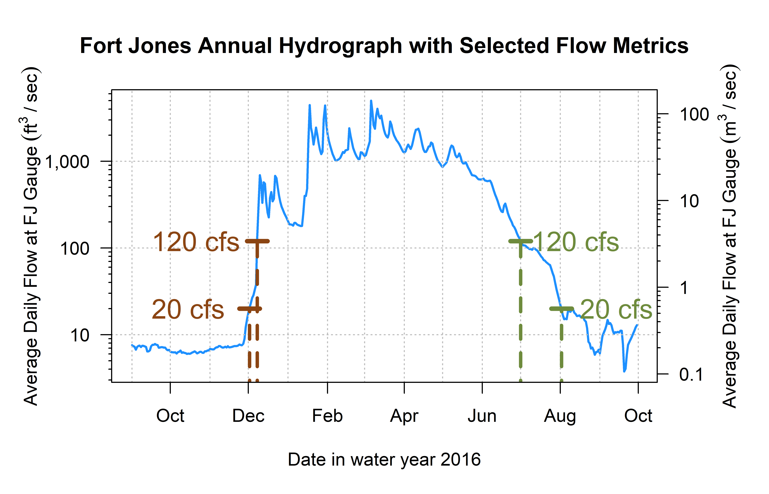

Figure 10: Reconnection and disconnection dates are highlighted for one water year. Two example thresholds, 20 and 120 cfs (0.57 and 3.4 cms, respectively) are highlighted, which correspond to distinct river connectivity (and salmon habitat access) conditions in the Scott River watershed as observed at the Fort Jones gauge (see Results for more detail on selection of flow thresholds).

## 11.4 Screening Predictors for Collinearity

Table 13: Groups of collinear predictors (absolute value of R greater than 0.7), interpretation of their hydrologic significance, and the predictor selected from each group to reduce collinearity.

| ID | Group of Collinear Predictors | Hydrologic Significance (Coho Life Stage) | Predictor Selected from Group |
| --- | --- | --- | --- |
| 1 | wy1_Mean_Ann_Flow, s1_discon_20, s1_discon_40, s1_discon_120, f2_recon_20, f2_recon_40, w1_Wet_BFL_Mag_10, w1_Wet_BFL_Mag_50, s1_SP_Dur, s1_SP_Mag, wy1_WY_Cat, d2_DS_Tim, d2_DS_Mag_50, d2_DS_Mag_90 | How wet was the wet season? (year 1, as eggs and fry) | w1_Wet_BFL_Mag_50 |
| 2 | wy2_Mean_Ann_Flow, s2_discon_120, w2_Wet_BFL_Mag_10, w2_Wet_BFL_Mag_50, s2_SP_Dur, s2_SP_Mag, wy2_WY_Cat | How wet was the wet season? (year 2, as rearing juv.) | w2_Wet_BFL_Mag_50 |
| 3 | d1_DS_Tim, f1_recon_20, f1_recon_40, d1_DS_Dur_WS, d1_DS_Mag_50 | How dry was the dry season? (pre-spawning) | d1_DS_Mag_50 |
| 4 | w2_Wet_Tim, d2_DS_Dur_WS, f2_FA_Tim, w2_Wet_BFL_Dur | Dry to wet season transition timing (juvenile fish) | w2_Wet_Tim |
| 5 | w1_Wet_BFL_Dur, w1_Wet_Tim, s1_SP_Tim | Dry to wet season transition timing (as eggs and fry) | w1_Wet_Tim |
| 6 | f1_FA_Mag, f1_FA_Dif_num | Fall pulse magnitude (parents' spawning) | f1_FA_Dif_num |
| 7 | f1_FA_Tim, w1_Wet_Tim | Dry to wet season transition timing (parents' spawning or as eggs) | w1_Wet_Tim |
| 8 | f2_FA_Mag, f2_FA_Dif_num | Fall pulse magnitude (rearing juv.) | f2_FA_Dif_num |

### 11.4.1 Groups 1 and 2

These metrics describe the magnitude and timing of wet-season flows (years 1 and 2), as well as (for w1) conditions during the following dry season, which can be summarized by the question, ‘how wet was the wet season?’ We selected median wet season flows w1_Wet_BFL_Mag_50 and w2_Wet_BFL_Mag_50 as the most conceptually central metric to represent the amount of water passing through the watershed. Seasons w1 and w2 are experienced by a cohort as eggs and newly-hatched alevin and fry, and as overwintering parr, respectively.

### 11.4.2 Group 3

These metrics describe the magnitude and timing of dry-season flows before the cohort’s spawning. We selected the dry season median flow, d1_DS_Mag_50, as the most conceptually central metric to represent the amount of water passing through the watershed during the dry season before a cohort’s parents’ spawning.

### 11.4.3 Groups 4, 5 and 7

These metrics relate to the timing of the transition from dry to wet season in year 2 and year 1. We selected w2_Wet_Tim and w1_Wet_Tim, the timing of the wet season onset, for both years. In w1 and w2, hydrology is experienced by a cohort of coho as eggs/new hatchlings and overwintering juveniles, respectively.

### 11.4.4 Groups 6 and 8

These metrics quantify the magnitude of the fall pulse flow (years 1 and 2). We selected the fall flow increase FA_dif_num (from Baruch et al. 2024) for both years, as it is the only fall flows magnitude metric occurring in every water year, with no missing values.

# 12 Ecological Data Features

## 12.1 Sources and methods

Table 14: Description and source information for ecological observations of the two salmonid species of concern.

| Obs. ID | Abbrev. | Description | Monitoring Details | Source(s) | Predictor Seasons |
| --- | --- | --- | --- | --- | --- |
| A | coho_spawner_abundance | Num. coho spawners (escapement) | Scott River Fish Counting Facility | Knechtle and Guidice 2023, CDFW | d1, f1, w1 |
| B | coho_redds_in_brood | Num. obs. coho redds | Spawning ground surveys | Sources in Section 3.2 | d1, f1, w1, s1 |
| C | coho_smolt_abun_est | Est. num. coho smolt | Rotary Screw Trap | Romero and Robinson, 2023 | d1, f1, w1, s1, d2, f2, w2, s2 |
| D | chinook_spawner_abundance | Num. Chinook spawners (escapement) | Scott River Fish Counting Facility | Knechtle and Guidice 2023, CDFW | d1, f1, w1 |
| E | chinook_spawner_old_method (NOT USED in this analysis) | Num. Chinook spawners (escapement) | Temporary fish marking weir, 1985-1991; capture-recapture method, 1992-2012; video fish counting facility post-2012 | Knechtle and Chesney 2012 | d1, f1, w1 |
| F | chinook_juvenile_abundance | Num. Chinook juveniles | Rotary Screw Trap | Romero and Robinson, 2023 | d1, f1, w1, s1 |
| -- | coho_smolt_per_fem | Coho smolt per fem. spawner | Ratio (C/A) for relevant cohort | Knechtle and Guidice 2023, CDFW | d1, f1, w1, s1, d2, f2, w2, s2 |
| -- | chinook_juv_per_adult | Chinook juv. per adult | Ratio (F/D) for relevant cohort | Knechtle and Guidice 2023, CDFW | d1, f1, w1, s1 |

## 12.2 Autocorrelation in ecological records

Autocorrelation, with a lag of 3, is evident in two ecological records: the abundances of coho redds and coho smolt (Figure 11). In other words, the 3-year-lagged record of coho smolt approaches, and for redds exceeds, the 95% confidence interval that it is not random noise.

Interestingly, for coho spawner abundance, although the sign of the autocorrelation is positive at 3 and 6 year lags (which we would expect, reflecting the cohort structure), autocorrelation in the coho spawner record is weaker than in the redd and smolt records.

No significant autocorrelation is evident in the three Chinook data types, and none is observed for coho smolt per female.

## png   
## 2

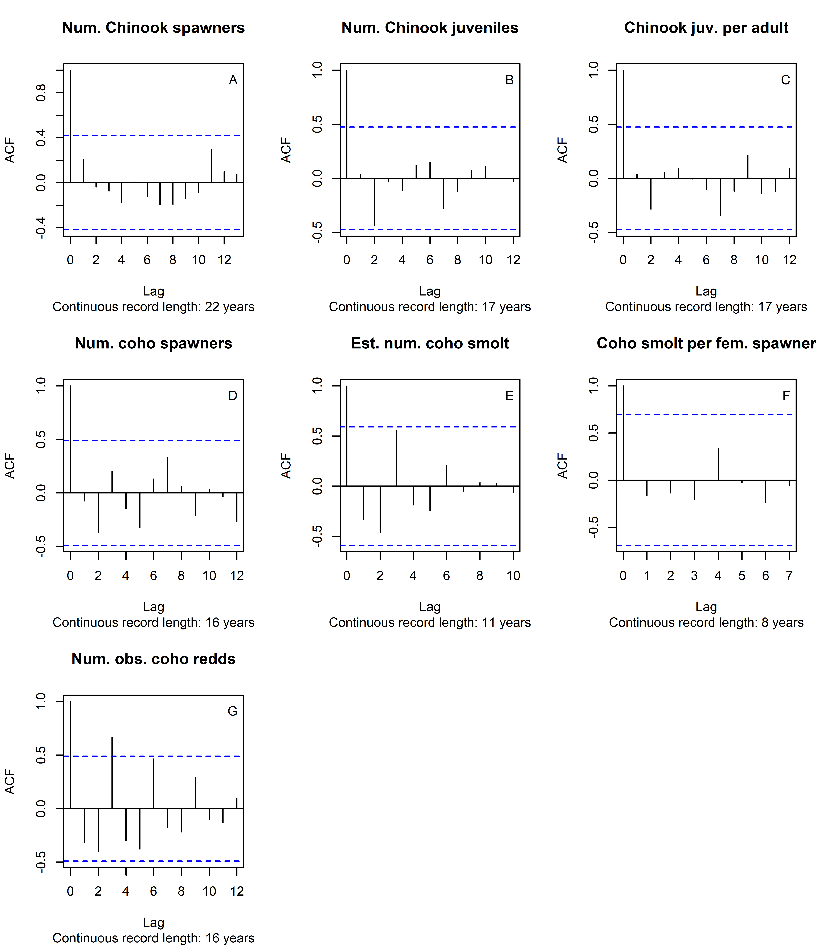

Figure 11: Autocorrelation function estimates for all available ecological outcome records.

# 13 Data tables: Alignment of predictor and response data

The aligned hydrologic predictor and ecological response data are shown in Tables 15 through 26 below. The first eight columns (Table 15) are composed of ecological responses observed for each brood year. The remaining 72 columns tabulate the functional flow and other hydrologic metrics, covering two years of coho salmon freshwater life stages, associated with each brood year. As discussed in methods, the seasonal abbreviations d1, f1, w1, s1, d2, f2, w2 and s2 indicate the season (first or second dry, fall, wet, or spring) in which or coho salmon cohort would experience the hydrology quantified in a given metric. (Juvenile Chinook salmon experience only one year of freshwater conditions before outmigrating.)

Table 15: Hydrologic metrics and ecological observations aligned by brood year of each salmon cohort, columns 1 through 8 of 80.

| brood year | coho smolt per fem | chinook juv per adult | coho spawner abundance | coho redds in brood | coho smolt abun est | chinook spawner abundance | chinook juvenile abundance |
| --- | --- | --- | --- | --- | --- | --- | --- |
| 1999 |  | 44.9 |  |  |  | 3,584 | 160,906 |
| 2000 |  | 100.8 |  |  |  | 6,253 | 630,151 |
| 2001 |  | 47.4 |  | 212 |  | 6,142 | 291,207 |
| 2002 |  | 29.2 |  | 20 |  | 4,308 | 125,909 |
| 2003 |  | 100.5 |  | 6 |  | 12,053 | 1,211,604 |
| 2004 |  | 453.6 |  | 960 | 95,815 | 467 | 211,847 |
| 2005 |  | 17.6 |  | 31 | 3,931 | 756 | 13,279 |
| 2006 |  | 74.7 |  | 14 | 1,142 | 4,960 | 370,622 |
| 2007 | 85.2 | 159.4 | 1,622 | 250 | 73,232 | 4,505 | 717,948 |
| 2008 | 101.8 | 229.1 | 63 | 24 | 3,257 | 4,673 | 1,070,520 |
| 2009 | 8.6 | 435.7 | 81 | 5 | 353 | 2,211 | 963,392 |
| 2010 | 98.7 | 64.9 | 907 | 162 | 63,135 | 2,508 | 162,706 |
| 2011 | 54.6 | 39.7 | 355 | 26 | 9,283 | 5,521 | 219,304 |
| 2012 | 78.3 | 82.1 | 201 | 24 | 6,734 | 9,532 | 782,804 |
| 2013 | 5.8 | 106.8 | 2,752 | 354 | 8,758 | 4,624 | 493,721 |
| 2014 | 18.8 | 22.8 | 485 | 103 | 3,372 | 12,470 | 284,329 |
| 2015 |  | 45.9 | 212 | 60 |  | 2,113 | 97,027 |
| 2016 | 83.6 |  | 226 | 95 | 14,628 | 1,515 |  |
| 2017 | 90.3 | 159.4 | 382 |  | 15,705 | 2,576 | 410,688 |
| 2018 | 34.7 | 108.6 | 739 |  | 14,628 | 1,279 | 138,947 |
| 2019 | 9.0 | 187.4 | 346 | 79 | 1,762 | 2,090 | 391,643 |
| 2020 | 77.7 | 266.3 | 1,766 |  |  | 855 | 227,716 |
| 2021 |  |  | 852 |  |  |  |  |
| 2022 |  |  | 238 |  |  |  |  |

Table 16: Hydrologic metrics and ecological observations aligned by brood year of each salmon cohort, columns 9 through 15 of 80.

| brood year | f1 recon 20 | f1 recon 40 | f1 recon 120 | s1 discon 20 | s1 discon 40 | s1 discon 120 | f2 recon 20 |
| --- | --- | --- | --- | --- | --- | --- | --- |
| 1999 | 1 | 1 | 59 | 346 | 337 | 319 | 7 |
| 2000 | 7 | 43 | 172 | 292 | 287 | 228 | 83 |
| 2001 | 83 | 83 | 83 | 341 | 329 | 306 | 56 |
| 2002 | 56 | 69 | 70 | 365 | 362 | 323 | 1 |
| 2003 | 1 | 1 | 70 | 341 | 332 | 309 | 29 |
| 2004 | 29 | 49 | 98 | 347 | 338 | 317 | 25 |
| 2005 | 25 | 55 | 67 | 365 | 357 | 324 | 1 |
| 2006 | 1 | 4 | 74 | 334 | 313 | 289 | 46 |
| 2007 | 46 | 49 | 49 | 348 | 340 | 313 | 27 |
| 2008 | 27 | 52 | 63 | 327 | 314 | 300 | 46 |
| 2009 | 46 | 70 | 113 | 365 | 346 | 328 | 1 |
| 2010 | 1 | 19 | 54 | 365 | 365 | 343 | 1 |
| 2011 | 1 | 1 | 84 | 345 | 337 | 310 | 33 |
| 2012 | 33 | 57 | 81 | 323 | 305 | 286 | 30 |
| 2013 | 30 | 30 | 164 | 294 | 289 | 256 | 55 |
| 2014 | 55 | 55 | 56 | 300 | 294 | 257 | 93 |
| 2015 | 93 | 99 | 99 | 337 | 332 | 305 | 42 |
| 2016 | 42 | 45 | 46 | 365 | 356 | 326 | 1 |
| 2017 | 1 | 3 | 74 | 312 | 299 | 282 | 64 |
| 2018 | 64 | 83 | 108 | 340 | 334 | 312 | 15 |
| 2019 | 15 | 29 | 99 | 312 | 305 | 294 | 77 |
| 2020 | 77 | 108 | 108 | 300 | 296 | 281 | 54 |
| 2021 | 54 | 54 | 55 | 333 | 318 | 301 | 84 |
| 2022 | 84 | 95 | 116 | 347 | 340 | 316 | 1 |

Table 17: Hydrologic metrics and ecological observations aligned by brood year of each salmon cohort, columns 16 through 22 of 80.

| brood year | f2 recon 40 | f2 recon 120 | s2 discon 120 | d1 DS Dur WS | d1 DS Tim | d1 DS Mag 50 | d1 DS Mag 90 |
| --- | --- | --- | --- | --- | --- | --- | --- |
| 1999 | 43 | 172 | 228 | 100 | 324 | 63.0 | 182.0 |
| 2000 | 83 | 83 | 365 | 154 | 308 | 50.0 | 97.0 |
| 2001 | 69 | 70 | 365 | 170 | 260 | 5.3 | 16.0 |
| 2002 | 1 | 70 | 366 | 137 | 301 | 15.1 | 78.1 |
| 2003 | 49 | 98 | 365 | 97 | 329 | 61.4 | 114.6 |
| 2004 | 55 | 67 | 365 | 127 | 305 | 25.3 | 95.3 |
| 2005 | 4 | 74 | 289 | 109 | 310 | 27.8 | 204.7 |
| 2006 | 49 | 49 | 366 | 115 | 321 | 61.9 | 286.0 |
| 2007 | 52 | 63 | 300 | 129 | 279 | 12.6 | 91.5 |
| 2008 | 70 | 113 | 365 | 86 | 310 | 19.4 | 39.7 |
| 2009 | 19 | 54 | 365 | 117 | 286 | 10.6 | 27.6 |
| 2010 | 1 | 84 | 366 | 84 | 318 | 47.3 | 316.6 |
| 2011 | 57 | 81 | 286 | 124 | 330 | 94.8 | 108.6 |
| 2012 | 30 | 164 | 256 | 109 | 306 | 20.5 | 55.0 |
| 2013 | 55 | 56 | 257 | 209 | 276 | 46.0 | 56.2 |
| 2014 | 99 | 99 | 305 | 156 | 260 | 8.1 | 70.7 |
| 2015 | 45 | 46 | 365 | 248 | 221 | 9.4 | 225.4 |
| 2016 | 3 | 74 | 282 | 129 | 305 | 18.5 | 527.4 |
| 2017 | 83 | 108 | 365 | 95 | 319 | 61.2 | 84.4 |
| 2018 | 29 | 99 | 294 | 173 | 268 | 13.4 | 62.4 |
| 2019 | 108 | 108 | 281 | 174 | 305 | 53.5 | 134.0 |
| 2020 | 54 | 55 | 301 | 158 | 278 | 8.8 | 15.5 |
| 2021 | 95 | 116 | 365 | 131 | 268 | 9.3 | 18.1 |
| 2022 | 25 | 94 | 366 | 159 | 290 | 9.3 | 45.1 |

Table 18: Hydrologic metrics and ecological observations aligned by brood year of each salmon cohort, columns 23 through 29 of 80.

| brood year | f1 FA Dur | f1 FA Mag | f1 FA Tim | f1 FA Dif num | w1 Wet BFL Dur | w1 Wet BFL Mag 10 | w1 Wet BFL Mag 50 |
| --- | --- | --- | --- | --- | --- | --- | --- |
| 1999 | 5 | 141.0 | 30 | 78.0 | 178 | 209.0 | 1,030.0 |
| 2000 |  |  |  | 15.0 | 131 | 99.1 | 177.0 |
| 2001 | 4 | 502.0 | 53 | 496.7 | 177 | 410.8 | 638.0 |
| 2002 | 15 | 37.5 | 34 | 22.4 | 169 | 633.3 | 1,240.0 |
| 2003 | 5 | 99.0 | 29 | 35.1 | 156 | 308.0 | 756.0 |
| 2004 | 3 | 103.0 | 25 | 77.0 | 173 | 329.3 | 555.0 |
| 2005 | 9 | 488.0 | 38 | 460.2 | 178 | 607.0 | 1,580.0 |
| 2006 | 12 | 103.0 | 42 | 39.5 | 106 | 330.6 | 670.0 |
| 2007 | 11 | 778.0 | 20 | 764.3 | 199 | 166.6 | 502.5 |
| 2008 | 11 | 39.9 | 12 | 19.3 | 200 | 101.0 | 228.0 |
| 2009 | 2 | 32.9 | 17 | 21.5 | 220 | 54.4 | 472.0 |
| 2010 | 4 | 755.0 | 25 | 707.6 | 235 | 411.5 | 1,025.0 |
| 2011 |  |  |  | 36.0 | 140 | 175.0 | 635.0 |
| 2012 | 2 | 55.4 | 45 | 34.6 | 171 | 259.1 | 427.0 |
| 2013 |  |  |  | 22.2 | 72 | 82.1 | 421.0 |
| 2014 | 5 | 192.0 | 26 | 183.8 | 79 | 282.9 | 532.0 |
| 2015 | 14 | 692.0 | 71 | 682.5 | 91 | 1,060.0 | 1,560.0 |
| 2016 | 7 | 486.0 | 17 | 467.0 | 148 | 813.4 | 1,720.0 |
| 2017 | 4 | 114.0 | 42 | 52.6 | 169 | 146.0 | 372.5 |
| 2018 | 4 | 108.0 | 61 | 94.5 | 152 | 239.2 | 918.0 |
| 2019 | 6 | 273.0 | 69 | 219.0 | 130 | 174.0 | 268.0 |
| 2020 | 2 | 35.0 | 47 | 26.1 | 157 | 89.1 | 279.5 |
| 2021 | 2 | 501.0 | 25 | 491.6 | 215 | 112.5 | 259.0 |
| 2022 | 16 | 40.0 | 62 | 30.6 | 148 | 268.0 | 693.0 |

Table 19: Hydrologic metrics and ecological observations aligned by brood year of each salmon cohort, columns 30 through 36 of 80.

| brood year | w1 Wet Tim | w1 Peak Tim 10 | w1 Peak Tim 2 | w1 Peak Tim 5 | w1 Peak Dur 10 | w1 Peak Dur 2 | w1 Peak Dur 5 |
| --- | --- | --- | --- | --- | --- | --- | --- |
| 1999 | 59 |  |  |  |  |  |  |
| 2000 | 97 |  |  |  |  |  |  |
| 2001 | 65 |  |  |  |  |  |  |
| 2002 | 73 |  | 89.0 |  |  | 2 |  |
| 2003 | 61 |  | 141.0 |  |  | 1 |  |
| 2004 | 67 |  |  |  |  |  |  |
| 2005 | 54 | 92 | 83.0 | 92 | 1 | 12 | 1 |
| 2006 | 71 |  |  |  |  |  |  |
| 2007 | 43 |  |  |  |  |  |  |
| 2008 | 31 |  |  |  |  |  |  |
| 2009 | 38 |  |  |  |  |  |  |
| 2010 | 37 |  |  |  |  |  |  |
| 2011 | 89 |  | 183.0 |  |  | 1 |  |
| 2012 | 50 |  | 66.0 |  |  | 1 |  |
| 2013 | 120 |  |  |  |  |  |  |
| 2014 | 51 |  | 130.0 | 130 |  | 3 | 1 |
| 2015 | 104 |  | 158.0 |  |  | 1 |  |
| 2016 | 69 |  | 104.5 | 133 |  | 8 | 1 |
| 2017 | 49 |  |  |  |  |  |  |
| 2018 | 76 |  | 191.0 |  |  | 1 |  |
| 2019 | 114 |  |  |  |  |  |  |
| 2020 | 71 |  |  |  |  |  |  |
| 2021 | 34 |  |  |  |  |  |  |
| 2022 | 84 |  |  |  |  |  |  |

Table 20: Hydrologic metrics and ecological observations aligned by brood year of each salmon cohort, columns 37 through 43 of 80.

| brood year | w1 Peak 10 | w1 Peak 2 | w1 Peak 5 | w1 Peak Fre 10 | w1 Peak Fre 2 | w1 Peak Fre 5 | s1 SP ROC |
| --- | --- | --- | --- | --- | --- | --- | --- |
| 1999 | 13,440 | 4,520 | 10,960 |  |  |  | 0.069 |
| 2000 | 13,440 | 4,520 | 10,960 |  |  |  | 0.106 |
| 2001 | 13,440 | 4,520 | 10,960 |  |  |  | 0.062 |
| 2002 | 13,440 | 4,520 | 10,960 |  | 1 |  | 0.066 |
| 2003 | 13,440 | 4,520 | 10,960 |  | 1 |  | 0.065 |
| 2004 | 13,440 | 4,520 | 10,960 |  |  |  | 0.072 |
| 2005 | 13,440 | 4,520 | 10,960 | 1 | 3 | 1 | 0.060 |
| 2006 | 13,440 | 4,520 | 10,960 |  |  |  | 0.056 |
| 2007 | 13,440 | 4,520 | 10,960 |  |  |  | 0.050 |
| 2008 | 13,440 | 4,520 | 10,960 |  |  |  | 0.070 |
| 2009 | 13,440 | 4,520 | 10,960 |  |  |  | 0.069 |
| 2010 | 13,440 | 4,520 | 10,960 |  |  |  | 0.056 |
| 2011 | 13,440 | 4,520 | 10,960 |  | 1 |  | 0.064 |
| 2012 | 13,440 | 4,520 | 10,960 |  | 1 |  | 0.063 |
| 2013 | 13,440 | 4,520 | 10,960 |  |  |  | 0.051 |
| 2014 | 13,440 | 4,520 | 10,960 |  | 1 | 1 | 0.051 |
| 2015 | 13,440 | 4,520 | 10,960 |  | 1 |  | 0.060 |
| 2016 | 13,440 | 4,520 | 10,960 |  | 4 | 1 | 0.059 |
| 2017 | 13,440 | 4,520 | 10,960 |  |  |  | 0.081 |
| 2018 | 13,440 | 4,520 | 10,960 |  | 1 |  | 0.067 |
| 2019 | 13,440 | 4,520 | 10,960 |  |  |  | 0.093 |
| 2020 | 13,440 | 4,520 | 10,960 |  |  |  | 0.066 |
| 2021 | 13,440 | 4,520 | 10,960 |  |  |  | 0.084 |
| 2022 | 13,440 | 4,520 | 10,960 |  |  |  | 0.063 |

Table 21: Hydrologic metrics and ecological observations aligned by brood year of each salmon cohort, columns 44 through 50 of 80.

| brood year | s1 SP ROC Max | s1 SP Dur | s1 SP Mag | s1 SP Tim | wy1 Mean Ann Flow | wy1 WY Cat | d2 DS Dur WS |
| --- | --- | --- | --- | --- | --- | --- | --- |
| 1999 | 0.138 | 71 | 1,770 | 237 | 582 | mod year | 154 |
| 2000 | 0.315 | 32 | 1,040 | 228 | 132 | dry year | 170 |
| 2001 | 0.134 | 59 | 1,030 | 242 | 411 | mod year | 137 |
| 2002 | 0.190 | 87 | 2,300 | 242 | 807 | wet year | 97 |
| 2003 | 0.158 | 88 | 1,470 | 217 | 490 | mod year | 127 |
| 2004 | 0.181 | 70 | 1,570 | 240 | 436 | mod year | 109 |
| 2005 | 0.156 | 89 | 3,600 | 232 | 1,252 | wet year | 115 |
| 2006 | 0.142 | 102 | 1,120 | 177 | 410 | mod year | 129 |
| 2007 | 0.144 | 68 | 1,340 | 242 | 412 | mod year | 86 |
| 2008 | 0.197 | 55 | 1,160 | 231 | 269 | dry year | 117 |
| 2009 | 0.148 | 60 | 1,690 | 258 | 463 | mod year | 84 |
| 2010 | 0.255 | 58 | 2,310 | 272 | 769 | wet year | 124 |
| 2011 | 0.191 | 77 | 1,680 | 229 | 434 | mod year | 109 |
| 2012 | 0.133 | 55 | 1,060 | 221 | 327 | dry year | 209 |
| 2013 | 0.119 | 68 | 443 | 192 | 170 | dry year | 156 |
| 2014 | 0.505 | 91 | 12,800 | 130 | 405 | dry year | 248 |
| 2015 | 0.166 | 110 | 2,380 | 195 | 677 | mod year | 129 |
| 2016 | 0.247 | 102 | 3,650 | 217 | 1,193 | wet year | 95 |
| 2017 | 0.159 | 50 | 606 | 218 | 255 | dry year | 173 |
| 2018 | 0.237 | 77 | 2,100 | 228 | 566 | mod year | 174 |
| 2019 | 0.146 | 34 | 517 | 244 | 168 | dry year | 158 |
| 2020 | 0.149 | 40 | 422 | 228 | 151 | dry year | 131 |
| 2021 | 0.215 | 41 | 539 | 249 | 190 | dry year | 159 |
| 2022 | 0.181 | 78 | 3,000 | 232 | 513 | mod year | 117 |

Table 22: Hydrologic metrics and ecological observations aligned by brood year of each salmon cohort, columns 51 through 57 of 80.

| brood year | d2 DS Tim | d2 DS Mag 50 | d2 DS Mag 90 | f2 FA Dur | f2 FA Mag | f2 FA Tim | f2 FA Dif num |
| --- | --- | --- | --- | --- | --- | --- | --- |
| 1999 | 308 | 50.0 | 97.0 |  |  |  | 15.0 |
| 2000 | 260 | 5.3 | 16.0 | 4 | 502.0 | 53 | 496.7 |
| 2001 | 301 | 15.1 | 78.1 | 15 | 37.5 | 34 | 22.4 |
| 2002 | 329 | 61.4 | 114.6 | 5 | 99.0 | 29 | 35.1 |
| 2003 | 305 | 25.3 | 95.3 | 3 | 103.0 | 25 | 77.0 |
| 2004 | 310 | 27.8 | 204.7 | 9 | 488.0 | 38 | 460.2 |
| 2005 | 321 | 61.9 | 286.0 | 12 | 103.0 | 42 | 39.5 |
| 2006 | 279 | 12.6 | 91.5 | 11 | 778.0 | 20 | 764.3 |
| 2007 | 310 | 19.4 | 39.7 | 11 | 39.9 | 12 | 19.3 |
| 2008 | 286 | 10.6 | 27.6 | 2 | 32.9 | 17 | 21.5 |
| 2009 | 318 | 47.3 | 316.6 | 4 | 755.0 | 25 | 707.6 |
| 2010 | 330 | 94.8 | 108.6 |  |  |  | 36.0 |
| 2011 | 306 | 20.5 | 55.0 | 2 | 55.4 | 45 | 34.6 |
| 2012 | 276 | 46.0 | 56.2 |  |  |  | 22.2 |
| 2013 | 260 | 8.1 | 70.7 | 5 | 192.0 | 26 | 183.8 |
| 2014 | 221 | 9.4 | 225.4 | 14 | 692.0 | 71 | 682.5 |
| 2015 | 305 | 18.5 | 527.4 | 7 | 486.0 | 17 | 467.0 |
| 2016 | 319 | 61.2 | 84.4 | 4 | 114.0 | 42 | 52.6 |
| 2017 | 268 | 13.4 | 62.4 | 4 | 108.0 | 61 | 94.5 |
| 2018 | 305 | 53.5 | 134.0 | 6 | 273.0 | 69 | 219.0 |
| 2019 | 278 | 8.8 | 15.5 | 2 | 35.0 | 47 | 26.1 |
| 2020 | 268 | 9.3 | 18.1 | 2 | 501.0 | 25 | 491.6 |
| 2021 | 290 | 9.3 | 45.1 | 16 | 40.0 | 62 | 30.6 |
| 2022 | 310 | 47.5 | 83.3 | 8 | 83.8 | 40 | 36.2 |

Table 23: Hydrologic metrics and ecological observations aligned by brood year of each salmon cohort, columns 58 through 64 of 80.

| brood year | w2 Wet BFL Dur | w2 Wet BFL Mag 10 | w2 Wet BFL Mag 50 | w2 Wet Tim | w2 Peak Tim 10 | w2 Peak Tim 2 | w2 Peak Tim 5 |
| --- | --- | --- | --- | --- | --- | --- | --- |
| 1999 | 131 | 99.1 | 177.0 | 97 |  |  |  |
| 2000 | 177 | 410.8 | 638.0 | 65 |  |  |  |
| 2001 | 169 | 633.3 | 1,240.0 | 73 |  | 89.0 |  |
| 2002 | 156 | 308.0 | 756.0 | 61 |  | 141.0 |  |
| 2003 | 173 | 329.3 | 555.0 | 67 |  |  |  |
| 2004 | 178 | 607.0 | 1,580.0 | 54 | 92 | 83.0 | 92 |
| 2005 | 106 | 330.6 | 670.0 | 71 |  |  |  |
| 2006 | 199 | 166.6 | 502.5 | 43 |  |  |  |
| 2007 | 200 | 101.0 | 228.0 | 31 |  |  |  |
| 2008 | 220 | 54.4 | 472.0 | 38 |  |  |  |
| 2009 | 235 | 411.5 | 1,025.0 | 37 |  |  |  |
| 2010 | 140 | 175.0 | 635.0 | 89 |  | 183.0 |  |
| 2011 | 171 | 259.1 | 427.0 | 50 |  | 66.0 |  |
| 2012 | 72 | 82.1 | 421.0 | 120 |  |  |  |
| 2013 | 79 | 282.9 | 532.0 | 51 |  | 130.0 | 130 |
| 2014 | 91 | 1,060.0 | 1,560.0 | 104 |  | 158.0 |  |
| 2015 | 148 | 813.4 | 1,720.0 | 69 |  | 104.5 | 133 |
| 2016 | 169 | 146.0 | 372.5 | 49 |  |  |  |
| 2017 | 152 | 239.2 | 918.0 | 76 |  | 191.0 |  |
| 2018 | 130 | 174.0 | 268.0 | 114 |  |  |  |
| 2019 | 157 | 89.1 | 279.5 | 71 |  |  |  |
| 2020 | 215 | 112.5 | 259.0 | 34 |  |  |  |
| 2021 | 148 | 268.0 | 693.0 | 84 |  |  |  |
| 2022 | 168 | 251.0 | 917.0 | 62 |  |  |  |

Table 24: Hydrologic metrics and ecological observations aligned by brood year of each salmon cohort, columns 65 through 71 of 80.

| brood year | w2 Peak Dur 10 | w2 Peak Dur 2 | w2 Peak Dur 5 | w2 Peak 10 | w2 Peak 2 | w2 Peak 5 | w2 Peak Fre 10 |
| --- | --- | --- | --- | --- | --- | --- | --- |
| 1999 |  |  |  | 13,440 | 4,520 | 10,960 |  |
| 2000 |  |  |  | 13,440 | 4,520 | 10,960 |  |
| 2001 |  | 2 |  | 13,440 | 4,520 | 10,960 |  |
| 2002 |  | 1 |  | 13,440 | 4,520 | 10,960 |  |
| 2003 |  |  |  | 13,440 | 4,520 | 10,960 |  |
| 2004 | 1 | 12 | 1 | 13,440 | 4,520 | 10,960 | 1 |
| 2005 |  |  |  | 13,440 | 4,520 | 10,960 |  |
| 2006 |  |  |  | 13,440 | 4,520 | 10,960 |  |
| 2007 |  |  |  | 13,440 | 4,520 | 10,960 |  |
| 2008 |  |  |  | 13,440 | 4,520 | 10,960 |  |
| 2009 |  |  |  | 13,440 | 4,520 | 10,960 |  |
| 2010 |  | 1 |  | 13,440 | 4,520 | 10,960 |  |
| 2011 |  | 1 |  | 13,440 | 4,520 | 10,960 |  |
| 2012 |  |  |  | 13,440 | 4,520 | 10,960 |  |
| 2013 |  | 3 | 1 | 13,440 | 4,520 | 10,960 |  |
| 2014 |  | 1 |  | 13,440 | 4,520 | 10,960 |  |
| 2015 |  | 8 | 1 | 13,440 | 4,520 | 10,960 |  |
| 2016 |  |  |  | 13,440 | 4,520 | 10,960 |  |
| 2017 |  | 1 |  | 13,440 | 4,520 | 10,960 |  |
| 2018 |  |  |  | 13,440 | 4,520 | 10,960 |  |
| 2019 |  |  |  | 13,440 | 4,520 | 10,960 |  |
| 2020 |  |  |  | 13,440 | 4,520 | 10,960 |  |
| 2021 |  |  |  | 13,440 | 4,520 | 10,960 |  |
| 2022 |  |  |  | 13,440 | 4,520 | 10,960 |  |

Table 25: Hydrologic metrics and ecological observations aligned by brood year of each salmon cohort, columns 72 through 78 of 80.

| brood year | w2 Peak Fre 2 | w2 Peak Fre 5 | s2 SP ROC | s2 SP ROC Max | s2 SP Dur | s2 SP Mag | s2 SP Tim |
| --- | --- | --- | --- | --- | --- | --- | --- |
| 1999 |  |  | 0.106 | 0.315 | 32 | 1,040 | 228 |
| 2000 |  |  | 0.062 | 0.134 | 59 | 1,030 | 242 |
| 2001 | 1 |  | 0.066 | 0.190 | 87 | 2,300 | 242 |
| 2002 | 1 |  | 0.065 | 0.158 | 88 | 1,470 | 217 |
| 2003 |  |  | 0.072 | 0.181 | 70 | 1,570 | 240 |
| 2004 | 3 | 1 | 0.060 | 0.156 | 89 | 3,600 | 232 |
| 2005 |  |  | 0.056 | 0.142 | 102 | 1,120 | 177 |
| 2006 |  |  | 0.050 | 0.144 | 68 | 1,340 | 242 |
| 2007 |  |  | 0.070 | 0.197 | 55 | 1,160 | 231 |
| 2008 |  |  | 0.069 | 0.148 | 60 | 1,690 | 258 |
| 2009 |  |  | 0.056 | 0.255 | 58 | 2,310 | 272 |
| 2010 | 1 |  | 0.064 | 0.191 | 77 | 1,680 | 229 |
| 2011 | 1 |  | 0.063 | 0.133 | 55 | 1,060 | 221 |
| 2012 |  |  | 0.051 | 0.119 | 68 | 443 | 192 |
| 2013 | 1 | 1 | 0.051 | 0.505 | 91 | 12,800 | 130 |
| 2014 | 1 |  | 0.060 | 0.166 | 110 | 2,380 | 195 |
| 2015 | 4 | 1 | 0.059 | 0.247 | 102 | 3,650 | 217 |
| 2016 |  |  | 0.081 | 0.159 | 50 | 606 | 218 |
| 2017 | 1 |  | 0.067 | 0.237 | 77 | 2,100 | 228 |
| 2018 |  |  | 0.093 | 0.146 | 34 | 517 | 244 |
| 2019 |  |  | 0.066 | 0.149 | 40 | 422 | 228 |
| 2020 |  |  | 0.084 | 0.215 | 41 | 539 | 249 |
| 2021 |  |  | 0.063 | 0.181 | 78 | 3,000 | 232 |
| 2022 |  |  | 0.063 | 0.121 | 71 | 1,910 | 230 |

Table 26: Hydrologic metrics and ecological observations aligned by brood year of each salmon cohort, columns 79 through 80 of 80.

| brood year | wy2 Mean Ann Flow | wy2 WY Cat |
| --- | --- | --- |
| 1999 | 132 | dry year |
| 2000 | 411 | mod year |
| 2001 | 807 | wet year |
| 2002 | 490 | mod year |
| 2003 | 436 | mod year |
| 2004 | 1,252 | wet year |
| 2005 | 410 | mod year |
| 2006 | 412 | mod year |
| 2007 | 269 | dry year |
| 2008 | 463 | mod year |
| 2009 | 769 | wet year |
| 2010 | 434 | mod year |
| 2011 | 327 | dry year |
| 2012 | 170 | dry year |
| 2013 | 405 | dry year |
| 2014 | 677 | mod year |
| 2015 | 1,193 | wet year |
| 2016 | 255 | dry year |
| 2017 | 566 | mod year |
| 2018 | 168 | dry year |
| 2019 | 151 | dry year |
| 2020 | 190 | dry year |
| 2021 | 513 | mod year |
| 2022 | 554 | mod year |

# 14 Six statistical modeling structures - method details

**LASSO model of juveniles-per-spawner:** Cross-validation produced a clear minimum-error $λ$ value for Chinook (Figure 12). For coho, we proposed an alternate lambda value that explained more percent deviance (Figure 12, middle left panel) while retaining a near-minimum test error (Figure 12, top left panel). This produced a model with three non-zero coefficients for both species (Figure 12, lower two panels; Tables 27 and 28)

**LASSO model of juvenile abundance, hydrology and spawners:** the selected predictors included spawners only for Chinook (Tables 31 and 32).

**Lasso model of juvenile abundance, hydrologic metrics only:** replicating the approach for the LASSO model of juveniles-per-spawner, we proposed an alternate lambda value for the coho model (Figure 13). Selected predictors for coho were similar to the juvenile abundance, hydrology-plus-spawners LASSO model, while for Chinook, the minimum-error model selected only one predictor (Tables 29 and 30).

**MARSS models of juveniles-per-spawner, single hydrologic covariate:** hydrology order of importance is taken from the small-sample-size-corrected Akaike Information Criterion (AICc), i.e., the lower the AICc, the better the prediction based on that hydrologic metric (Tables 33 and 34).

**MARSS models of juveniles abundance, single hydrologic covariate:** hydrology order of importance interpreted as described above (Tables 33 and 34); this is used to test the utility of adding spawners as a covariate.

**MARSS models of juvenile abundance, two covariates:** This model structure calculates a coefficient value for spawners and for any single hydrologic metric (Tables 37 and 38). For the four best models, hydrology coefficients are equal to or greater than coefficients for spawners. For worse, higher-AICc models, spawner influence grows to be much greater than the hydrology.

MARSS models tended to perform better at predicting coho than Chinook (Figures 15, 16, and 17, possibly because Chinook records did not contain significant autocorrelation (Figure 11).

# 15 LASSO regression

LASSO (Least Absolute Shrinkage and Selection Operator) regression minimizes the following quantity:

$$\sum_{i=1}^{n}{{\left(y_{i}−β_{0}−\sum_{j=1}^{p}{β_{j}x_{ij}}\right)}^{2}}+λ\sum_{j=1}^{p}{\left|β_{j}\right|}$$

Where:

* $n$ is the number of ecological observations;
* $i$ enumerates the brood years;
* $p$ is the number of predictors;
* $j$ enumerates the hydrologic predictors;
* $x_{ij}$ is the observed value of hydrologic predictor $j$ for brood year $i$ (independent variable);
* $y_{i}$ is the observed value of ecological response in the salmon cohort with brood year $i$ (dependent variable);
* $β_{0}$ is the intercept value for the resulting linear model;
* $β_{j}$ is the coefficient value for hydrologic predictor $j$ in the resulting linear model; and
* $λ$ is a tuning parameter, referred to as a shrinkage penalty.

In this formulation, sufficiently large values of lambda generally shrink the values of all coefficients to 0 (the infinite-lambda case). The infinite-lambda case produces a model consisting solely of the $β_{0}$ intercept term, which takes on a value that is the average of all the observed $y$ values. Conversely, sufficiently small values of $λ$ will produce linear models incorporating information from many predictors. The selection of the appropriate $λ$ value is a critical step in the regression procedure, and is best done using cross-validation within the training dataset (James et al. 2013).

## 15.1 LASSO results: juveniles-per-spawner based on hydrologic metrics

For purposes of statistical model comparison, we predicted the ratio of juveniles per spawner for coho and Chinook based on a predictor set that included only Z-scored hydrologic metrics.

## png   
## 2

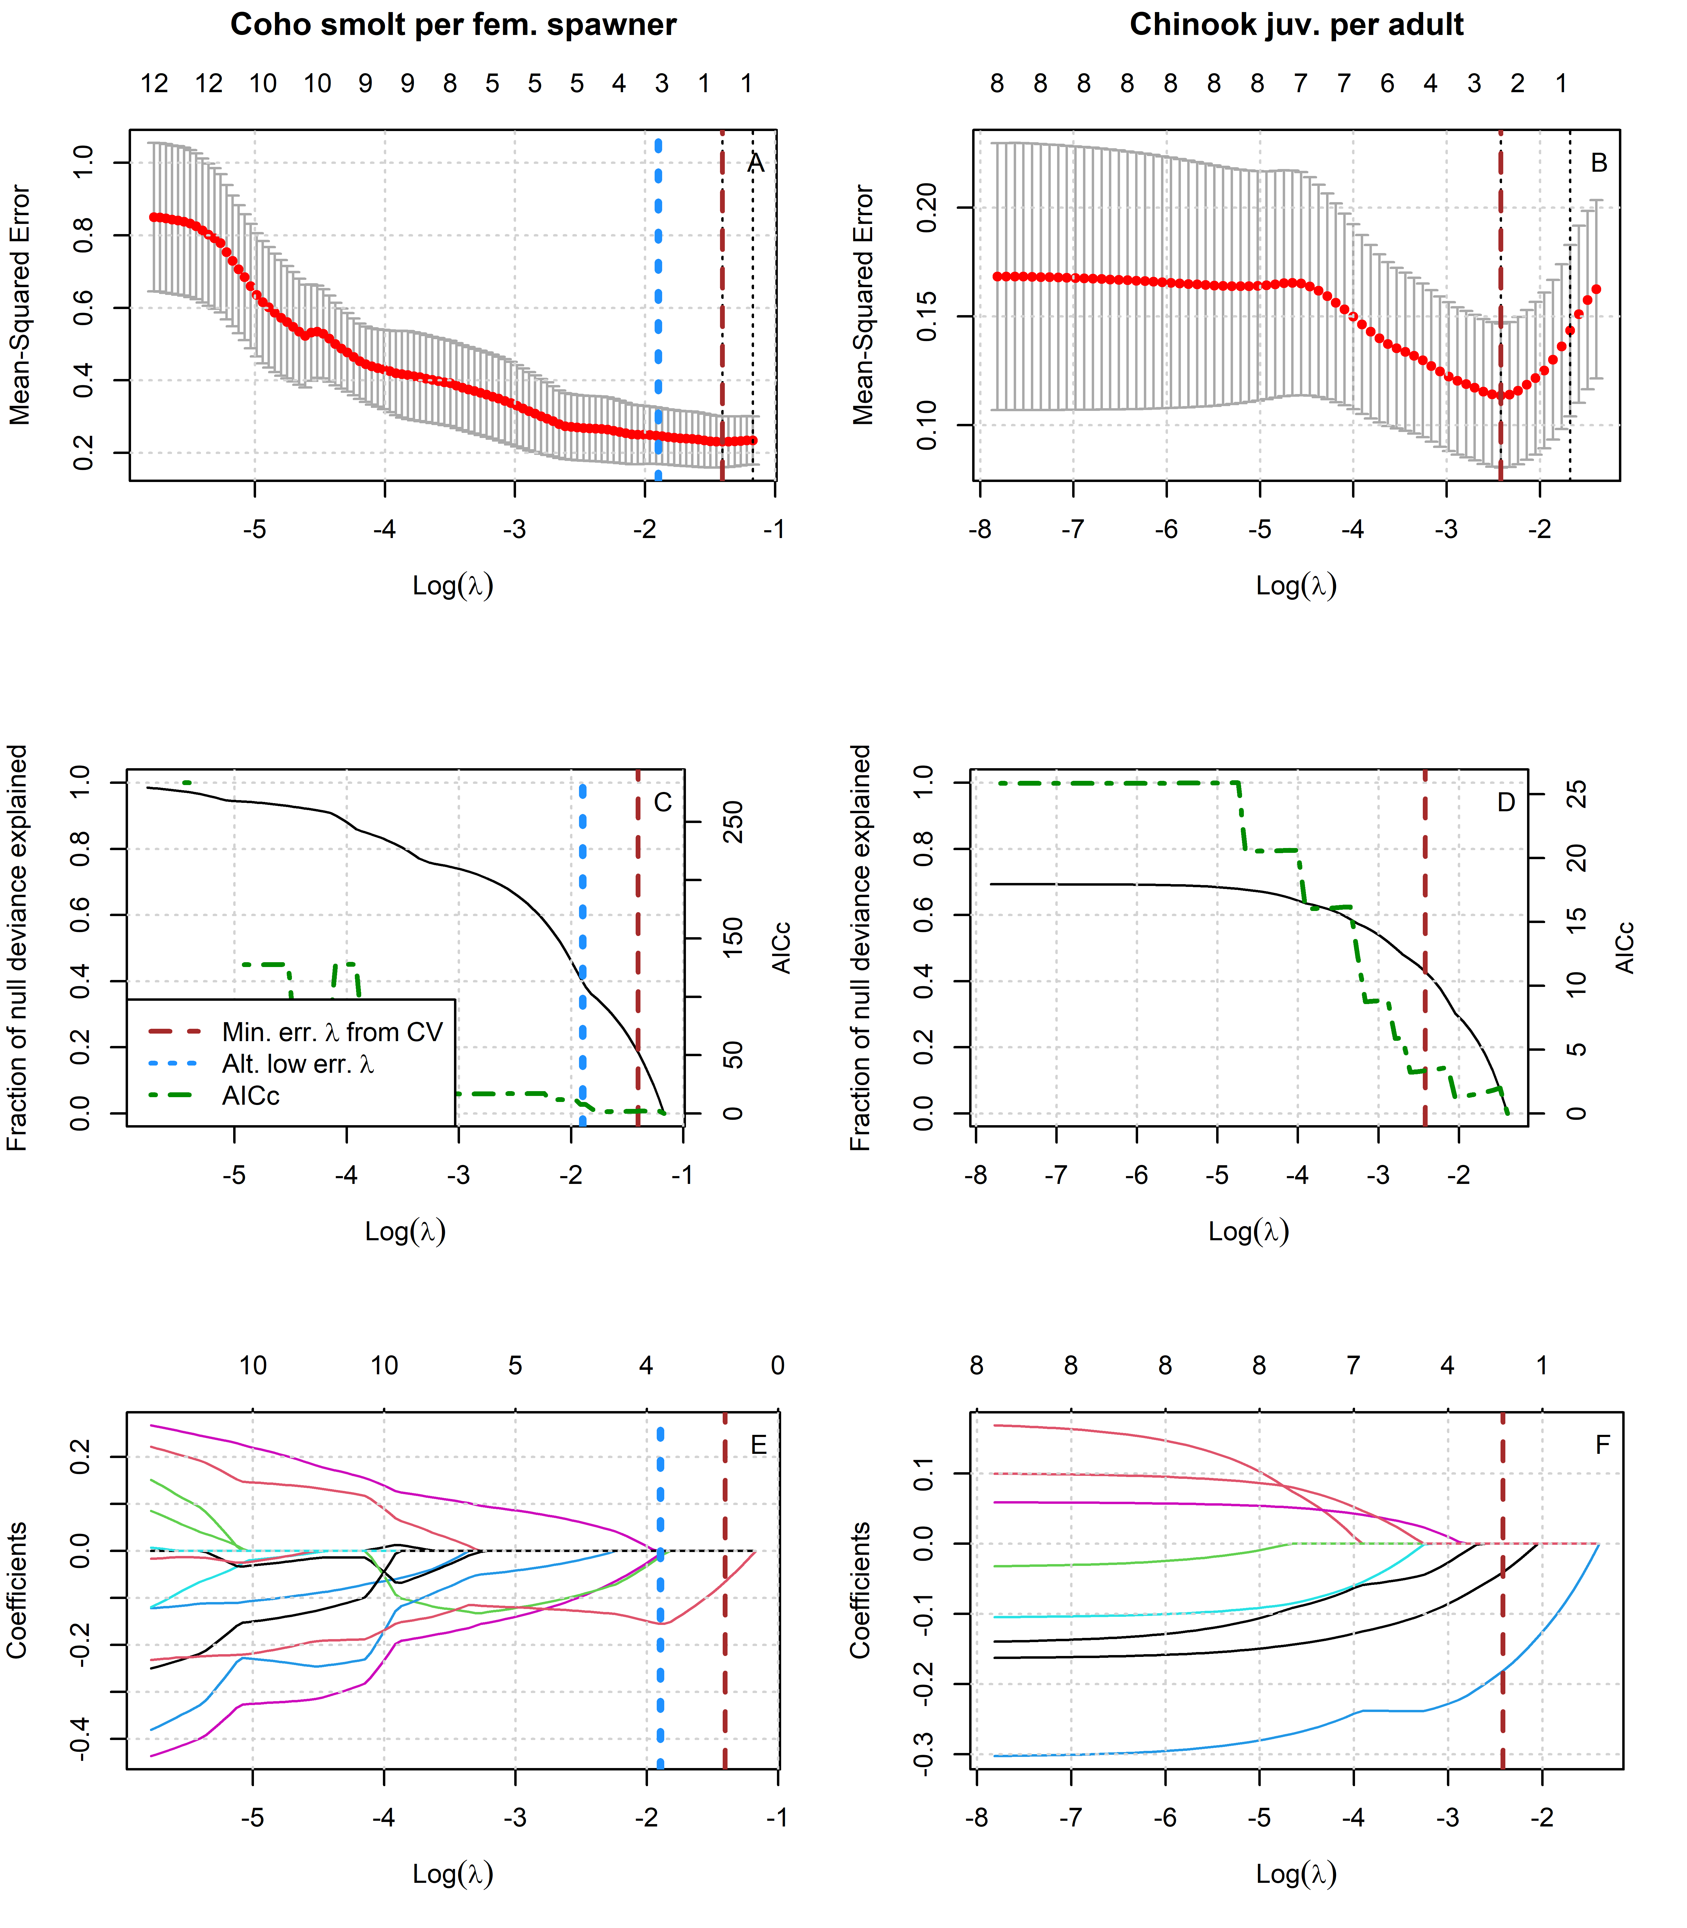

Figure 12: Results of lasso regression to predict log-transformed coho and Chinook outcomes with Z-scored hydrologic metrics. Models with more coefficients explain a greater fraction of deviance in the dataset (middle panel), but also produce higher test errors (top panel), indicating some overfitting at lower lambda values. Higher values of lambda tend to shrink the absolute values of regression coefficients toward 0 (bottom panel).

Table 27: Values for the intercept and coefficient terms in the Hydrologic Benefit function for estimated coho spf based on hydrology only, including a description of which phenomena are associated with higher ecological outcome values.

| Predictor | Value | Greater Hydrologic Benefit value associated with |
| --- | --- | --- |
|  | 1.592 | (Intercept) |
| f1_recon_120 | -0.155 | Earlier fall reconnection (during parents' spawning) |
| f2_FA_Dif_num | -0.012 | Smaller fall pulse (as juvenile fish) |
| w1_Wet_Tim | -0.007 | Earlier wet season onset (as eggs and fry) |

Table 28: Values for the intercept and coefficient terms in the Hydrologic Benefit function for estimatedChinook jpa based on hydrology only, including a description of which hydrologic phenomena are associated with higher ecological outcome values.

| Predictor | Value | Greater Hydrologic Benefit value associated with |
| --- | --- | --- |
|  | 1.944 | (Intercept) |
| w1_Wet_BFL_Mag_50 | -0.181 | Smaller wet season baseflows (as eggs and hatchlings) |
| s1_SP_ROC_Max | -0.041 | Slower max. rate of change, spring recession (as outmigrating smolt) |

## 15.2 LASSO results: juvenile abundance on hydrologic metrics only

For purposes of statistical model comparison, we predicted juvenile abundance of coho and Chinook based on a predictor set that included only Z-scored hydrologic metrics.

## png   
## 2

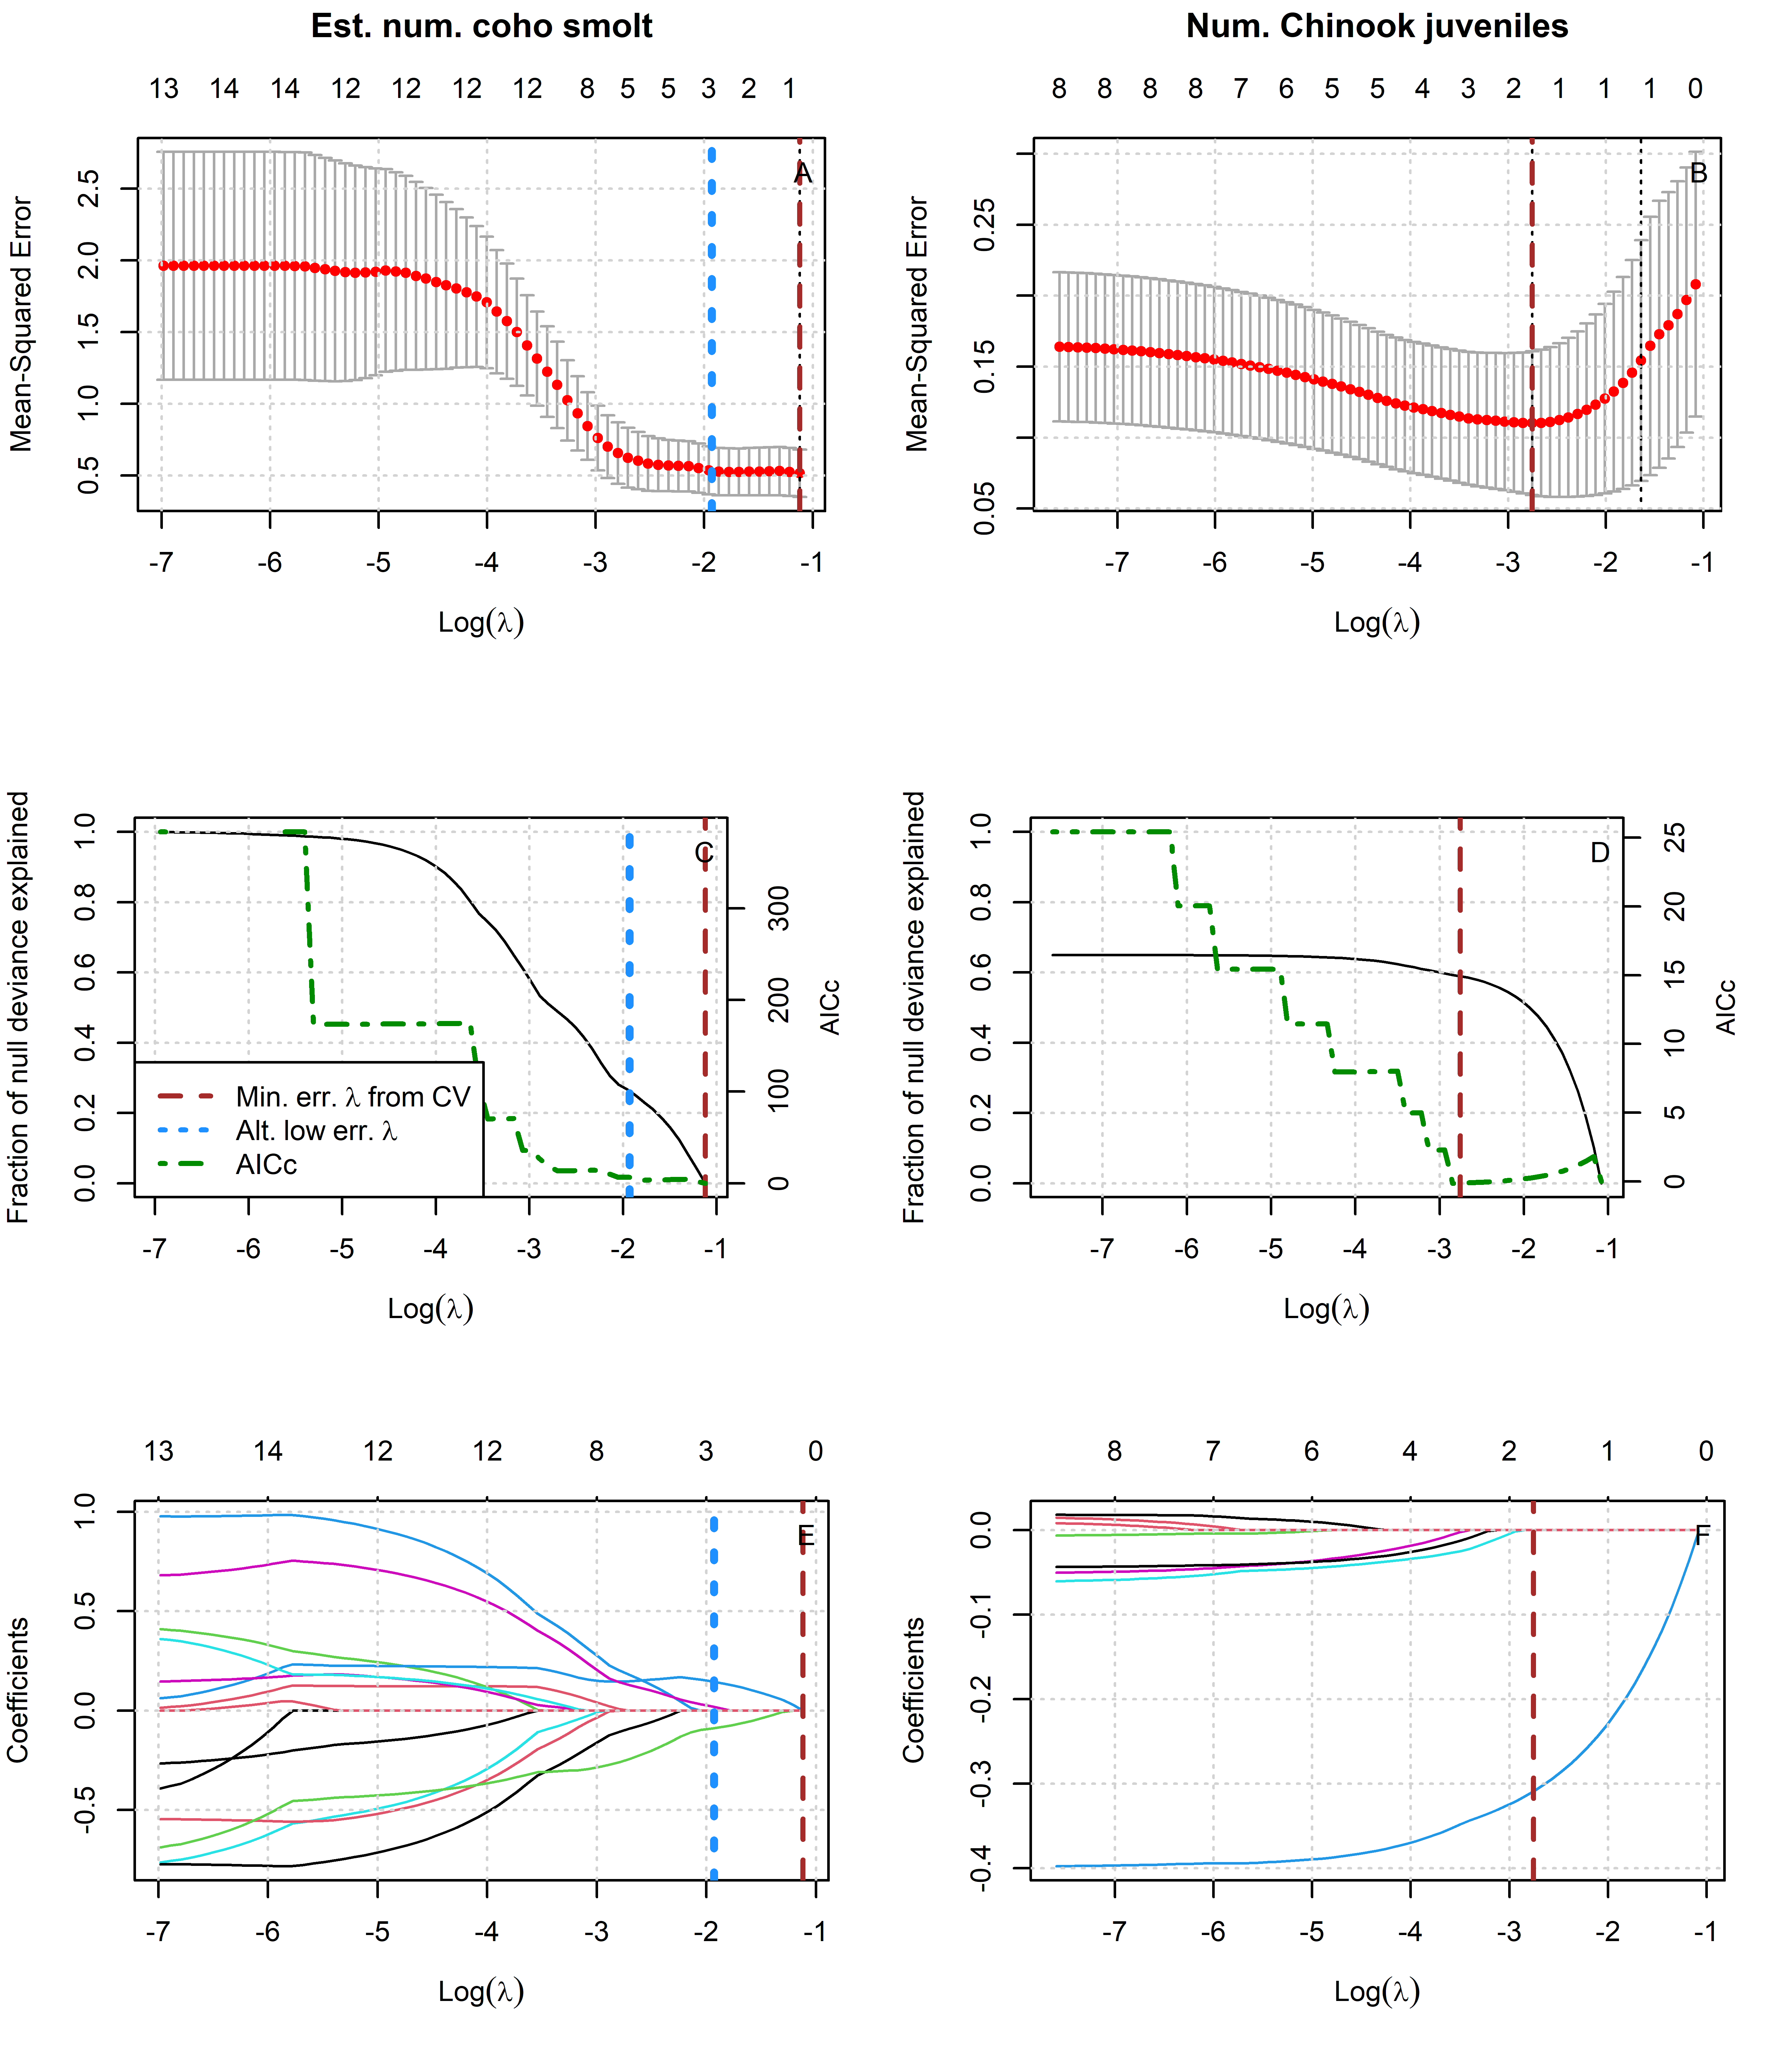

Figure 13: Results of lasso regression to predict log-transformed coho and Chinook outcomes with Z-scored hydrologic metrics. Models with more coefficients explain a greater fraction of deviance in the dataset (middle panel), but also produce higher test errors (top panel), indicating some overfitting at lower lambda values. Higher values of lambda tend to shrink the absolute values of regression coefficients toward 0 (bottom panel).

Table 29: Values for the intercept and coefficient terms in the Hydrologic Benefit function for estimated coho smolt abundance based on hydrology only, including a description of which phenomena are associated with higher ecological outcome values.

| Predictor | Value | Greater Hydrologic Benefit value associated with |
| --- | --- | --- |
|  | 3.901 | (Intercept) |
| f1_FA_Dif_num | 0.145 | Larger fall flow increase (during parents' spawning) |
| f2_FA_Dif_num | -0.088 | Smaller fall flow increase (as juvenile fish) |
| s2_SP_ROC | 0.019 | Faster rate of change, spring recession (as outmigrating smolt) |

Table 30: Values for the intercept and coefficient terms in the Hydrologic Benefit function for estimatedChinook juv. abundance based on hydrology only, including a description of which hydrologic phenomena are associated with higher ecological outcome values.

| Predictor | Value | Greater Hydrologic Benefit value associated with |
| --- | --- | --- |
|  | 5.450 | (Intercept) |
| w1_Wet_BFL_Mag_50 | -0.309 | Lower wet season baseflows (as eggs and hatchlings) |

## 15.3 LASSO results: juvenile abundance on hydrologic metrics and spawner abundance

For purposes of statistical model comparison, we predicted juvenile abundance of coho and Chinook based on a predictor set that included Z-scored hydrologic metrics as well as Z-scored spawner abundances.

## png   
## 2

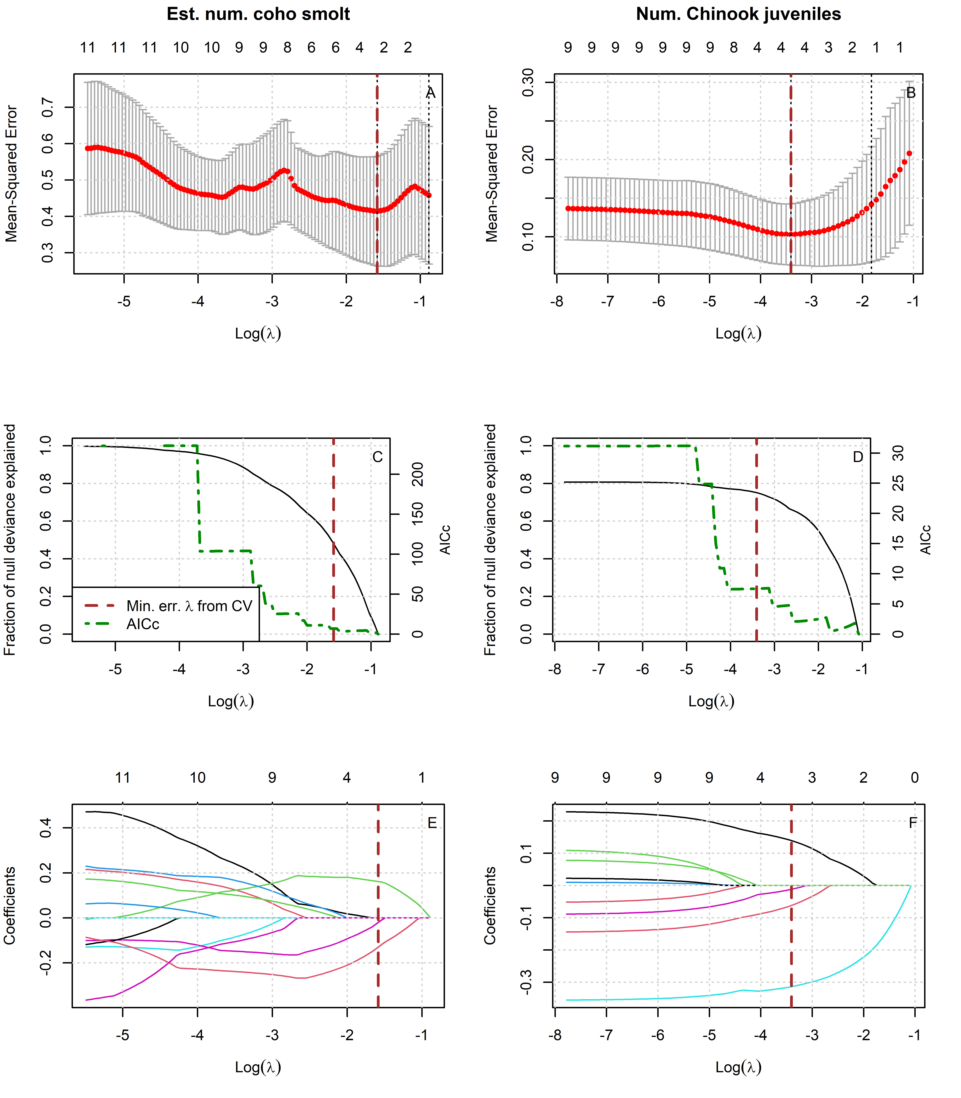

Figure 14: Results of lasso regression to predict log-transformed coho and Chinook outcomes with Z-scored hydrologic metrics and spawner abundance.

[1] “juvenile abundance, hydro and spawners” ::: {custom-style=“Table Caption”}

Table 31: Values for the intercept and coefficient terms in the Hydrologic Benefit function for estimated coho smolt abundance based on hydrologic metrics and spawner abundance, including a description of which phenomena are associated with higher ecological outcome values.

:::

| Predictor | Value | Greater Hydrologic Benefit value associated with |
| --- | --- | --- |
|  | 3.872 | (Intercept) |
| f1_FA_Dif_num | 0.162 | Larger fall flow increase (during parents' spawning) |
| f2_FA_Dif_num | -0.130 | Smaller fall flow increase (as juvenile fish) |
| s1_SP_ROC | -0.020 | Slower rate of change, spring recession (as recent hatchlings) |

Table 32: Values for the intercept and coefficient terms in the Hydrologic Benefit function for estimatedChinook juv. abundance based on hydrologic metrics and spawner abundance, including a description of which hydrologic phenomena are associated with higher ecological outcome values.

| Predictor | Value | Greater Hydrologic Benefit value associated with |
| --- | --- | --- |
|  | 5.442 | (Intercept) |
| w1_Wet_BFL_Mag_50 | -0.314 | Lower wet season baseflows (as eggs and hatchlings) |
| chinook_spawners_zscored | 0.139 | Abundance of spawners (parents of designated cohort) |
| s1_SP_ROC_Max | -0.062 | Slower max. rate of change, spring recession (as outmigrating smolt) |
| w1_Wet_Tim | -0.012 | Earlier wet season onset (as eggs and hatchlings) |

# 16 MARSS Models

## 16.1 MARSS models of juveniles per spawner, single hydrologic covariate

For purposes of statistical model comparison, we calculated multiple MARSS models (15 for coho and 8 for Chinook) that predicted the observed ratio of juveniles-per-spawner for coho and Chinook based on a single Z-scored hydrologic metric.

Table 33: Each row corresponds to a MARSS model predicting the time series of coho spf observations using itself (up to time t) and one hydrologic metric covariate. Coefficient sign and value indicate the direction and strength of the influence of the hydrologic metric; i.e., a negative coefficient for hydrologic metric f1_recon_120 indicates that an earlier first fall river reconnection (120 cfs) is associated with a greater coho spf value. Models are listed in order from best (lowest AICc value) to worst. Values marked with -- indicate that gaps in the time series for the hydrologic metric prevented the calculation of a model using that covariate.

| Covariate | Coefficient | AICc |
| --- | --- | --- |
| f1_recon_120 | -0.403 | 21.24 |
| f1_FA_Dif_num | 0.306 | 23.13 |
| w1_Wet_BFL_Mag_50 | 0.136 | 26.46 |
| d1_DS_Mag_90 | 0.102 | 27.05 |
| s2_SP_ROC_Max | -0.093 | 27.34 |
| f2_recon_120 | -0.173 | 27.5 |
| s2_SP_ROC | 0.085 | 27.55 |
| d1_DS_Mag_50 | -0.109 | 27.74 |
| w2_Wet_BFL_Mag_50 | 0.085 | 27.93 |
| s1_SP_ROC_Max | 0.046 | 28.25 |
| s2_SP_Tim | 0.029 | 28.26 |
| w1_Wet_Tim | -0.025 | 28.45 |
| w2_Wet_Tim | -0.023 | 28.47 |
| f2_FA_Dif_num | 0.036 | 28.5 |
| s1_SP_ROC | 0.007 | 28.55 |
| f1_FA_Dur | -- | -- |
| f2_FA_Dur | -- | -- |

Table 34: Each row corresponds to a MARSS model predicting the time series of Chinook jpa observations using itself (up to time t) and one hydrologic metric covariate. Coefficient sign and value indicate the direction and strength of the influence of the hydrologic metric; i.e., a negative coefficient for hydrologic metric f1_recon_120 indicates that an earlier first fall river reconnection (120 cfs) is associated with a greater Chinook jpa value. Models are listed in order from best (lowest AICc value) to worst. Values marked with -- indicate that gaps in the time series for the hydrologic metric prevented the calculation of a model using that covariate.

| Covariate | Coefficient | AICc |
| --- | --- | --- |
| d1_DS_Mag_90 | 0.069 | 28.91 |
| s1_SP_ROC_Max | -0.057 | 29.17 |
| f1_recon_120 | -0.039 | 29.61 |
| d1_DS_Mag_50 | -0.039 | 29.72 |
| w1_Wet_BFL_Mag_50 | 0.031 | 29.74 |
| w1_Wet_Tim | 0.006 | 29.88 |
| f1_FA_Dif_num | -0.013 | 29.88 |
| s1_SP_ROC | 0.002 | 29.89 |
| f1_FA_Dur | -- | -- |

## png   
## 2

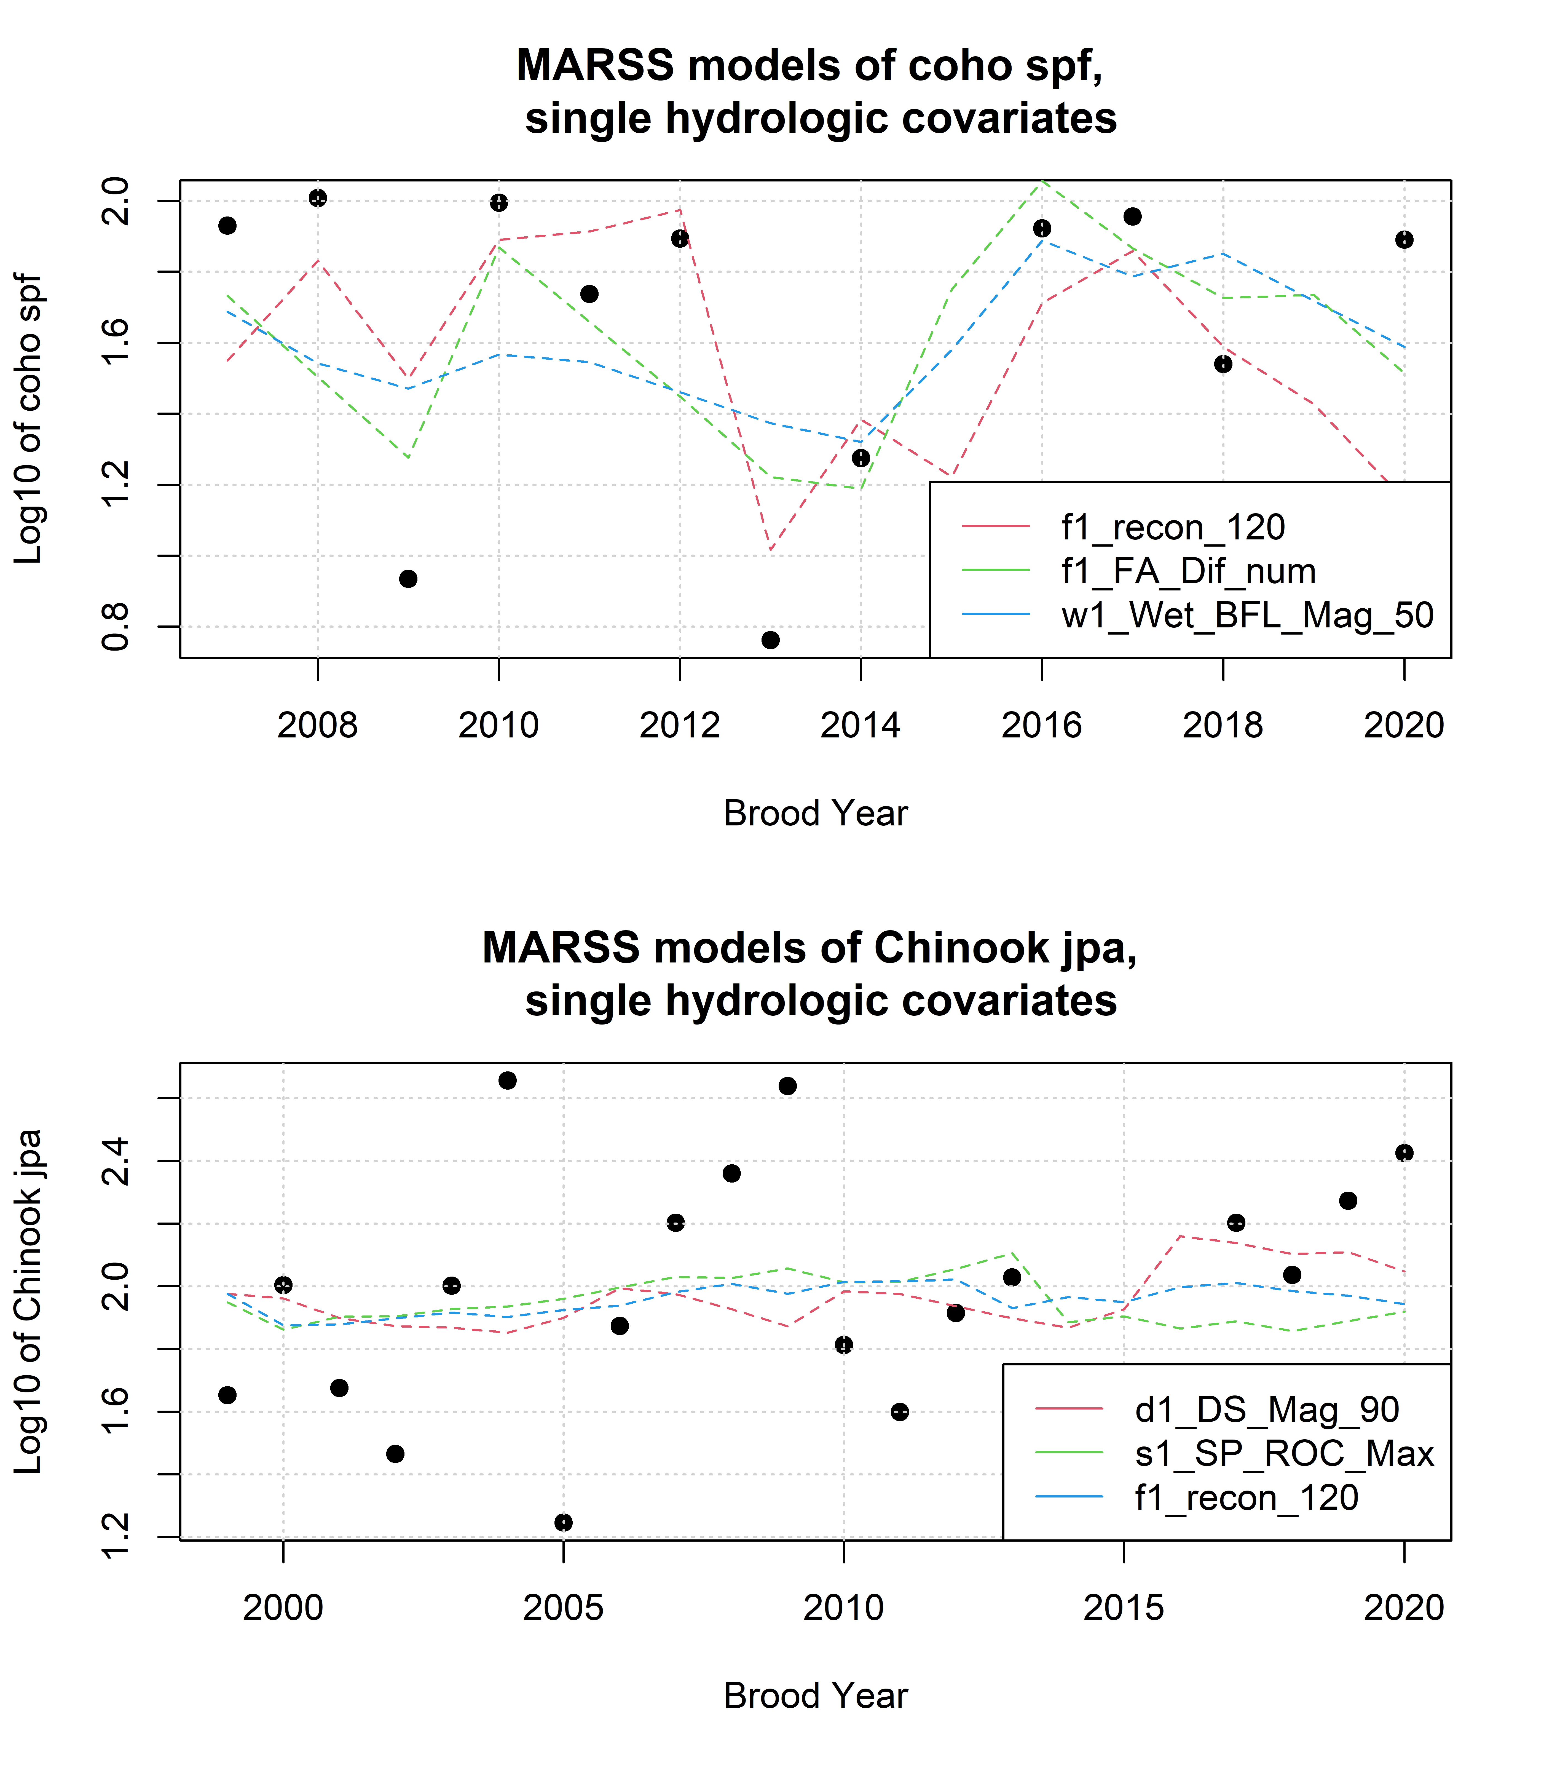

Figure 15: Results of the three best single-hydrologic-covariate MARSS models to predict log-transformed Chinook and coho juvenile-per-spawners ratios with Z-scored hydrologic metrics.

## 16.2 MARSS models of juveniles abundance, single hydrologic covariate

For purposes of statistical model comparison, we calculated multiple MARSS models (15 for coho and 8 for Chinook) that predicted juvenile abundance for coho and Chinook based on a single Z-scored hydrologic metric.

Table 35: Each row corresponds to a MARSS model predicting the time series of coho smolt abundance observations using itself (up to time t) and one hydrologic metric covariate. Coefficient sign and value indicate the direction and strength of the influence of the hydrologic metric; i.e., a negative coefficient for hydrologic metric f1_recon_120 indicates that an earlier first fall river reconnection (120 cfs) is associated with a greater coho smolt abundance value. Models are listed in order from best (lowest AICc value) to worst. Values marked with -- indicate that gaps in the time series for the hydrologic metric prevented the calculation of a model using that covariate.

| Covariate | Coefficient | AICc |
| --- | --- | --- |
| f1_FA_Dif_num | 0.206 | 40.37 |
| f2_FA_Dif_num | -0.136 | 41.55 |
| w2_Wet_BFL_Mag_50 | 0.08 | 41.74 |
| d1_DS_Mag_90 | 0.058 | 41.78 |
| s1_SP_ROC_Max | 0.061 | 41.78 |
| s2_SP_ROC_Max | 0.06 | 41.8 |
| w1_Wet_BFL_Mag_50 | 0.059 | 41.83 |
| s2_SP_ROC | 0.045 | 41.83 |
| w2_Wet_Tim | 0.039 | 41.88 |
| s1_SP_ROC | -0.017 | 41.98 |
| f1_recon_120 | -0.035 | 41.98 |
| d1_DS_Mag_50 | -0.015 | 42.01 |
| f2_recon_120 | -0.018 | 42.01 |
| w1_Wet_Tim | 0.007 | 42.01 |
| s2_SP_Tim | -0.002 | 42.02 |
| f1_FA_Dur | -- | -- |
| f2_FA_Dur | -- | -- |

Table 36: Each row corresponds to a MARSS model predicting the time series of Chinook juv. abundance observations using itself (up to time t) and one hydrologic metric covariate. Coefficient sign and value indicate the direction and strength of the influence of the hydrologic metric; i.e., a negative coefficient for hydrologic metric f1_recon_120 indicates that an earlier first fall river reconnection (120 cfs) is associated with a greater Chinook juv. abundance value. Models are listed in order from best (lowest AICc value) to worst. Values marked with -- indicate that gaps in the time series for the hydrologic metric prevented the calculation of a model using that covariate.

| Covariate | Coefficient | AICc |
| --- | --- | --- |
| w1_Wet_BFL_Mag_50 | -0.135 | 32.65 |
| s1_SP_ROC_Max | -0.106 | 33.11 |
| d1_DS_Mag_50 | 0.089 | 34.36 |
| w1_Wet_Tim | -0.043 | 34.44 |
| f1_recon_120 | -0.062 | 34.5 |
| f1_FA_Dif_num | -0.053 | 34.85 |
| s1_SP_ROC | 0.007 | 35.06 |
| d1_DS_Mag_90 | -0.006 | 35.08 |
| f1_FA_Dur | -- | -- |

## png   
## 2

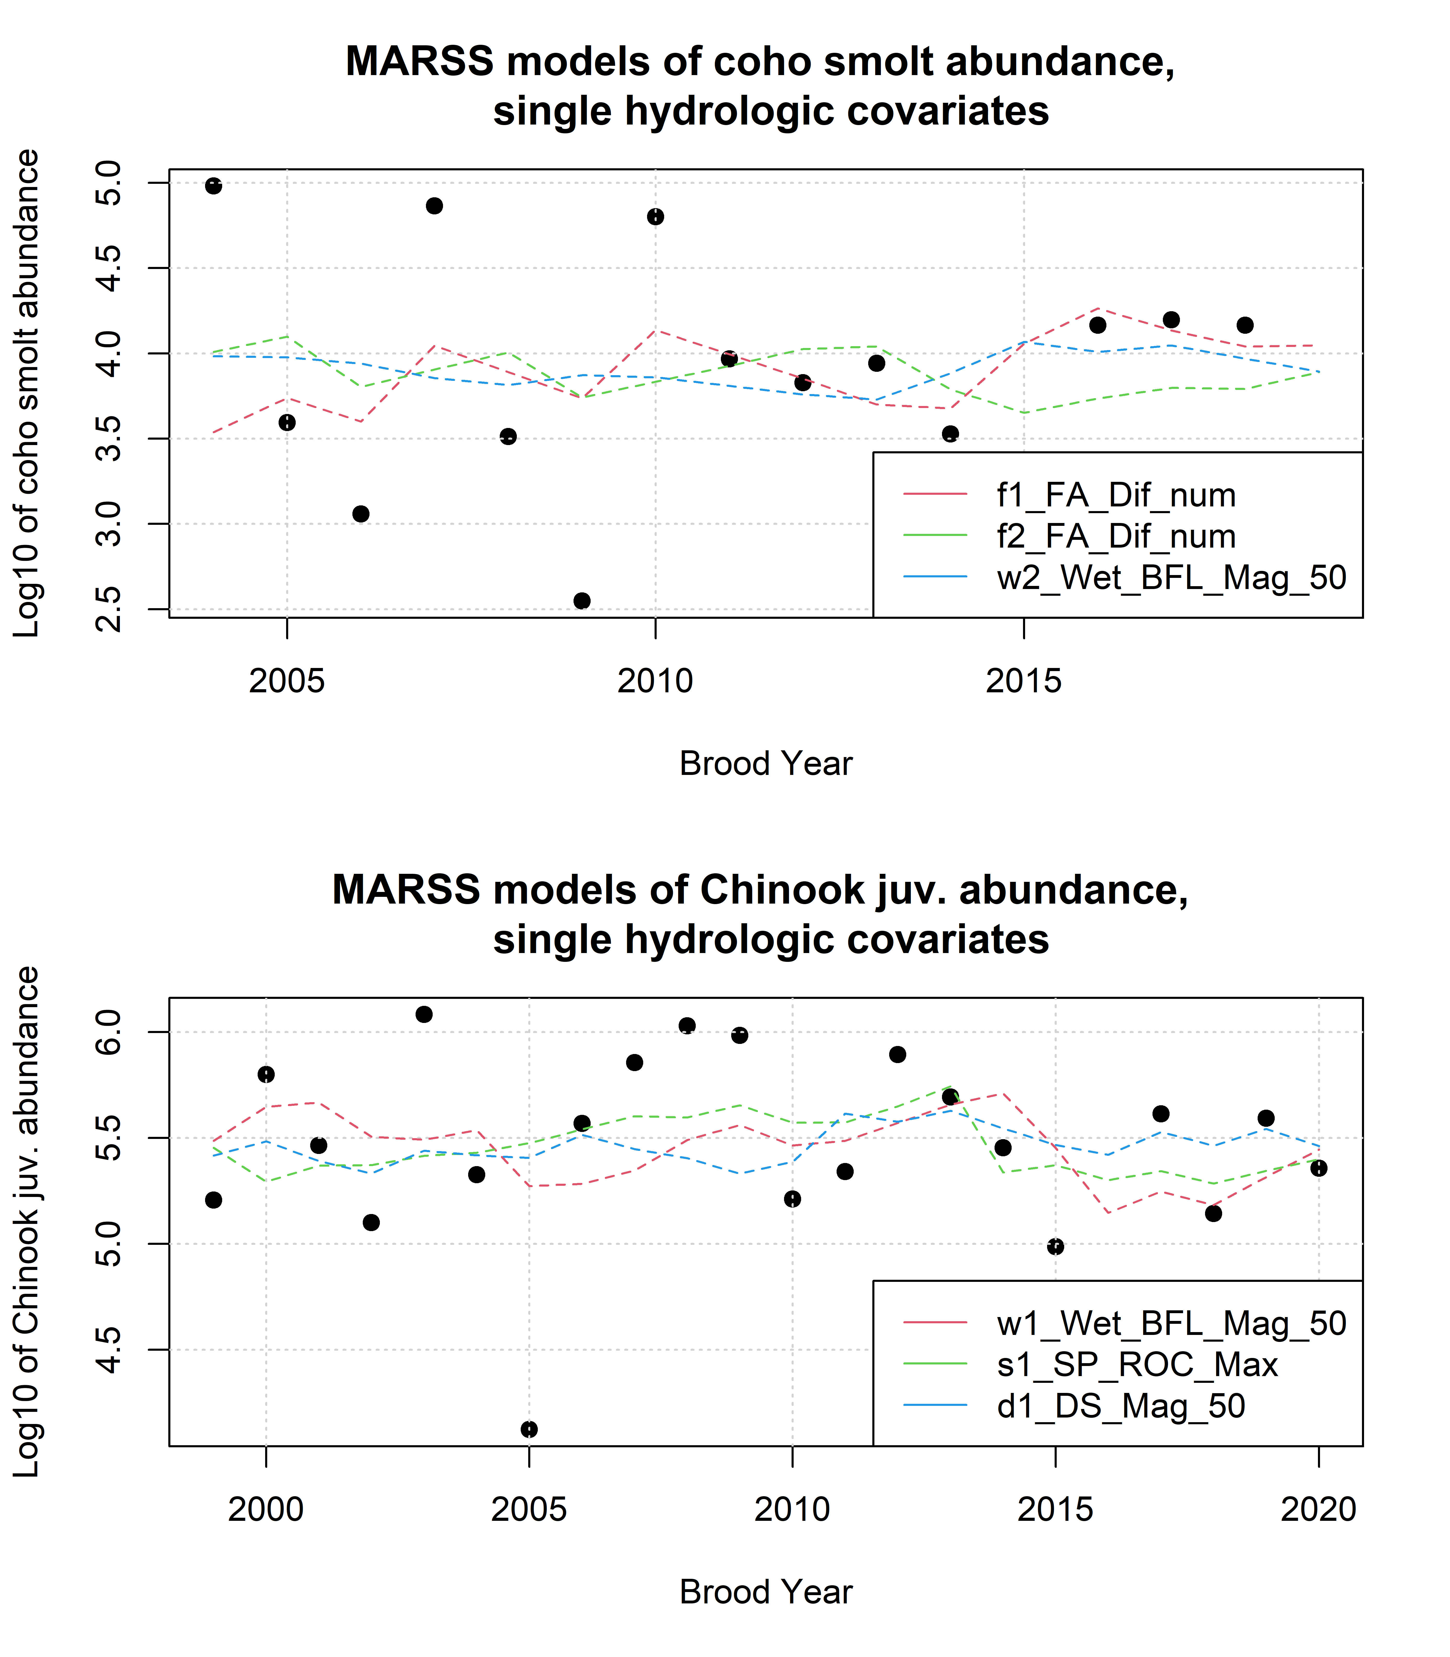

Figure 16: Results of the three best single-hydrologic-covariate MARSS models to predict log-transformed Chinook and coho outcomes with Z-scored hydrologic metrics.

## 16.3 MARSS models of juvenile abundance, two covariates (spawner abundance and one hydrologic)

For purposes of statistical model comparison, we calculated multiple MARSS models (15 for coho and 8 for Chinook) that predicted juvenile abundance for coho and Chinook based on a single Z-scored hydrologic metric and Z-scored parental spawner abundance; thus, coefficients were calculated for both the hydrology and spawner covariates.

Table 37: Characteristics of MARSS models of coho smolt abundance using one hydrologic metric and Z-scored spawner abundance as the two covariates in each model.

| Hydrologic Covariate | AICc | Hydro Coef. | Spawner Coef. | Hyd. / Sp. |
| --- | --- | --- | --- | --- |
| f1_FA_Dif_num | 32.11 | 0.550 | 0.374 | 1.5 |
| f1_recon_120 | 37.67 | -0.605 | 0.452 | -1.3 |
| d1_DS_Mag_90 | 38.16 | 0.229 | 0.338 | 0.7 |
| w1_Wet_BFL_Mag_50 | 38.27 | 0.245 | 0.301 | 0.8 |
| f2_recon_120 | 40.62 | -0.237 | 0.161 | -1.5 |
| w2_Wet_BFL_Mag_50 | 41.18 | 0.110 | 0.201 | 0.5 |
| s1_SP_ROC | 41.32 | -0.065 | 0.160 | -0.4 |
| s1_SP_ROC_Max | 41.50 | 0.052 | 0.186 | 0.3 |
| w2_Wet_Tim | 41.50 | 0.049 | 0.176 | 0.3 |
| d1_DS_Mag_50 | 41.61 | 0.045 | 0.164 | 0.3 |
| f2_FA_Dif_num | 41.65 | -0.040 | 0.160 | -0.2 |
| w1_Wet_Tim | 41.66 | -0.021 | 0.171 | -0.1 |
| s2_SP_ROC | 41.66 | 0.017 | 0.169 | 0.1 |
| s2_SP_Tim | 41.67 | -0.010 | 0.159 | -0.1 |
| s2_SP_ROC_Max | 41.68 | -0.004 | 0.167 | 0.0 |
| f1_FA_Dur |  |  |  |  |
| f2_FA_Dur |  |  |  |  |

Table 38: Characteristics of MARSS models of Chinook juv. abundance using one hydrologic metric and Z-scored spawner abundance as the two covariates in each model.

| Hydrologic Covariate | AICc | Hydro Coef. | Spawner Coef. | HtoS_ratio |
| --- | --- | --- | --- | --- |
| s1_SP_ROC_Max | 36.03 | -0.116 | 0.0573 | -2.0 |
| w1_Wet_BFL_Mag_50 | 36.06 | -0.132 | 0.0209 | -6.3 |
| f1_recon_120 | 37.77 | -0.062 | 0.0361 | -1.7 |
| w1_Wet_Tim | 37.80 | -0.040 | 0.0287 | -1.4 |
| d1_DS_Mag_50 | 37.81 | 0.081 | 0.0183 | 4.4 |
| f1_FA_Dif_num | 38.18 | -0.046 | 0.0318 | -1.4 |
| s1_SP_ROC | 38.19 | 0.021 | 0.0528 | 0.4 |
| d1_DS_Mag_90 | 38.35 | 0.004 | 0.0378 | 0.1 |
| f2_recon_120 |  |  |  |  |
| f1_FA_Dur |  |  |  |  |
| f2_FA_Dur |  |  |  |  |
| f2_FA_Dif_num |  |  |  |  |
| w2_Wet_BFL_Mag_50 |  |  |  |  |
| w2_Wet_Tim |  |  |  |  |
| s2_SP_ROC |  |  |  |  |
| s2_SP_ROC_Max |  |  |  |  |
| s2_SP_Tim |  |  |  |  |

## png   
## 2

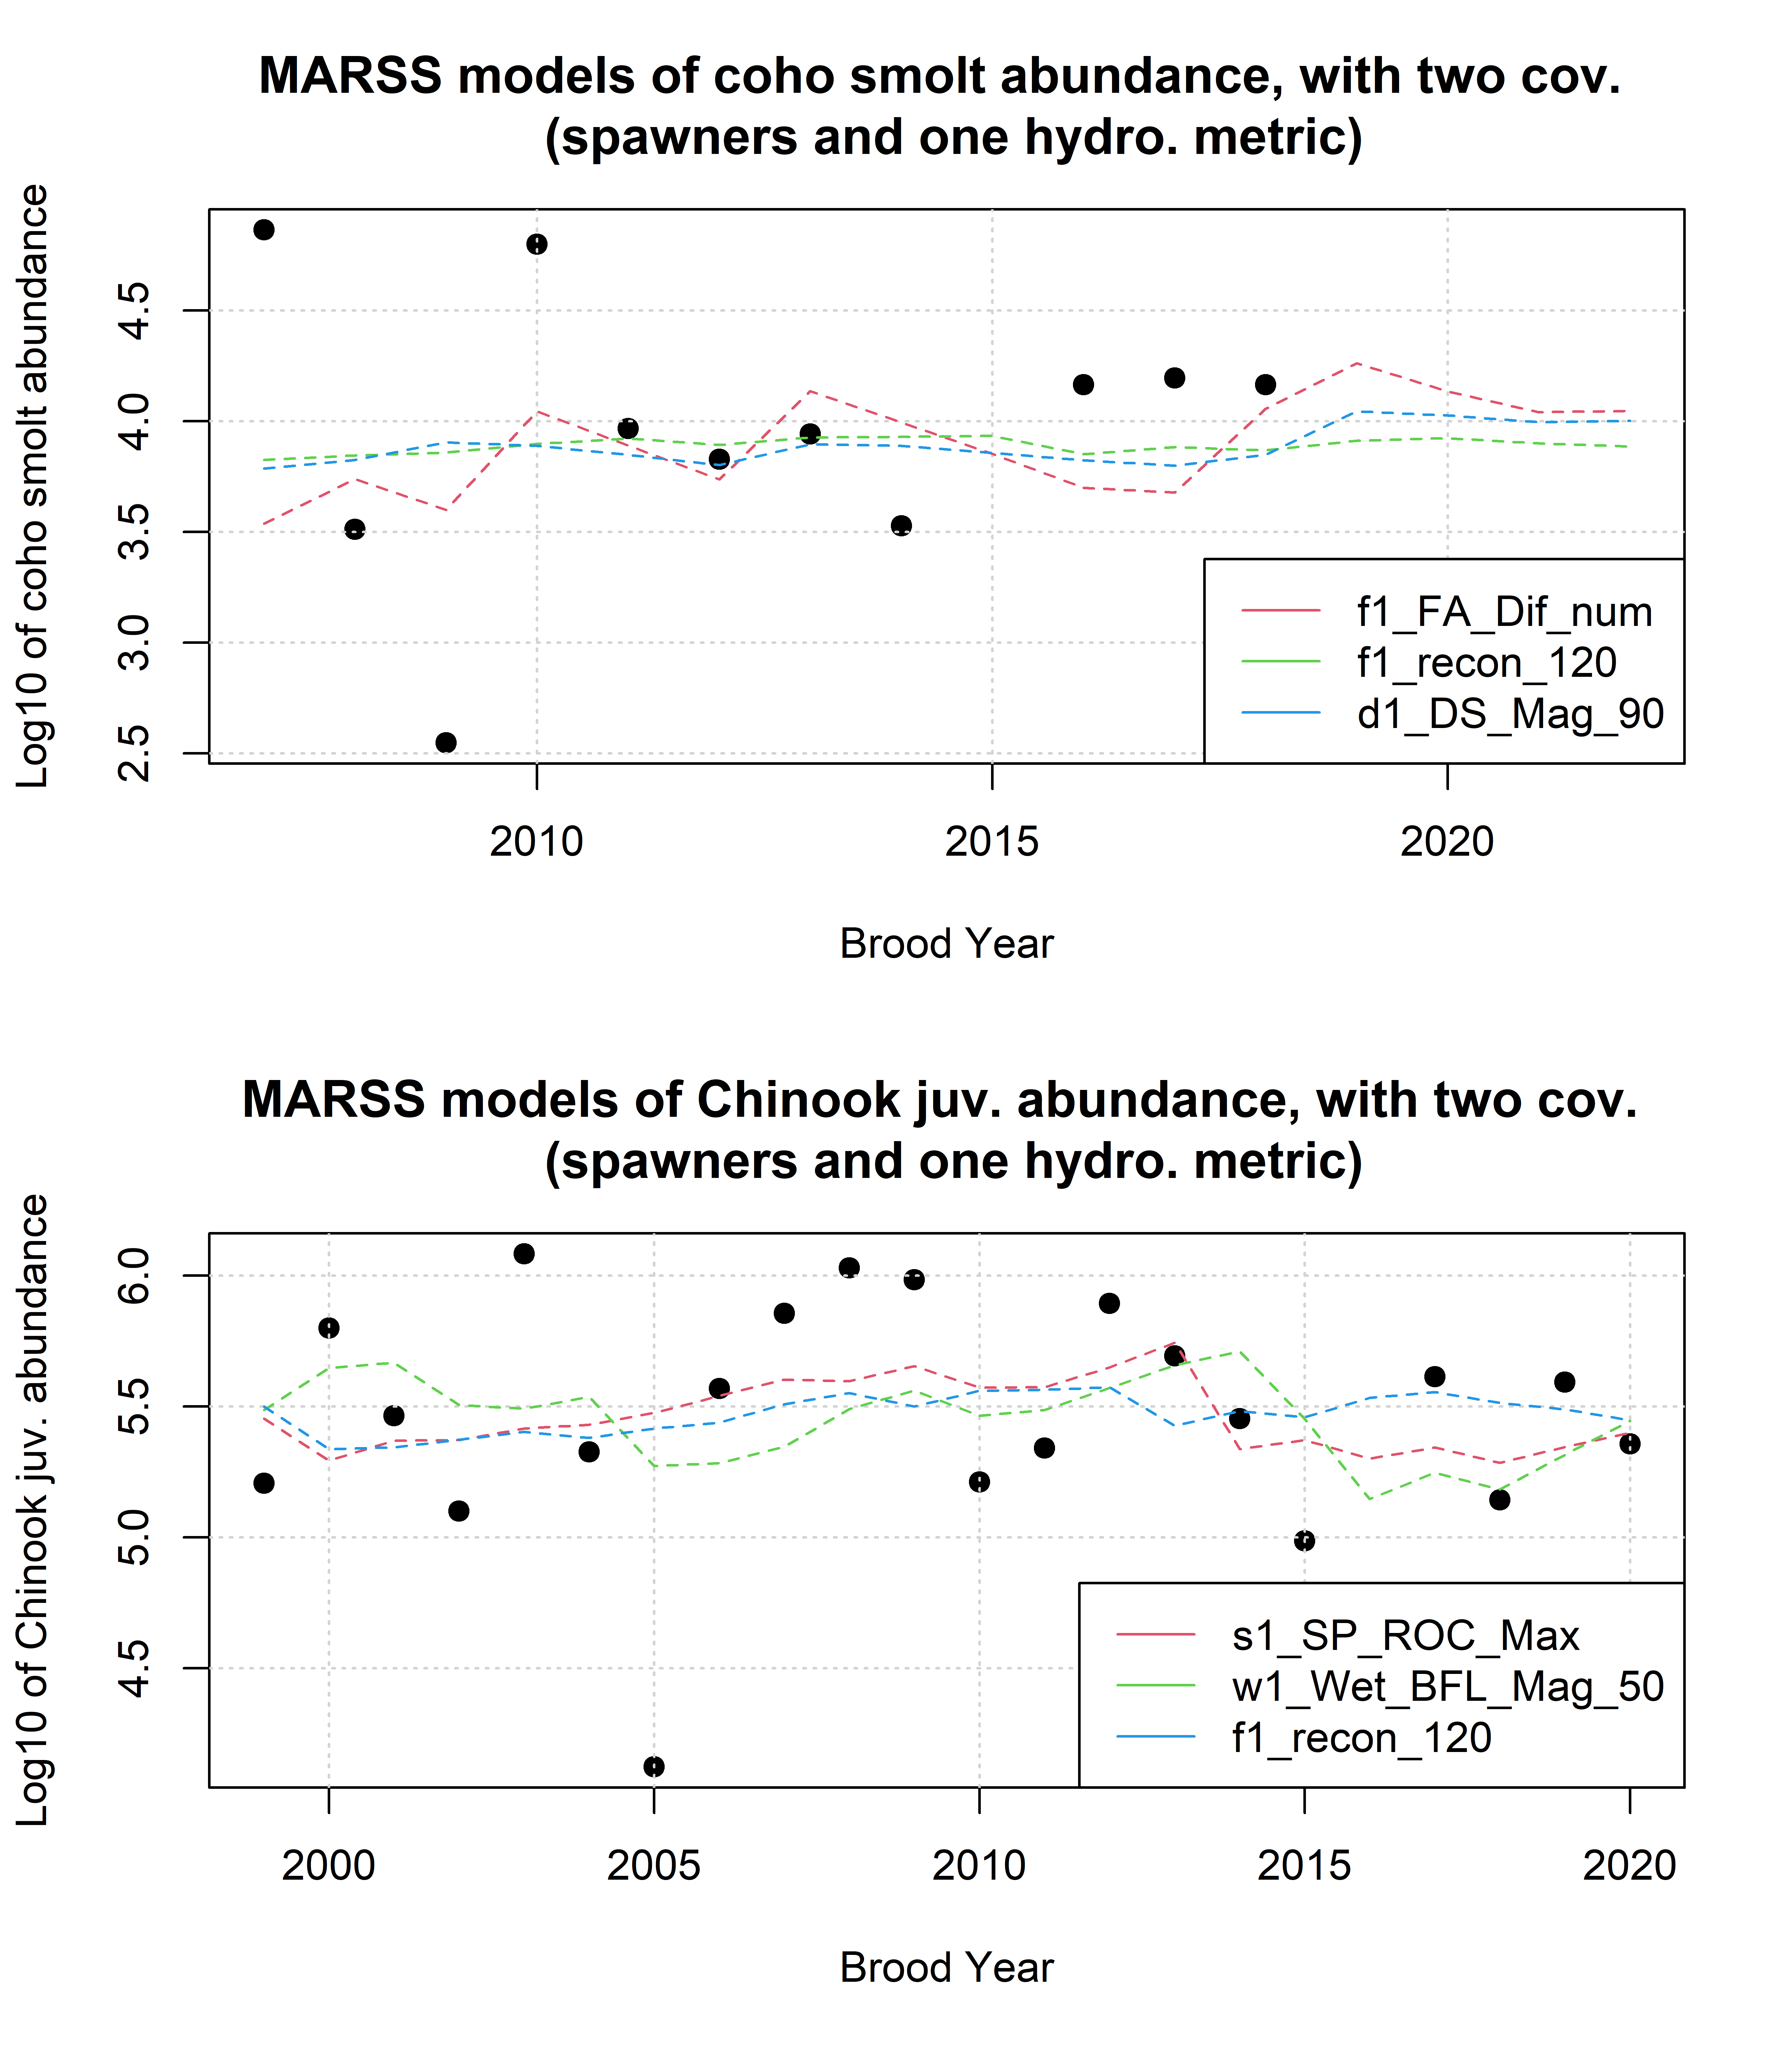

Figure 17: Results of MARSS to predict log-transformed juvenile abundance for coho and Chinook outcomes with Z-scored hydrologic metrics plus spawner data.